Heritage Impact Assessment: Site opposite Market, Market St Torquayrp
HELAA2021 Ref: | 21T037
Site Address: | Site opposite Market, Market St Torquay
Site Area (ha): | 0.25
Site Yield: | 40
HIA Assessment

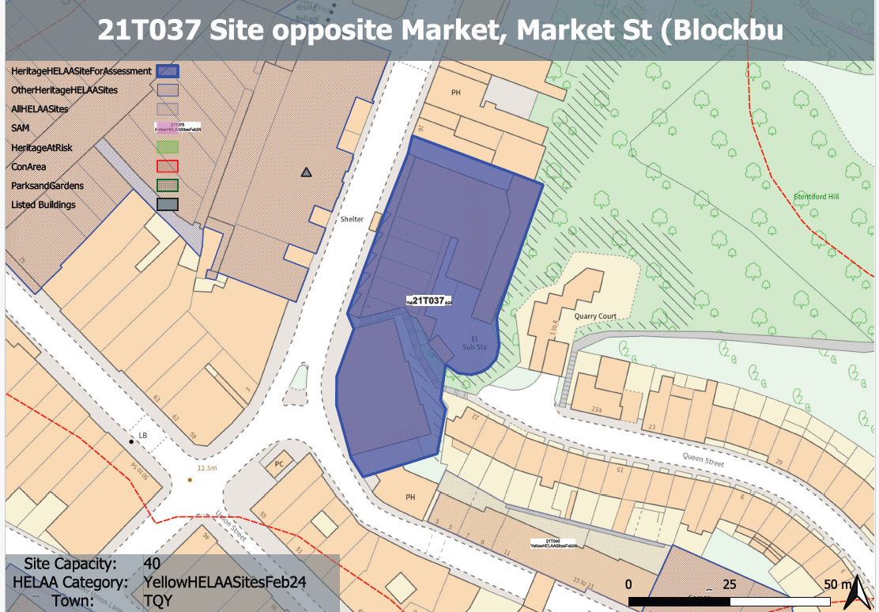
Site overview and heritage context:
The site comprises a number of buildings located on the eastern side of Market Street. The buildings range from 2 Market Street which turns the corner with Pimlico and is 3 storeys in height, a series of single-storey retail units with a distinct pattern of mono-pitched roofs and late 20th century shopfronts, to a single storey commercial building which rises to 2 storeys to the rear of the site. The whole site backs into the rock face to the east.
To the north of the site is a 19th century terrace along Market Street. To the west is the Grade II listed Market building and a late 20th century infill building. To the south is 2-3 storey development which predominantly services the retail uses accessed along Union Street.
The site is a mixture of commercial use, much of which is vacant and a medical diagnosis centre which is to be located within the southern building.

Planning History:
P/2023/0829 - External alterations to elevations including replacement windows, installation of quench pipe, external plant and substation, and associated works to enable the use of the unit as a medical diagnostics centre (Use Class E). Approved: 26/10/2023

Heritage Asset Affected by Allocation | Designation | Contributing Elements to Significance | Impact of Development on Significance | Mitigation Measures for any Identified Harm /Opportunities to Enhance Significance | Impact on Significance with Mitigation in place
Torquay Market | Grade II listed building | Pannier Market, originally constructed in 1852 to the designs of John Tapley Harvey. The setting and significance of the asset has been compromised by surrounding insensitive 20th development. The site contributes to this and currently has a minor detrimental impact on the setting and significance of this heritage asset. | The quantum of housing specified would likely require the demolition and redevelopment of the northern half of the site and the potential conversion of the southern building. If new development were designed to respect the scale and form of the surrounding historic environment and followed the building line and rhythm of the 19th century development found to the north of the site, it is likely that this would have a positive impact on the surrounding townscape including this asset. | n/a | Positive impact

