Heritage Impact Assessment: Land R/O Market Street, Torquay
HELAA2021 Ref: | 21T034
Site Address: | Land R/O Market Street, Torquay
Site Area (ha): | 0.24
Site Yield: | 30
HIA Assessment

Site overview and heritage context:
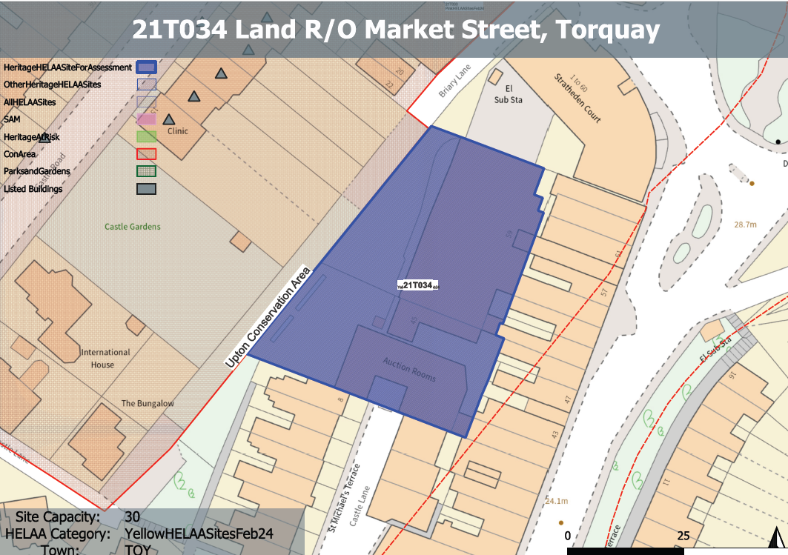
The site is located adjacent to the border of the Upton Conservation Area which can be found immediately to the west. The site comprises the ‘Auction Rooms’ a 2 and 3 storey flat-roofed vacant building accessed from the south from St. Michael’s Terrace. Within the site is No.45, a monopitched L-shaped structure adjoined to No.59, a large gabled building which was the former Salvation Army Barracks. The buildings on the site appear to date from the late 19th/very early 20th century built upon the former grounds of Ellacombe House.
A Grade II listed terrace can be found west of the site on elevated ground and separated by a band of mature trees. To the east the site is separated from Market St by a 3 storey late Victorian terrace whose gardens back onto the site, a 6 storey apartment block to the north and a 2 storey terrace to the south leading to Castle Lane.

Planning History:
P/1989/2045 – Removal of existing buildings and erection of 36 residential flats – Withdrawn: 21/02/1990
Heritage Asset Affected by Allocation | Designation | Contributing Elements to Significance | Impact of Development on Significance | Mitigation Measures for any Identified Harm /Opportunities to Enhance Significance | Impact on Significance with Mitigation in place
Upton Conservation Area (immediately W of site)  15-25 Castle Road (immediately W of site)  Garden Walls and Gate Piers to Nos 12 to 30 Castle Road (W of site)  12-30 Castle Road (W of site) | Conservation Area  Grade II listed buildings (each address individually listed)  Grade II listed building  Grade II listed building | The Upton Conservation Area is predominantly characteristed by an informal arrangement of detached and semi-detached villas reflecting the resort’s fashionable status by the end of the 19th century, along with areas of smaller mid-late 19th century terraced housing.  The site sits outside of the conservation area and makes a limited contribution to its significance as a designated heritage asset.  Terrace of 5 houses dating from the 1870s. The site sits within the urban setting of this asset, however, due to the topography of the site, the existing landscaping and surrounding built form, it makes a limited contribution to the overall quality of the historic environment within the area.  Garden walls and gate piers to Nos 12-30 (even) Castle Road c1870s, have demonstrable group value with 12-30 Castle Road. The site is not considered to be within the setting of the asset and does not contribute to its significance.  Terrace of 10 houses dating from the 1870s. The site is not considered to be within the setting of the asset and does not contribute to its significance. | The redevelopment of the site to the specified quantum, whilst considering the constrained nature of the site, may result in a structure located closer to the western boundary of the site, higher than the prevailing height and which may have a minor detrimental impact on the significance of the asset.  The redevelopment of the site to the specified quantum, whilst considering the constrained nature of the site, may result in a structure located closer to the western boundary of the site, higher than the prevailing height and which may have a minor detrimental impact on the significance of the asset.  n/a  n/a | The redevelopment of the site to an appropriate scale, form and height (likely 3 storeys) which included the retention of the existing landscaping on the western boundary would have a neutral impact on the significance of the Upton Conservation Area.  The redevelopment of the site to an appropriate scale, form and height (likely 3 storeys) which included the retention of the existing landscaping on the western boundary would have a neutral impact on the significance of the asset.  n/a  n/a | Neutral  Neutral  n/a  n/a

