Heritage Impact Assessment: Torquay Town Hall Car Park, Torquay
HELAA2021 Ref: | 21T032a
Site Address: | Torquay Town Hall Car Park, Torquay
Site Area (ha): | 0.63
Site Yield: | 50
HIA Assessment

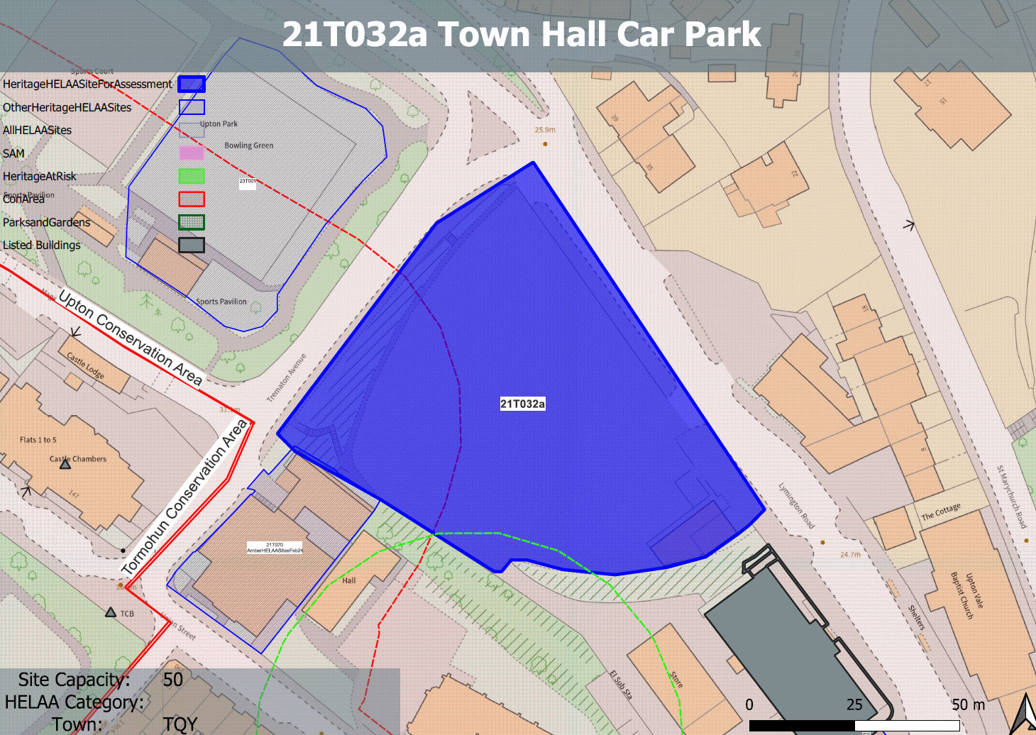
Site overview and heritage context:
The site sits at the northern end of the town centre of Torquay and compromises a car park which sits to the north of a concentration of mid-late 19th and early 20th century public buildings in the town centre which provide an important focal point within the conservation area.
The site is framed by the adjacent public highways of Lymington Road and Trematon Avenue, along with the Court House and the Grade II* Listed St Mary Magdalene’s Church to the southwest. Although the site is dominated by the expanse of open car parking it also contains a small single-storey building in the southeastern corner, which currently accommodates a shopmobility operation.
The site is situated within the Upton conservation area containing a wealth of heritage and character, including several listed buildings and interesting architectural styles, topography and green spaces to reflect the resort’s fashionable status by the end of the 19th century, a number of which share a close relationship with the town hall.
As a result, the site is particularly sensitive from a historic environment perspective.

Planning History
P/2011/0351 - Demolition of one-storey building in the south-east corner of the site and formation of a 3-4 storey office building to provide a mix of A2 (financial and professional services) and B1 use (business) with vehicular and pedestrian access – Approved: 26/09/2011

Heritage Asset Affected by Allocation | Designation | Contributing Elements to Significance | Impact of Development on Significance | Mitigation Measures for any Identified Harm /Opportunities to Enhance Significance | Impact on Significance with Mitigation in place
Torquay Town Hall  Upton Conservation Area  Electric House  Torquay Library (N of site)  Parish Church of St. Mary Magdalene (SE of site)  2 St Marychurch Road (SE of site)  Tormohun Conservation Area (W and SW of site)  Railings, Walls and Drinking Fountain (NW of site)  Castle Chambers (NW of site) | Grade II listed building  Conservation Area  Grade II listed building  Grade II listed building  Grade II* listed building  Grade II listed building  Conservation Area  Grade II listed building  Grade II listed building | The town hall was built in two phases. The Carnegie Public Library, designed by Thomas Davison was built 1906-7 by R E Narracott of Stoke Gabriel. The Town Hall and its function rooms were built 1910-11 by R Wilkins and were by the same architect. It is in Edwardian Baroque style and has demonstrable architectural, artistic, historic and communal value. The site forms part of the urban setting of the asset and makes a neutral contribution to its significance.  The site is an open space which was historically undeveloped. It sits north of a concentration of mid-late 19th and early 20th century public buildings in the town centre which provide an important focal point within the conservation area. The site is considered to currently make a neutral contribution to the significance of the conservation area.  Forms part of the group of civic buildings to the south of the site. Is a modernist extension to the town hall dating from 1935 and was designed by P W Ladmore. It is clear architectural interest and retains many of its original internal features and fittings. The site forms part of the urban setting of the asset and makes a neutral contribution to its significance.  This asset forms part of the group of civic buildings on the site. It dates from 1937 and has clear architectural value as an interesting example of an Art Deco library. The site forms part of the urban setting of the asset and makes a neutral contribution to its significance  Parish church. 1843-9 to the designs of A Salvin, contractor Jacob Harvey; altered and partly re-fitted under GG Scott 1881-2. The site sits within the urban setting of this asset with the church and its spire being a prominent feature in views from the site. The site allows clear views of the church from the E and NE and therefore makes a minor positive contribution to its overall significance.  Villa constructed in the mid 19th century. The site sits within the urban setting of this asset and makes a neutral contribution to its significance.  The site sits within the urban setting of this asset and makes a neutral contribution to its significance.  Railings and walls south-west, south-east and north-east of Castle Chambers including drinking fountain. Dating from 1892-93, contemporary with the rebuilding of the hospital. The site sits within the urban setting of this asset and makes a neutral contribution to its significance.  Hospital, used as County court and now in residential use. 1850 in origin, with alterations dating from 1892-93. The site sits within the urban setting of this asset and makes a neutral contribution to its significance. | A 3/4 storey development which follows the established building line and is subservient to the asset whilst employing a well executed contemporary approach to its design which respected the established character of the surrounding historic environment would have a neutral impact on the significance of the asset.  Although historically undeveloped, the open nature of the site makes a limited contribution to the significance of the conservation area. A 3/4 storey development which follows the established building line and is subservient to the asset whilst employing a well-executed contemporary approach to its design which respected the established character of the surrounding historic environment would have a neutral impact on the significance of the asset.  A 3/4 storey development which follows the established building line and is subservient to the asset whilst employing a well executed contemporary approach to its design which respected the established character of the surrounding historic environment would have a neutral impact on the significance of the asset.  A 3/4 storey development which follows the established building line and is subservient to the asset, by potentially maintaining the prevailing height closer to the asset and providing an adequate buffer between the two whilst employing a well executed contemporary approach to its design which respected the established character of the surrounding historic environment would have a neutral impact on the significance of the asset.  A 3/4 storey development which follows the established building line, employed a well executed contemporary approach to its design which respected the established character of the surrounding historic environment and which maintained the opportunities for views of the church and its spire from within and around the site would a neutral impact on the significance of the asset.  A 3/4 storey development which follows the established building line and employed a well executed contemporary approach to its design which respected the established character of the surrounding historic environment would have a neutral impact on the significance of the asset.  The redevelopment of the site to the quantum proposed would have a limited impact on the significance of the asset.  The redevelopment of the site to the quantum proposed would have a limited impact on the significance of the asset.  A 3/4 storey development which follows the established building line, employed a well-executed contemporary approach to its design which respected the established character of the surrounding historic environment and which maintained the opportunities for views of the asset within and around the site would a neutral impact on the significance of the asset. | n/a  n/a  n/a  n/a  n/a  n/a  .  n/a  n/a  n/a | Neutral  Neutral  Neutral  Neutral  Neutral  Neutral  Neutral  Neutral  Neutral

