Heritage Impact Assessment: 50/54 Swan Street, Torquay
HELAA2021 Ref: | 21T014
Site Address: | 50/54 Swan Street, Torquay , Torquay
Site Area (ha): | 0.07
Site Yield: | 10
HIA Assessment

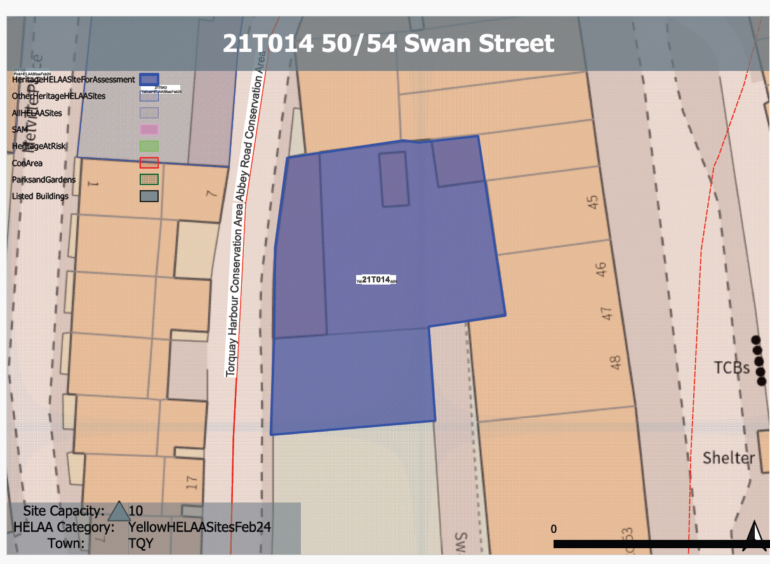
Site overview and heritage context:
The site is located within the Torquay Harbour Conservation Area between Swan Street and facing Rock Road. It comprises a single storey brick built structure with a pitched slate roof believed to date from the 19th century and may contain fabric from the former brewery on the site which has now been largely demolished.
There is a considerable and sharp change in ground levels with Rock Road to the west of the site siting in an elevated position above the main central part of the site and the eastern boundary.
Access to the site is from Swan Street and part of the site is currently in use as a outside space for a licensed premises.

Planning History:
P/2006/1824 - Mixed Development Comprising Refurbishment And New Retail Accommodation; 25 Apartments With Parking And Vehicular Access – Approved: 09/02/2007
P/2012/0090 - Change of use of the vacant land for the creation of an outdoor area alongside the existing licensed premises;enlargement of doorways on the north elevation and the addition of an external fire escape – Approved: 26/03/2012
P/2012/0883 - Change of use of the vacant land for the creation of an outdoor area alongside the existing licensed premises – Approved: 16/04/2013

Heritage Asset Affected by Allocation | Designation | Contributing Elements to Significance | Impact of Development on Significance | Mitigation Measures for any Identified Harm /Opportunities to Enhance Significance | Impact on Significance with Mitigation in place
Torquay Harbour Conservation Area  Coburg Place and attached area railings | Conservation Area  Grade II listed building | The existing building on the site, although containing historic fabric and traditional architectural detailing is identified as making a limited contribution to the significance of the conservation area  Terrace of four 19th century houses with attached railings. The site forms part of the urban setting of the asset and forms part of the surrounding historic environment. It makes a neutral impact to its significance. | The demolition of the existing structure and replacement with new development to accommodate 10 units may result in minor harm to the significance of the conservation area through the loss of historic fabric.  The demolition of the existing structure and replacement with new development to accommodate 10 units may have a detrimental impact on the significance of this asset through inappropriate development within its setting and a detrimental impact to the surrounding historic environment. | A heritage-led scheme which incorporates and is sensitive to the historic environment within and surrounding the site would likely result in neutral impact to the significance of the conservation area.  A heritage-led scheme which incorporates and is sensitive to the historic environment within and surrounding the site would likely result in neutral impact to the significance of the asset. | Neutral  Neutral

