Heritage Impact Assessment: Chilcote Close Car Park, Torquay
HELAA2021 Ref: | 21T008
Site Address: | Chilcote Close Car Park, St Marychurch, Torquay
Site Area (ha): | 0.145
Site Yield: | 10
HIA Assessment

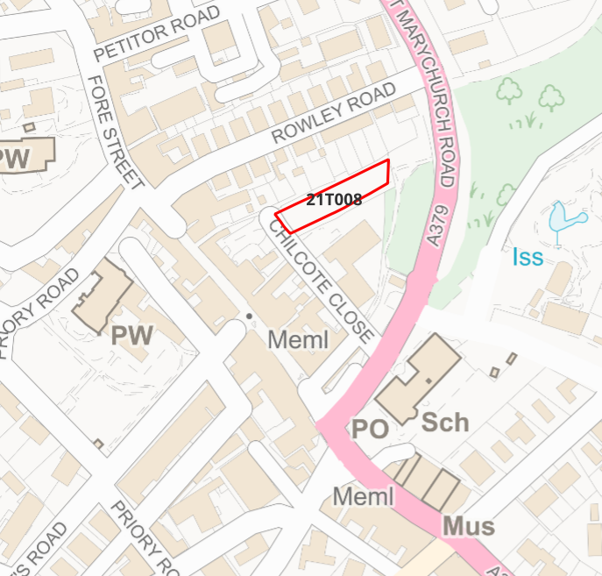
Site overview and heritage context:

The site is a long, narrow strip within St Marychurch Conservation Area, currently in use as a car park. It is situated within the developed areas of Fore Street and Rowley Road, but is shielded by mature planting on three sides which gives it a rural feel. There is a small area of green space to the east of the site, which continues eastwards on the other side of St Marychurch Road.
The Conservation Area Appraisal indicates this site may have once been strip fields associated with the medieval settlement at St Marychurch. The 1840 tithe map notes this field as an orchard, and the 1904 OS map marks the site as gardens, indicating a long standing natural character. Nearby there is one GI listed church, and several GII listed buildings.

Planning History:

Heritage Asset Affected by Allocation | Designation | Contributing Elements to Significance | Impact of Development on Significance | Mitigation Measures for any Identified Harm /Opportunities to Enhance Significance | Impact on Significance with Mitigation in place
Saint Marychurch Conservation Area  Roman Church of Our Lady, Help of Christians and St Denis  Jubilee Street Lamp  Abbey School  Margaret Clitherow House  Presbytery to Church of Our Lady Help of Christians and St Denis | Conservation Area  GI Listed Building  GII Listed Building  GII Listed Building  GII Listed Building  GII Listed Building | St Marychurch Conservation Area is characterised by its planned development of the later 19th-century including the town centre, along with the close-knit terraced houses that originally housed workers for local industries. The Conservation Area has a high rate of survival of historic features, as well as boundary features and street furniture.  The Conservation Area Appraisal identifies the trees at this site as important ‘main tree groups and individual trees’. The verdant character of the site has a positive impact on the character of the Conservation Area.  The site sits within the wider setting of the heritage asset and makes a limited contribution to its significance.  The site sits within the wider setting of the heritage asset and makes a limited contribution to its significance.  The site sits within the wider setting of the heritage asset and makes a limited contribution to its significance.  The site sits within the wider setting of the heritage asset and makes a limited contribution to its significance.  The site sits within the wider setting of the heritage asset and makes a limited contribution to its significance. | Development to the quantum stated in this small site has the potential to cause a massing of development that would detract from the verdant nature of the site. This would result in less than substantial harm to the Conservation Area.  Development of the site to the quantum stated could be achieved through sensitive design which maintains the verdant backdrop of the site.  Development of the site to the quantum stated could be achieved through sensitive design which maintains the verdant backdrop of the site.  Development of the site to the quantum stated could be achieved through sensitive design which maintains the verdant backdrop of the site.  Development of the site to the quantum stated could be achieved through sensitive design which maintains the verdant backdrop of the site.  Development of the site to the quantum stated could be achieved through sensitive design which maintains the verdant backdrop of the site. | Carefully considered design and attention to landscaping may mitigate the level of harm to result in a neutral impact.  N/A  N/A  N/A  N/A  N/A | Neutral  Neutral  Neutral  Neutral  Neutral  Neutral

