Heritage Impact Assessment: Shelley Court Hotel, 29 Croft Road, Torquay
HELAA2021 Ref: | 21T003
Site Address: | Shelley Court Hotel, 29 Croft Road, Torquay
Site Area (ha): | 0.2169
Site Yield: | 11
HIA Assessment

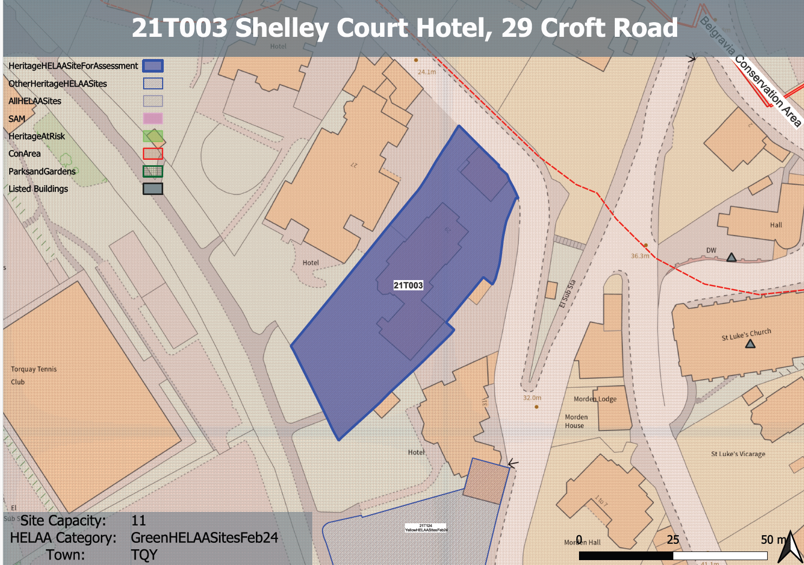
Site overview and heritage context:
The site is a two-storey, former hotel that is noted as being a key building in a group of original Victorian villas that were built between 1830-1860. The site includes a Coach House and two vehicle entry points. The building has undergone significant alterations and extensions over the decades, including a three storey extension to the southern elevation. The site area is 2,028 square metres. The site lies to the southern side of Croft Road and is adjacent to a hotel at No.27 Croft Road and holiday apartments, at No.31 Croft Road. The site is within the Belgravia Conservation Area and is subject to an Area Tree Protection Order (1976.09 Area 2).

Planning History
P/2019/0337 - Change of use, regeneration, extension and alterations to the former hotel to create 10 one- and two-bedroom apartments and 1 house. Approved 20 October 2021.

Heritage Asset Affected by Allocation | Designation | Contributing Elements to Significance | Impact of Development on Significance | Mitigation Measures for any Identified Harm /Opportunities to Enhance Significance | Impact on Significance with Mitigation in place
Belgravia Conservation Area  Howden Court Hotel, 28 Croft Road  Shelley Court | Conservation Area  Grade II listed building  Non-designated heritage asset | The site is identified as making a positive contribution to the character and appearance of the conservation area within the Belgravia Conservation Area Appraisal (2006). The appraisal states that the property was built in the 1850s along with the neighbouring villas which are set in large gardens south of Croft Road.  Shelly Court occupies a corner site and is therefore a prominent feature within the conservation area. It has undergone some clear unsympathetic alteration in the past which has resulted in an overly large and dominating poorly designed south eastern corner extension, a poorly designed porch and rear flat roofed extension.  Despite this, the villa, although in relatively poor condition does retain much of its high-quality historic character through the retention of fabric of historic and architectural interest, including decorative stucco detail, some sash windows, bracketed eaves, slate roof and chimneys.  It therefore continues to make a demonstrable positive contribution to the character and appearance of the Belgravia Conservation Area and contributes to the group value of the villas found in this area which are identified as being one of special characteristics of the conservation area.  In addition, it is considered that the original garden to the south and its associated mature trees and landscaping also make a positive contribution to the conservation area.  The site therefore makes a considerable contribution to the significance of the Belgravia Conservation Area.  The former coach house, although believed to date from the same period as the villa, has been significantly altered to the point where much of its architectural and historic value has been lost. Although highly visible within the street scene, this makes a limited contribution to the significance of the conservation area.  Located opposite the site, this is a grand Italianate villa believed to be constructed in the late 19th century. The site is considered to be within the setting of this designated heritage asset.  Due to the historic and architectural features that have remained within the villa, its prominent location within the street scene and its demonstrable group value with neighbouring villas of a similar age, it is considered that the Shelley Court Hotel is a non-designated heritage asset, albeit one which has clear opportunity for enhancement. | The proposed yield of 11 could be achieved through the sensitive conversion of the site which would result in a neutral or positive impact to the significance of this asset.  The proposed yield of 11 could be achieved through the sensitive conversion of the site which would result in a neutral or positive impact to the significance of this asset.  The proposed yield of 11 could be achieved through the sensitive conversion of the site which would result in a neutral or positive impact to the significance of this asset. | Opportunity to enhance significance through sensitive conversion of the site and removal of detrimental elements no longer necessary for hotel use.  Opportunity to enhance significance through sensitive conversion of the site and removal of detrimental elements no longer necessary for hotel use.  Opportunity to enhance significance through sensitive conversion of the site and removal of detrimental elements no longer necessary for hotel use. | Positive  Positive  Positive

