Heritage Impact Assessment: Former Kia Garage, Totnes Road, Paignton
HELAA2021 Ref: | 21P088
Site Address: | Former Kia Garage, Totnes Road, Paignton
Site Area (ha): | 0.29
Site Yield: | 25
HIA Assessment

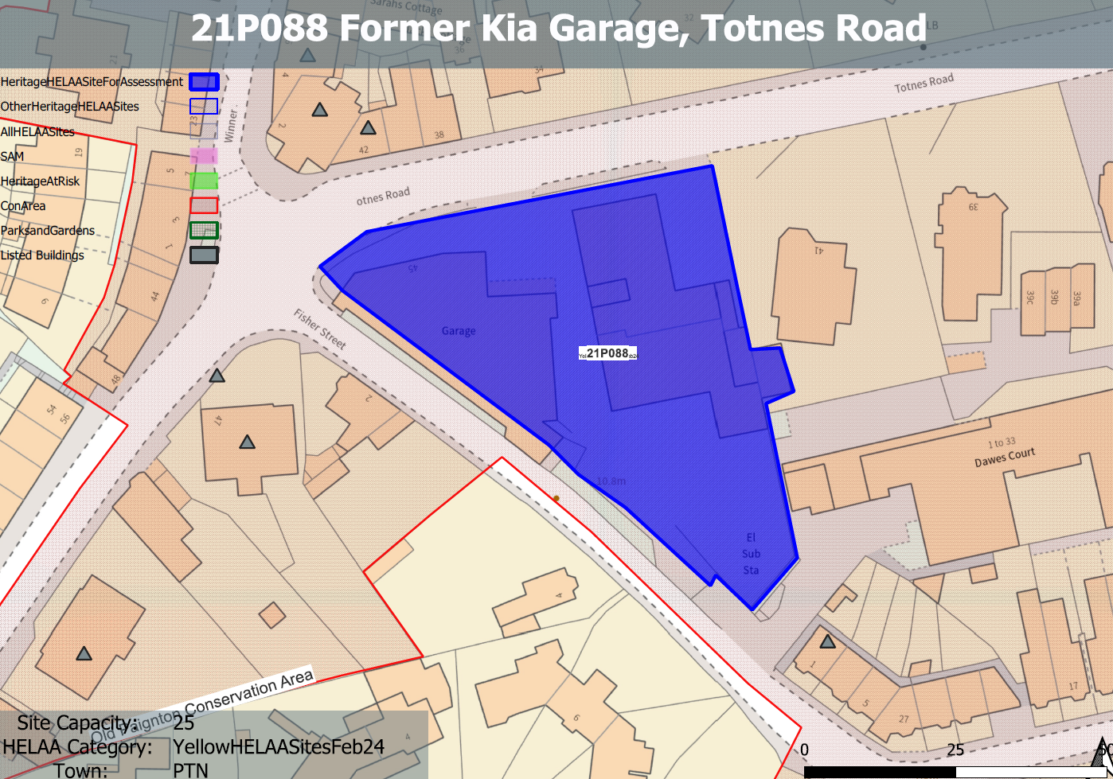
Site overview and heritage context:
Vacant car dealership located on the corner of Fisher Street and Totnes Road close to Paignton’s town centre. The property is arranged as two buildings (together comprising 1,500 sq m), the first being a purpose-built car sales showroom with ancillary administration offices and stores. To the rear of the showroom is extensive workshop accommodation and staff welfare facilities. The second building is a covered canopy (previously used for vehicle display), with office, stores and workshops to the rear. To the rear of the site is extensive further parking. The site has a long and prominent frontage onto Totnes Road.
The site is within the Old Paignton Conservation Area and is surrounded by a number of designated heritage assets.

Planning History:
P/2024/0473 - Change of use from Sui Generis to Class B8 (Storage or Distribution), together with associated external alterations.- APPROVED 16/01/2025

Heritage Asset Affected by Allocation | Designation | Contributing Elements to Significance | Impact of Development on Significance | Mitigation Measures for any Identified Harm /Opportunities to Enhance Significance | Impact on Significance with Mitigation in place
Paignton Old Town Conservation Area  4 Winner Street (N of site)  Belgrave House, 2 Winner Street (N of site)  38, 40 and 42 Totnes Rd (N of site)  Wall and railings to garden north of No 47 (W of site)  47 Totnes Road (W of site)  53 Totnes Road (W of site)  Eaton Place (Terrace), 1-4 Fisher Street (S of site) | Conservation Area  Grade II listed building  Grade II listed building  Grade II listed building  Grade II listed building  Grade II listed building  Grade II listed building  Grade II listed building | The conservation area evidences the origins of Paignton from its medieval core to the expansive developments of the 19th and 20th century’s which illustrate its growth as a popular seaside resort. It has a wide range of architectural typologies, predominantly 19th century which evidence the expansion of the town.  The site sits within the boundaries of the conservation area but makes a limited contribution to its significance.  Shop with accommodation over. c1850, possibly originally part of Belgrave House, Winner Street (qv), to which it is attached. Late C19/early C20 shopfront. The site sits within the urban setting of the asset but makes a limited contribution to its significance.  House, in use as language school. c1850. The site sits within the urban setting of the asset but makes a limited contribution to its significance.  3 houses. c1850. The site sits within the urban setting of the asset but makes a limited contribution to its significance.  Garden wall and railings. c1820s, contemporary with No.47. The site sits within the urban setting of the asset but makes a limited contribution to its significance.  Villa, used as school of dancing. c1820s. The site sits within the urban setting of the asset but makes a limited contribution to its significance.  Detached villa in use as hostel. 1835-1845. The site makes a limited contribution to the significance of the asset.  Row of 3 cottages, formerly 4, perhaps originally one house. Late C17/early C18 with C20 alterations. The site sits within the urban setting of the asset but makes a limited contribution to its significance. | The development of the site to the quantum stated could be achieved through sensitive design which respects the surrounding historic environment and improves on the existing architectural quality of the site. This would have a neutral impact on the significance of the asset.  The development of the site to the quantum stated could be achieved through sensitive design which respects the surrounding historic environment and improves on the existing architectural quality of the site. This would have a neutral impact on the significance of the asset.  The development of the site to the quantum stated could be achieved through sensitive design which respects the surrounding historic environment and improves on the existing architectural quality of the site. This would have a neutral impact on the significance of the asset.  The development of the site to the quantum stated could be achieved through sensitive design which respects the surrounding historic environment and improves on the existing architectural quality of the site. This would have a neutral impact on the significance of the asset.  The development of the site to the quantum stated could be achieved through sensitive design which respects the surrounding historic environment and improves on the existing architectural quality of the site. This would have a neutral impact on the significance of the asset.  The development of the site to the quantum stated could be achieved through sensitive design which respects the surrounding historic environment and improves on the existing architectural quality of the site. This would have a neutral impact on the significance of the asset.  Development of the site would have a neutral impact on the significance of the asset.  The development of the site to the quantum stated could be achieved through sensitive design which respects the surrounding historic environment and improves on the existing architectural quality of the site. This would have a neutral impact on the significance of the asset. | n/a  .  n/a  n/a  n/a  n/a  n/a  n/a  n/a | Neutral  Neutral  Neutral  Neutral  Neutral  Neutral  Neutral  Neutral

