Heritage Impact Assessment: Land north of Blagdon Road, Paignton
HELAA2021 Ref: | 21P073
Site Address: | Land north of Blagdon Road, Paignton
Site Area (ha): | 1.31
Site Yield: | 70
HIA Assessment

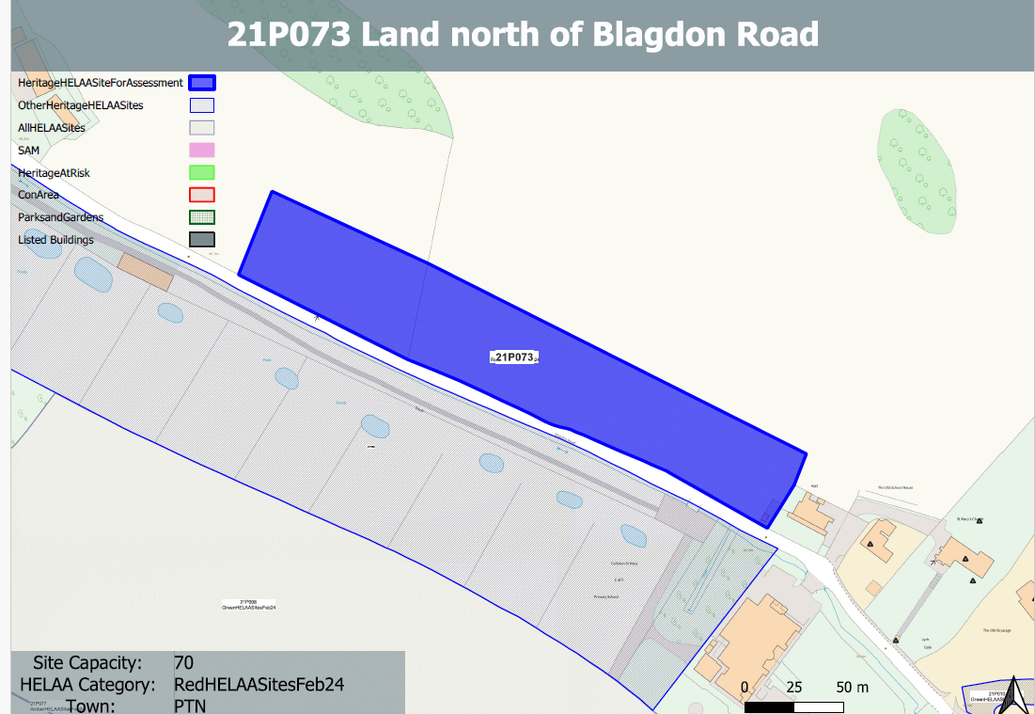
Site overview and heritage context:
The site is a long thin parcel of open land, to the north of Blagdon Road. The land is currently laid to pasture and rises steeply to the north.
The site is bordered by an established hedgerow to its southern boundary with Blagdon Road and western boundary. It lies open to the north and east.
There are a number of designated heritage assets in close proximity to the east clustered around the Church of St. Mary and the former school.

Planning History
No relevant planning history.

Heritage Asset Affected by Allocation | Designation | Contributing Elements to Significance | Impact of Development on Significance | Mitigation Measures for any Identified Harm /Opportunities to Enhance Significance | Impact on Significance with Mitigation in place
Church of St Mary (E of site)  Memorials within churchyard (E of site)  Old Vicarage (E of site)  Lych Gate (E of site)  Collaton St. Mary School (E of site) | Grade II* listed building  Grade II listed buildings  Grade II listed building  Grade II listed building  Grade II listed building | Mid 19th century parish church, set on edge of built development in a rural setting. Group value with lych gate, rectory and school. The site contributes to the rural setting of the parish church and could impact on the experience of the church and its churchyard.  Monuments of varying ages within churchyard. Setting is limited to the immediate area within the churchyard and the church itself, although the development of the site could impact on the way in which the memorials within the churchyard are experienced within their rural setting.  Rectory, now in use as house and offices dating from 1864. Has clear relationship and group value with neighbouring church, lych gate and school. The site is separated from the asset and its grounds by existing development and the church and its churchyard. It makes a limited contribution to its significance.  Mid 19th century lych gate in association with church, rectory and school which have group value. The undeveloped fields contribute to the wider rural setting of the asset but do not share intervisibility with it.  Mid 19th century school which has group value with the church, lych gate and vicarage. The site is partly separated from the asset by the existing pre-school. The site contributes to the wider rural setting of the asset. | Less than substantial harm.  Less than substantial harm  Neutral impact on significance  Neutral impact on significance  Less than substantial harm | Any quantum of development on the site would have a detrimental impact on the rural setting of the church which would be harmful to its significance.  Any quantum of development on the site would have a detrimental impact on the rural setting of the churchyard which would be harmful to its significance.  n/a  n/a  Any quantum of development on the site would have a detrimental impact on the rural setting of the churchyard which would be harmful to its significance. | Less than substantial harm  Less than substantial harm  Neutral  Neutral  Less than substantial harm.

