Heritage Impact Assessment: Lower Yalberton Holiday Park, Long Road, Paignton
HELAA2021 Ref: | 21P066
Site Address: | Lower Yalberton Holiday Park, Long Road, Paignton
Site Area (ha): | 9.32
Site Yield: | 50
HIA Assessment

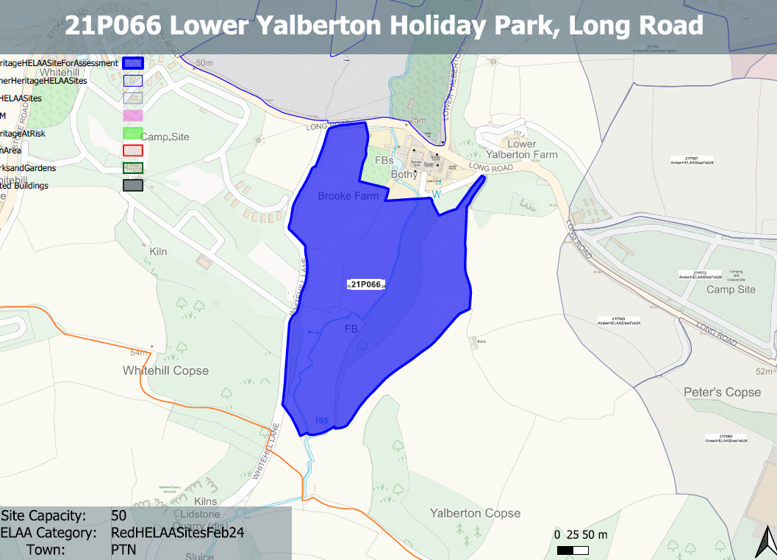
Site overview and heritage context:
Land south of Long Road. Note that although called Lower Yalberton Holiday Park the main use appears to be agricultural, with Whitehill Hol Park located to the West.
A number of designated heritage assets are located to the north of the site.
Archaeology: Medieval farmsteads and settlement. Requires programme of archaeological assessment, evaluation and mitigation.

Planning History:
None

Heritage Asset Affected by Allocation | Designation | Contributing Elements to Significance | Impact of Development on Significance | Mitigation Measures for any Identified Harm /Opportunities to Enhance Significance | Impact on Significance with Mitigation in place
Lower Yalberton Farmhouse and attached outbuilding to south west (N of site) | Grade II listed building | Farmhouse and outbuilding. c1830, forms part of a group with the other elements of the farmstead. The site forms part of the immediate rural setting of the historic farmstead and elements of the site appear to have a historic relationship with the asset.  The site in its undeveloped form makes a clear positive contribution to the asset’s significance. | Development of the quantum proposed would have a detrimental impact on the rural setting of the asset which would cause a clear degree of less than substantial harm to its significance. | The introduction of built form onto the site, even of a reduced quantum would still have a detrimental impact on the rural character of the area and the setting of the asset. This would continue to result in less than substantial harm to its significance. | Less than substantial harm
Shippon on north side of higher yard at Lower Yalberton Farm (N of site) | Grade II listed building | Shippon, used as kennels. c1830s, part of planned farmyard at Lower Yalberton farm, forms part of a group with the other elements of the farmstead. The site forms part of the immediate rural setting of the historic farmstead and elements of the site appear to have a historic relationship with the asset.  The site in its undeveloped form makes a clear positive contribution to the asset’s significance. | Development of the quantum proposed would have a detrimental impact on the rural setting of the asset which would cause a clear degree of less than substantial harm to its significance. | The introduction of built form onto the site, even of a reduced quantum would still have a detrimental impact on the rural character of the area and the setting of the asset. This would continue to result in less than substantial harm to its significance. | Less than substantial harm
West, east and north ranges of farm buildings to wets farmyard at Lower Yalberton Farm (N of site) | Grade II listed building | 3 ranges of farmbuildings to lower (west) yard at Lower Yalberton farm. c1830s, contemporary with the farmhouse, forms part of a group with the other elements of the farmstead. The site forms part of the immediate rural setting of the historic farmstead and elements of the site appear to have a historic relationship with the asset.  The site in its undeveloped form makes a clear positive contribution to the asset’s significance. | Development of the quantum proposed would have a detrimental impact on the rural setting of the asset which would cause a clear degree of less than substantial harm to its significance. | The introduction of built form onto the site, even of a reduced quantum would still have a detrimental impact on the rural character of the area and the setting of the asset. This would continue to result in less than substantial harm to its significance. | Less than substantial harm
Granary in higher yard at Lower Yalberton Farm (N of site) | Grade II listed building | Granary over implement shed. c1830s. Part of planned farmyard at Lower Yalberton farm, forms part of a group with the other elements of the farmstead. The site forms part of the immediate rural setting of the historic farmstead and elements of the site appear to have a historic relationship with the asset.  The site in its undeveloped form makes a clear positive contribution to the asset’s significance. | Development of the quantum proposed would have a detrimental impact on the rural setting of the asset which would cause a clear degree of less than substantial harm to its significance. | The introduction of built form onto the site, even of a reduced quantum would still have a detrimental impact on the rural character of the area and the setting of the asset. This would continue to result in less than substantial harm to its significance. | Less than substantial harm
Stable range on south side of Lower Yard at Lower Yalberton Farm (N of Site) | Grade II listed building | Stable block. c1830s, part of a planned farmyard, forms part of a group with the other elements of the farmstead. The site forms part of the immediate rural setting of the historic farmstead and elements of the site appear to have a historic relationship with the asset.  The site in its undeveloped form makes a clear positive contribution to the asset’s significance. | Development of the quantum proposed would have a detrimental impact on the rural setting of the asset which would cause a clear degree of less than substantial harm to its significance. | The introduction of built form onto the site, even of a reduced quantum would still have a detrimental impact on the rural character of the area and the setting of the asset. This would continue to result in less than substantial harm to its significance. | Less than substantial harm

