**Heritage Impact Assessment:** Land West of Lower Yalberton

|  |  |
| --- | --- |
| **HELAA2021 Ref:** | 21P065a |
| **Site Address:** | Land West of Lower Yalberton |
| **Site Area (ha):** | 7.51 |
| **Site Yield:** | 200 |
| **HIA Assessment** |  |

**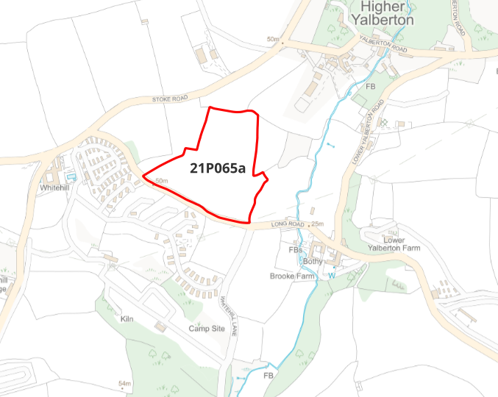  
Site overview and heritage context:**

The site is a series of four fields laid to pasture and separated by hedgerows, situated in Higher Yalberton towards the edge of the Torbay area. The site is bounded by Long Road to the south and open fields on all other sides. Existing residential development in the area is limited, with the historic hamlet of Higher Yalberton to the north east, and modern development of a caravan park to the south and an industrial complex to the north. The character of the site is overwhelmingly rural, with open fields on two sides and uninterrupted views southwards across the countryside.

The site is within the setting of several GII Listed Buildings. The site does not sit within or near any current Conservation Areas, however the Yalberton Valley area is being considered for designation as a Conservation Area as part of the ongoing Conservation Area review process. The surrounding area has evidence of medieval field systems, and any development should include a course of archeological investigation prior to commencement.

**Planning History:**

|  |  |  |  |  |  |
| --- | --- | --- | --- | --- | --- |
| **Heritage Asset Affected by Allocation** | **Designation** | **Contributing Elements to Significance** | **Impact of Development on Significance** | **Mitigation Measures for any Identified Harm /Opportunities to Enhance Significance** | **Impact on Significance with Mitigation in place** |
| Lower Yalberton Farmhouse and Attached Outbuilding to South West  Granary in Higher Yard at Lower Yalberton Farm  Shippon on North Side of Higher Yard at Lower Yalberton Farm  Stable Range on South Side of Lower Yard at Lower Yalberton Farm  West, East and North Ranges of Farm Buildings to West Farmyard at Lower Yalberton Farm  Higher Yalberton Farmhouse and Attached Outbuilding to East  Yalberton Farmhouse  Barn, Linhay and Stable South of Higher Yalberton Farmhouse  Barn Immediately to South of West Yalberton Farmhouse | GII Listed Building  GII Listed Building  GII Listed Building  GII Listed Building  GII Listed Building  GII Listed Building  GII Listed Building  GII Listed Building  GII Listed Building | The site is within the wider setting of this listed building. Its existing undeveloped character makes a positive contribution to the significance of the listed building by enhancing its rural setting.  The site is within the wider setting of this listed building. Its existing undeveloped character makes a positive contribution to the significance of the listed building by enhancing its rural setting.  The site is within the wider setting of this listed building. Its existing undeveloped character makes a positive contribution to the significance of the listed building by enhancing its rural setting.  The site is within the wider setting of this listed building. Its existing undeveloped character makes a positive contribution to the significance of the listed building by enhancing its rural setting.  The site is within the wider setting of this listed building. Its existing undeveloped character makes a positive contribution to the significance of the listed building by enhancing its rural setting.  The site is within the wider setting of this listed building. Its existing undeveloped character makes a positive contribution to the significance of the listed building by enhancing its rural setting.  The site is within the wider setting of this listed building. Its existing undeveloped character makes a positive contribution to the significance of the listed building by enhancing its rural setting.  The site is within the wider setting of this listed building. Its existing undeveloped character makes a positive contribution to the significance of the listed building by enhancing its rural setting.  The site is within the wider setting of this listed building. Its existing undeveloped character makes a positive contribution to the significance of the listed building by enhancing its rural setting. | Development of the site to the stated quantum would have a significant impact on the rural character of the setting of the listed building. This would amount to a degree of less than substantial harm.  Development of the site to the stated quantum would have a significant impact on the rural character of the setting of the listed building. This would amount to a degree of less than substantial harm.  Development of the site to the stated quantum would have a significant impact on the rural character of the setting of the listed building. This would amount to a degree of less than substantial harm.  Development of the site to the stated quantum would have a significant impact on the rural character of the setting of the listed building. This would amount to a degree of less than substantial harm.  Development of the site to the stated quantum would have a significant impact on the rural character of the setting of the listed building. This would amount to a degree of less than substantial harm.  Development of the site to the stated quantum would have a significant impact on the rural character of the setting of the listed building. This would amount to a degree of less than substantial harm.  Development of the site to the stated quantum would have a significant impact on the rural character of the setting of the listed building. This would amount to a degree of less than substantial harm.  Development of the site to the stated quantum would have a significant impact on the rural character of the setting of the listed building. This would amount to a degree of less than substantial harm.  Development of the site to the stated quantum would have a significant impact on the rural character of the setting of the listed building. This would amount to a degree of less than substantial harm. | Due to the elevated position of the site in relation to the listed building, there is no possibility of reducing the impact of development on its setting.  Due to the elevated position of the site in relation to the listed building, there is no possibility of reducing the impact of development on its setting.  Due to the elevated position of the site in relation to the listed building, there is no possibility of reducing the impact of development on its setting.  Due to the elevated position of the site in relation to the listed building, there is no possibility of reducing the impact of development on its setting.  Due to the elevated position of the site in relation to the listed building, there is no possibility of reducing the impact of development on its setting.  The degree of harm could be mitigated by reducing the quantum of development and limiting it to the north eastern part of the site. Substantial landscaping to retain the rural character of the area would further reduce the impact.  The degree of harm could be mitigated by reducing the quantum of development and limiting it to the north eastern part of the site. Substantial landscaping to retain the rural character of the area would further reduce the impact.  The degree of harm could be mitigated by reducing the quantum of development and limiting it to the north eastern part of the site. Substantial landscaping to retain the rural character of the area would further reduce the impact.  The degree of harm could be mitigated by reducing the quantum of development and limiting it to the north eastern part of the site. Substantial landscaping to retain the rural character of the area would further reduce the impact. | Harm  Harm  Harm  Harm  Harm  Neutral  Neutral  Neutral  Neutral |