Heritage Impact Assessment: Lower Yalberton Holiday Park, Long Road, Paignton
HELAA2021 Ref: | 21P065
Site Address: | Lower Yalberton Holiday Park, Long Road, Paignton
Site Area (ha): | 7.51
Site Yield: | 200
HIA Assessment

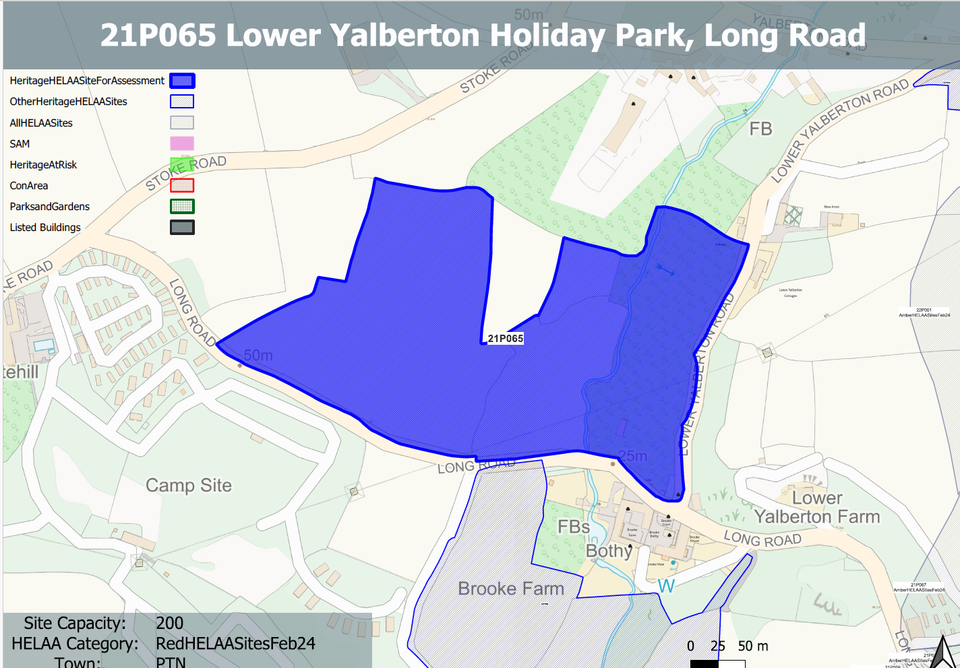
Site overview and heritage context:
Land north of Long Road and the south of Stoke Road.
A number of designated heritage assets are located to the north and south of the site.
Archaeology: Medieval farmsteads and settlement. Requires programme of archaeological assessment, evaluation and mitigation.

Planning History:
None

Heritage Asset Affected by Allocation | Designation | Contributing Elements to Significance | Impact of Development on Significance | Mitigation Measures for any Identified Harm /Opportunities to Enhance Significance | Impact on Significance with Mitigation in place
Lower Yalberton Farmhouse and attached outbuilding to south west (S of site) | Grade II listed building | Farmhouse and outbuilding. c1830, forms part of a group with the other elements of the farmstead. The site forms part of the immediate rural setting of the historic farmstead and elements of the site appear to have a historic relationship with the asset.  The site in its undeveloped form makes a clear positive contribution to the asset’s significance. | Development of the quantum proposed would have a detrimental impact on the rural setting of the asset which would cause a clear degree of less than substantial harm to its significance. | The introduction of built form onto the site, even of a reduced quantum would still have a detrimental impact on the rural character of the area and the setting of the asset. This would continue to result in less than substantial harm to its significance. | Less than substantial harm
Shippon on north side of higher yard at Lower Yalberton Farm (S of site) | Grade II listed building | Shippon, used as kennels. c1830s, part of planned farmyard at Lower Yalberton farm, forms part of a group with the other elements of the farmstead. The site forms part of the immediate rural setting of the historic farmstead and elements of the site appear to have a historic relationship with the asset.  The site in its undeveloped form makes a clear positive contribution to the asset’s significance. | Development of the quantum proposed would have a detrimental impact on the rural setting of the asset which would cause a clear degree of less than substantial harm to its significance. | The introduction of built form onto the site, even of a reduced quantum would still have a detrimental impact on the rural character of the area and the setting of the asset. This would continue to result in less than substantial harm to its significance. | Less than substantial harm
West, east and north ranges of farm buildings to wets farmyard at Lower Yalberton Farm (S of site) | Grade II listed building | 3 ranges of farmbuildings to lower (west) yard at Lower Yalberton farm. c1830s, contemporary with the farmhouse, forms part of a group with the other elements of the farmstead. The site forms part of the immediate rural setting of the historic farmstead and elements of the site appear to have a historic relationship with the asset.  The site in its undeveloped form makes a clear positive contribution to the asset’s significance. | Development of the quantum proposed would have a detrimental impact on the rural setting of the asset which would cause a clear degree of less than substantial harm to its significance. | The introduction of built form onto the site, even of a reduced quantum would still have a detrimental impact on the rural character of the area and the setting of the asset. This would continue to result in less than substantial harm to its significance. | Less than substantial harm
Granary in higher yard at Lower Yalberton Farm (S of site) | Grade II listed building | Granary over implement shed. c1830s. Part of planned farmyard at Lower Yalberton farm, forms part of a group with the other elements of the farmstead. The site forms part of the immediate rural setting of the historic farmstead and elements of the site appear to have a historic relationship with the asset.  The site in its undeveloped form makes a clear positive contribution to the asset’s significance. | Development of the quantum proposed would have a detrimental impact on the rural setting of the asset which would cause a clear degree of less than substantial harm to its significance. | The introduction of built form onto the site, even of a reduced quantum would still have a detrimental impact on the rural character of the area and the setting of the asset. This would continue to result in less than substantial harm to its significance. | Less than substantial harm
Stable range on south side of Lower Yard at Lower Yalberton Farm (S of Site) | Grade II listed building | Stable block. c1830s, part of a planned farmyard, forms part of a group with the other elements of the farmstead. The site forms part of the immediate rural setting of the historic farmstead and elements of the site appear to have a historic relationship with the asset.  The site in its undeveloped form makes a clear positive contribution to the asset’s significance. | Development of the quantum proposed would have a detrimental impact on the rural setting of the asset which would cause a clear degree of less than substantial harm to its significance. | The introduction of built form onto the site, even of a reduced quantum would still have a detrimental impact on the rural character of the area and the setting of the asset. This would continue to result in less than substantial harm to its significance. | Less than substantial harm
Higher Yalberton Farmhouse and attached outbuilding to east (N of site) | Grade II listed building | Farmhouse and outbuilding. Mid C19, forms part of a group with other elements of the farmstead. The site forms part of the rural setting of the asset and in its undeveloped form denotes the pattern of isolated historic farmsteads found within the area which makes a positive contribution to the significance of the asset. | Development of the quantum proposed would have a detrimental impact on the rural setting of the asset and the established character of the area. This would cause less than substantial harm to the asset’s significance. | The introduction of built form onto the site, even of a reduced quantum would still have a detrimental impact on the rural character of the area and the setting of the asset. This would continue to result in less than substantial harm to its significance. | Less than substantial
Barn, Linhay and stable south of Higher Yalberton Farmhouse (N of site) | Grade II listed building | Multi-purpose farmbuilding comprising barn, linhay and stables. c1850s, probably contemporary with the farmhouse, forms part of a group with other elements of the farmstead. The site forms part of the rural setting of the asset and in its undeveloped form denotes the pattern of isolated historic farmsteads found within the area which makes a positive contribution to the significance of the asset. | Development of the quantum proposed would have a detrimental impact on the rural setting of the asset and the established character of the area. This would cause less than substantial harm to the asset’s significance. | The introduction of built form onto the site, even of a reduced quantum would still have a detrimental impact on the rural character of the area and the setting of the asset. This would continue to result in less than substantial harm to its significance. | Less than substantial
Barn immediately to south west of Yalberton Farmhouse (N of site) | Grade II listed building | Barn. Probably late C18 in origin, with extensive patching and remodelling, forms part of a group with other elements of the farmstead. The site forms part of the rural setting of the asset and in its undeveloped form denotes the pattern of isolated historic farmsteads found within the area which makes a positive contribution to the significance of the asset. | Development of the quantum proposed would have a detrimental impact on the rural setting of the asset and the established character of the area. This would cause less than substantial harm to the asset’s significance. | The introduction of built form onto the site, even of a reduced quantum would still have a detrimental impact on the rural character of the area and the setting of the asset. This would continue to result in less than substantial harm to its significance. | Less than substantial

