**Heritage Impact Assessment:** Land at Long Meadow, Collaton St Mary, Paignton

|  |  |
| --- | --- |
| **HELAA2021 Ref:** | 21P062 |
| **Site Address:** | Land at Long Meadow, Collaton St Mary, Paignton |
| **Site Area (ha):** | 3.83 |
| **Site Yield:** | 50 |
| **HIA Assessment** |  |

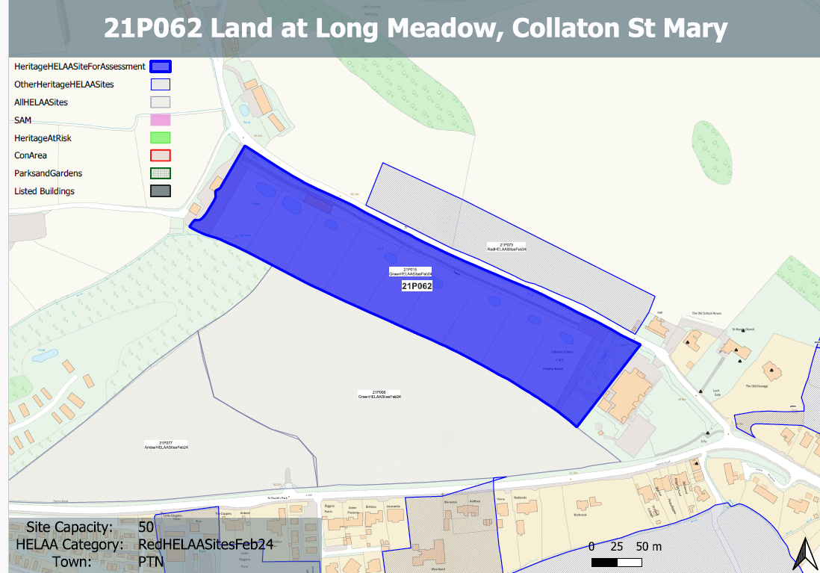

**Site overview and heritage context:**

The site is a long thin parcel of open land, to the north-west of Collaton-St-Mary C/E Primary School, and stretching up to the access road to Blagdon Barton Farm. The site is currently in agricultural use with various paddocks on the site.

The site is enclosed by existing bands of mature vegetation and is accessed by Blagdon Road on its northern border.

There are a number of designated heritage assets nearby, predominantly a cluster of listed buildings immediately to the east centred around the Church of St. Mary and the former school.

**Planning History**

Various relating to the agricultural use of the site.

|  |  |  |  |  |  |
| --- | --- | --- | --- | --- | --- |
| **Heritage Asset Affected by Allocation** | **Designation** | **Contributing Elements to Significance** | **Impact of Development on Significance** | **Mitigation Measures for any Identified Harm /Opportunities to Enhance Significance** | **Impact on Significance with Mitigation in place** |
| Church of St Mary (E of site)  Memorials within churchyard (E of site)  Old Vicarage (E of site)  Lych Gate (E of site)  Drinking fountain at the junction of Totnes and Blagdon Road (SE of site)  Collaton St. Mary School (E of site)  391-393 Totnes Road (SE of site) | Grade II* listed building  Grade II listed buildings  Grade II listed building  Grade II listed building  Grade II listed building  Grade II listed building  Grade II listed building | Mid 19th century parish church, set on edge of built development in a rural setting. Group value with lych gate, rectory and school. The site is separated from the church and its churchyard by a band of vegetation to the front of the site and by the existing primary school. The site contributes to the wider rural setting of the parish church and could impact on the experience of the churchyard.  Monuments of varying ages within churchyard. Setting is limited to the immediate area within the churchyard and the church itself, although the development of the site could impact on the way in which the memorials within the churchyard are experienced within their rural setting.  Rectory, now in use as house and offices dating from 1864. Has clear relationship and group value with neighbouring church, lych gate and school. The site is separated from the asset and its grounds by existing development and the church and its churchyard. It makes a limited contribution to its significance.  Mid 19th century lych gate in association with church, rectory and school which have group value. The undeveloped fields contribute to the wider rural setting of the asset but do not share intervisibility with it.  C1900 drinking fountain. The site does not make a contribution to its significance  .  Mid 19th century school which has group value with the church, lych gate and vicarage. The site is separated from the asset by a band of vegetation to the front of the site and the existing primary school. The site contributes to the wider rural setting of the asset  Pair of late 18th century cottages. The site does not make a contribution to its significance | Less than substantial harm.  Less than substantial harm  Neutral impact on significance  Neutral impact on significance  Neutral impact on significance  Less than substantial harm  Neutral impact on significance | Significantly reduce the quantum of development and adopt a landscape-led approach to ensure that the proposed development of the site sits comfortably within its rural surroundings. Maintain a strong landscape buffer surrounding the site and limit development to the western boundaries of the site.  Significantly reduce the quantum of development and adopt a landscape-led approach to ensure that the proposed development of the site sits comfortably within its rural surroundings. Maintain a strong landscape buffer surrounding the site and limit development to the western boundaries of the site.  n/a  n/a  n/a  Significantly reduce the quantum of development and adopt a landscape-led approach to ensure that the proposed development of the site sits comfortably within its rural surroundings. Maintain a strong landscape buffer surrounding the site and limit development to the western boundaries of the site.  n/a | Neutral  Neutral  Neutral  Neutral  Neutral  Neutral  Neutral |