Heritage Impact Assessment: Summerhill Hotel, 2 Braeside Rd, Paignton
HELAA2021 Ref: | 21P055
Site Address: | Summerhill Hotel, 2 Braeside Rd, Paignton
Site Area (ha): | 0.16
Site Yield: | 11
HIA Assessment

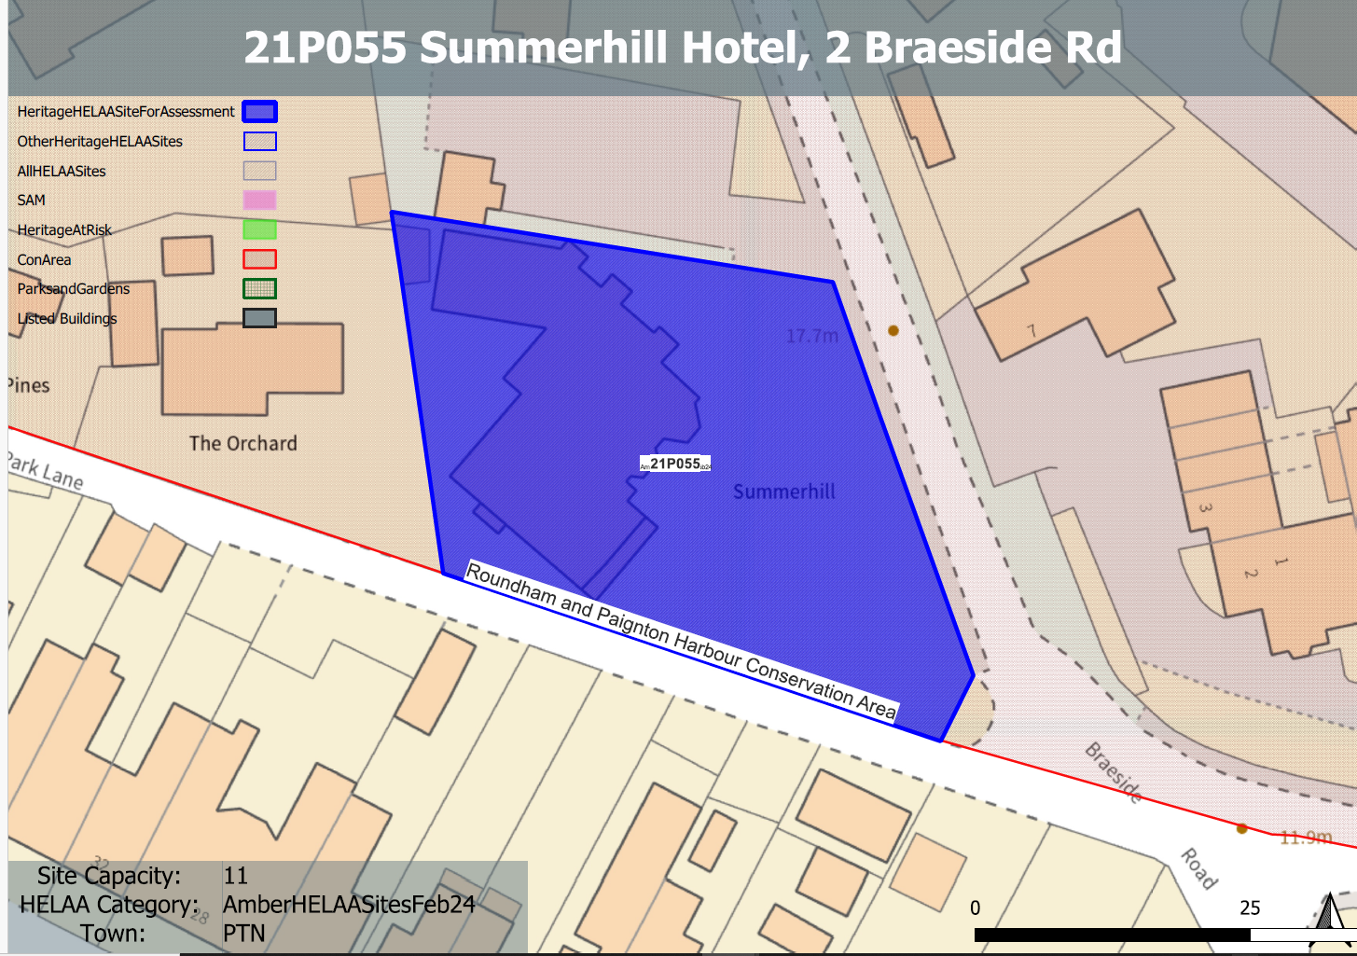
Site overview and heritage context:
The site includes a late Victorian villa located on Braeside Road which slopes steeply to the south with the Summerhill Hotel at its bottom. The building sits within the Roundham & Paignton Harbour Conservation Area and is identified as a key building within the associated conservation area appraisal.
The site is neighboured by Clevedon Hotel to the west and Kendall, a two-storey detached dwelling. The site is located adjacent to multiple hotels and short-term holiday lets, notably Amber House to the west and Goodrington Lodge to the south-east.

Planning History:
P/2023/0725: Change of use from hotel to three residential apartments. Refused: 06/02/2024, allowed at appeal: 08/05/2024 ref: APP/X1165/W/23/3335404

Heritage Asset Affected by Allocation | Designation | Contributing Elements to Significance | Impact of Development on Significance | Mitigation Measures for any Identified Harm /Opportunities to Enhance Significance | Impact on Significance with Mitigation in place
Roundham and Paignton Harbour Conservation Area | Conservation Area | The site is identified as a key building within the conservation area appraisal which makes a positive contribution to the conservation area’s significance through its architectural and historic value. | The required yield could be achieved through the conversion of the existing building with limited external alterations, which would have a neutral impact on the significance of this heritage asset. | The existing building has undergone a number of late 20th century extensions associated with its hotel use. Their removal or rationalization as part of a sensitive conversion scheme which retains the original building and improves landscaping within the site would have a positive impact on the significance of the conservation area. | Positive

