Heritage Impact Assessment: Imperial Hotel, Park Hill Road, Torquay
HELAA2021 Ref: | 21T093
Site Address: | Imperial Hotel, Park Hill Road, Torquay
Site Area (ha): | 2.22
Site Yield: | 50
HIA Assessment

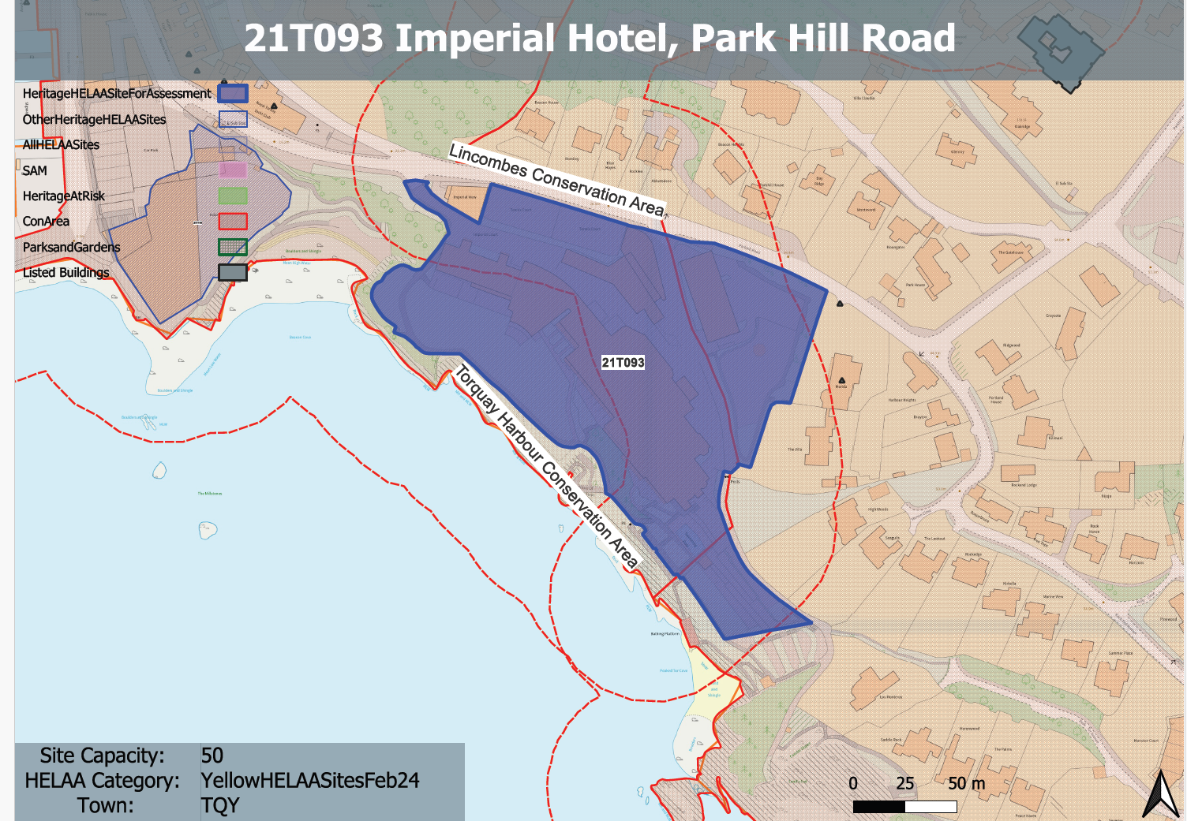
Site overview and heritage context:
The site is located approximately 300m to the south-east of Torquay Harbour. It occupies a prominent position on the coastline with the range of buildings visible around the Bay. The hotel is accessed from Parkhill Road, with a driveway that continues into the South West Coast Path (SWCP) as it passes the site to the east.
The main hotel building is nine storeys at its highest from the southern side with seven storeys facing within the site. Imperial Court lies further to the west and is seven storeys at its highest. It appears lower down and smaller in scale than the hotel due to its design and topography. Separating the buildings is a wedge-shaped two-storey building housing the hotel’s main event space, known as the Torbay Suite, spa and leisure facilities.
The site is predominantly within the Torquay Harbour Conservation Area, with the NE corner being within the Lincombes Conservation Area. Merida and its associated walls and gate piers are grade II listed and border the site immediately to the east. The Grade II listed building, Royal Torbay Yacht Club can be found to the west of the site.
There are several listed buildings on the slopes of Vane and Park Hills above the Hotel. These include Vane Hill Towers (Grade II) (originally Villa Lugano), Sundial Lodge (Grade II); and Devonshire Hotel (Grade II). It is accepted that there may be some partial intervisibility, however this exists through highly filtered planting and woodland across the hills. Consequently, it is considered that there is no clear legibility of these designated assets’ significance from the site and that change in their wider setting from the site will not affect their significance.
The site also forms a part of the broader setting of many designated and undesignated heritage assets, in particular in wider views from the south and south-west, and from the sea, but is not considered to demonstrably impact on their significance.

Planning History
P/2021/0120 - Renovation of existing hotel to retain (up to) 111 bedrooms. Construction of spa, 26 residential apartments and 25 apartments from conversion of bedroom wing with associated parking, access and landscape improvements.- Approved: 16.03.2023

Heritage Asset Affected by Allocation | Designation | Contributing Elements to Significance | Impact of Development on Significance | Mitigation Measures for any Identified Harm /Opportunities to Enhance Significance | Impact on Significance with Mitigation in place
Torquay Harbour Conservation Area  Lincombes Harbour Conservation Area (N and E)  Merida and associated boundary walls and gate piers  Royal Torbay Yacht Club | Conservation Area  Conservation Area  Grade II listed building  Grade II listed building | The original Imperial Hotel opened in 1866. It has continued to expand, but externally there is little surviving evidence of its 19th century origins. It currently makes a minor negative impact on the significance of the conservation area.  The 20th century expansion and alterations made to the building on the site has resulted in it causing a minor level of harm to the setting and significance of this asset.  Villa. c1830s. The site is separated from this asset through a band of mature vegetation and an area in use as a carpark, however, the height and scale of the existing building on site does result in intervisibility between the two sites. The 20th century alterations made to the building on the site has resulted in it causing a minor level of harm to the setting and significance of this asset.  Mid-19th century house with C20 alterations. The site has limited impact on setting of the asset and the way in which it is experienced.  . | A part conversion of the existing building to achieve 51 dwellings as approved through P/2021/0120 is considered to have a neutral to positive impact on this asset.  A part conversion of the existing building to achieve 51 dwellings as approved through P/2021/0120 is considered to have a neutral to positive impact on this asset.  A part conversion of the existing building to achieve 51 dwellings as approved through P/2021/0120 is considered to have a neutral to positive impact on this asset.  A part conversion of the existing building to achieve 51 dwellings as approved through P/2021/0120 is considered to have a neutral impact on this asset. | Improvement of architectural quality and external appearance of the existing building through conversion to residential use could result in a further positive impact to the significance of this asset.  Improvement of architectural quality and external appearance of the existing building through conversion to residential use could result in a further positive impact to the significance of this asset.  Improvement of architectural quality and external appearance of the existing building through conversion to residential use could result in a further positive impact to the significance of this asset.  Improvement of architectural quality and external appearance of the existing building through conversion to residential use could result in a further positive impact to the significance of this asset. | Positive  Positive  Positive  Positive

