**Heritage Impact Assessment:** Land at Hamelin Way and Moles Lane (Edginswell)

|  |  |
| --- | --- |
| **HELAA2021 Ref:** | 21T122 |
| **Site Address:** | Land at Hamelin Way and Moles Lane (Edginswell) |
| **Site Area (ha):** | 35 |
| **Site Yield:** | 400 |
| **HIA Assessment** |  |

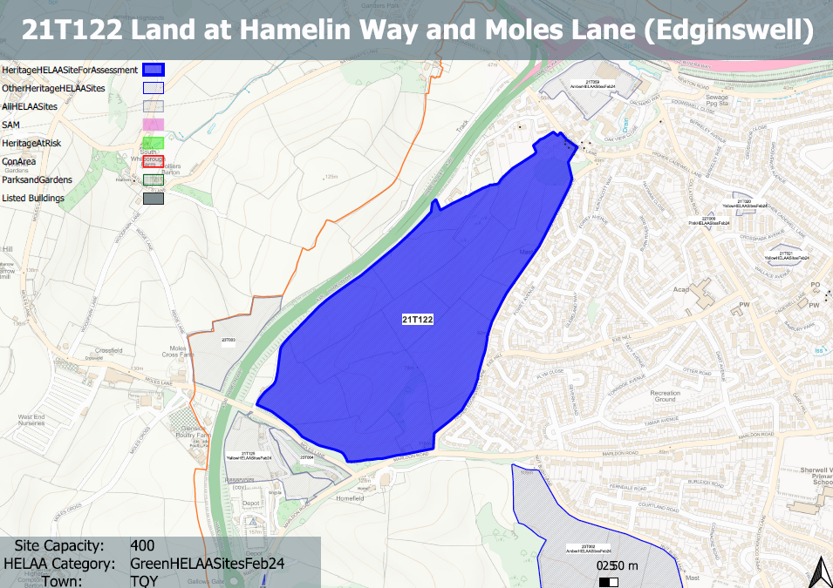

**Site overview and heritage context:**

A number of fields located to the south east of Hamelin Way, designated as an allocated Future Growth Area for housing and related development in the Torquay Gateway (Edginswell) Masterplan.

A group of listed buildings can be found to the north and northwest of the site.

Archaeology: Prehistoric finds in extensive site. Requires assessment and evaluation to inform layout and archaeological mitigation.

**Planning History:**

P/2023/0172- Formation of five dwellings with on-site parking, access roadway, landscaping and detached residents' storage and refuse 'barn'. Re-establishment of orchard included in project- Brends Orchard Land Adjacent Edginswell Farm House Edginswell Lane, TQ2 7JF– Refused 17/10/2024

P/2020/0929 Construction of five dwellings including access, parking and associated works. REFUSED

P/2021/0809 Formation of 5 dwellings including access, parking and associated works. REFUSED / APPEAL DISMISSSED

|  |  |  |  |  |  |
| --- | --- | --- | --- | --- | --- |
| **Heritage Asset Affected by Allocation** | **Designation** | **Contributing Elements to Significance** | **Impact of Development on Significance** | **Mitigation Measures for any Identified Harm /Opportunities to Enhance Significance** | **Impact on Significance with Mitigation in place** |
| Edginswell Hall, Edginswell Lane (NW of site) | Grade II listed building | House. Probably late 1830s or early 1840. The site forms part of the rural setting of the asset which directly overlooks the northern elements of the site which make a positive contribution to the landscape character of the area. This makes a positive contribution to the significance of the asset. | Development of the site to the quantum proposed could involve the introduction of built form into the established rural landscape which would have a detrimental impact on the asset’s significance, resulting in less than substantial harm. | A reduced quantum of development which maintains the rural landscape to the northern elements of the site, promotes access to it and which is designed to be sensitive to the historic and landscape characteristics of the area could reduce the degree of harm to a neutral level. | Neutral |
| Edginswell Farmhouse, Edginswell Lane (N of site) | Grade II listed building | Farmhouse. C17 wing (ruinous on survey); house probably an early C19 recasting of a C17 original, with later addition. The site forms part of the rural setting of the asset and is an integral part of the remaining countryside to the south of the asset which makes a positive contribution to its significance. | Development of the site to the quantum proposed could involve the introduction of built form into the established rural landscape which would have a detrimental impact on the asset’s significance, resulting in less than substantial harm. | A reduced quantum of development which maintains the rural landscape to the northern elements of the site, promotes access to it and which is designed to be sensitive to the historic and landscape characteristics of the area could reduce the degree of harm to a neutral level. | Neutral |
| Shippon/Stable east side of SW farmyard at Edginswell Farm, Edginswell Lane (N of site) | Grade II listed building | Farmbuilding, probably a shippon or stable. C19. Cob and stone rubble with sections of brick repair. The site forms part of the rural setting of the asset and is an integral part of the remaining countryside to the south of the asset which makes a positive contribution to its significance. | Development of the site to the quantum proposed could involve the introduction of built form into the established rural landscape which would have a detrimental impact on the asset’s significance, resulting in less than substantial harm. | A reduced quantum of development which maintains the rural landscape to the northern elements of the site, promotes access to it and which is designed to be sensitive to the historic and landscape characteristics of the area could reduce the degree of harm to a neutral level. | Neutral |
| Cider House/cartshed on south side of SW farmyard at Edginswell Farm (N of site) | Grade II listed building | Cider house/cartshed and shippon. Probably C18 in origin, altered in the C19. The site forms part of the rural setting of the asset and is an integral part of the remaining countryside to the south of the asset which makes a positive contribution to its significance. | Development of the site to the quantum proposed could involve the introduction of built form into the established rural landscape which would have a detrimental impact on the asset’s significance, resulting in less than substantial harm. | A reduced quantum of development which maintains the rural landscape to the northern elements of the site, promotes access to it and which is designed to be sensitive to the historic and landscape characteristics of the area could reduce the degree of harm to a neutral level. | Neutral |
| Linhay on SW side of SW farmyard at Edginswell Farm (N of site) | Grade II listed building | Linhay. Probably late C18/early C19. The site forms part of the rural setting of the asset and is an integral part of the remaining countryside to the south of the asset which makes a positive contribution to its significance. | Development of the site to the quantum proposed could involve the introduction of built form into the established rural landscape which would have a detrimental impact on the asset’s significance, resulting in less than substantial harm. | A reduced quantum of development which maintains the rural landscape to the northern elements of the site promotes access to it, and which is designed to be sensitive to the historic and landscape characteristics of the area could reduce the degree of harm to a neutral level. | Neutral |
| Calf house at NW end of SW farmyard at edginswell farmhouse (N of site) | Grade II listed building | Farmbuilding, probably calf house. Probably late C19. The site forms part of the rural setting of the asset and is an integral part of the remaining countryside to the south of the asset which makes a positive contribution to its significance. | Development of the site to the quantum proposed could involve the introduction of built form into the established rural landscape which would have a detrimental impact on the asset’s significance, resulting in less than substantial harm. | A reduced quantum of development which maintains the rural landscape to the northern elements of the site, promotes access to it and which is designed to be sensitive to the historic and landscape characteristics of the area could reduce the degree of harm to a neutral level. | Neutral |
| Barn on NE side of SW farmyard at Edginswell farmhouse (N of site) | Grade II listed building | Threshing barn. Probably late C18 in origin, extended in the early C19. The site forms part of the rural setting of the asset and is an integral part of the remaining countryside to the south of the asset which makes a positive contribution to its significance. | Development of the site to the quantum proposed could involve the introduction of built form into the established rural landscape which would have a detrimental impact on the asset’s significance, resulting in less than substantial harm. | A reduced quantum of development which maintains the rural landscape to the northern elements of the site, promotes access to it, and which is designed to be sensitive to the historic and landscape characteristics of the area could reduce the degree of harm to a neutral level. | Neutral |
| Linhay on S side of NE farmyard at Edginswell farmhouse (N of site) | Grade II listed building | Linhay. Probably early C19, now part of Edginswell Farm (qv) but probably originally associated with Higher Court Farm, to the north. The site forms part of the wider rural landscape associated with the scattering of farmsteads within the area, however, the asset readily experienced from the site due to intervening development. It therefore makes a limited contribution to its significance. | Development of the site would likely have a neutral impact on the significance of the asset. | n/a | Neutral |
| Shippon and cider house at west end of NE farmyard at Edginswell farmhouse (N of site) | Grade II listed building | Shippon and cider house. Early C19 cob on local stone rubble footings. The site forms part of the wider rural landscape associated with the scattering of farmsteads within the area, however, the asset readily experienced from the site due to intervening development. It therefore makes a limited contribution to its significance. | Development of the site would likely have a neutral impact on the significance of the asset. | n/a | Neutral |
| Thresing barn on NE side of NE farmyard at Edginswell farmhouse (N of site) | Grade II listed building | Threshing barn. Probably early C19. Cob on stone rubble footings, some brick repair. The site forms part of the wider rural landscape associated with the scattering of farmsteads within the area, however, the asset readily experienced from the site due to intervening development. It therefore makes a limited contribution to its significance. | Development of the site would likely have a neutral impact on the significance of the asset. | n/a | Neutral |