Heritage Impact Assessment: Torquay Town Hall, Torquay
HELAA2021 Ref: | 21T121
Site Address: | Torquay Town Hall, Torquay
Site Area (ha): | 0.34
Site Yield: | 50
HIA Assessment

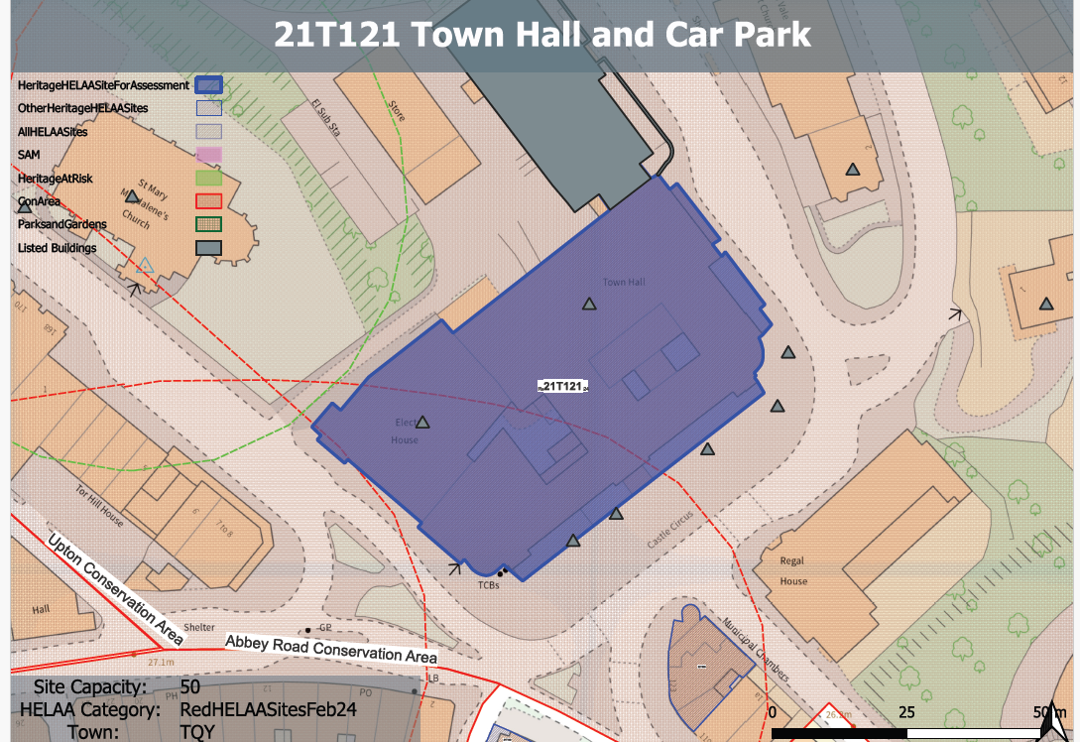
Site overview and heritage context:
The site sits at the northern end of the town centre of Torquay and predominantly compromises a Grade II listed building that forms an important focus to the upper region of the town at Castle Circus. The building was purpose built as a town hall in the Edwardian Baroque style and retains its original use, although it has undergone much alteration and renovation since its initial construction in order to maintain this use.
The site is situated within the Upton conservation area containing a wealth of heritage and character, including several listed buildings and interesting architectural styles, topography and green spaces to reflect the resort’s fashionable status by the end of the 19th century, a number of which share a close relationship with the town hall.
As a result, the site is particularly sensitive from a historic environment perspective.

Planning History
Various applications relating to the ongoing use of the site as a public building.

Heritage Asset Affected by Allocation | Designation | Contributing Elements to Significance | Impact of Development on Significance | Mitigation Measures for any Identified Harm /Opportunities to Enhance Significance | Impact on Significance with Mitigation in place
Torquay Town Hall  Upton Conservation Area  Electric House  Torquay Library (N of site)  Lamp Posts to S of Town Hall (5 in total)  Parish Church of St. Mary Magdalene (SE of site)  Boundary Wall and Gate Piers South of Parish Church of St Mary Magdalene  2 St Marychurch Road (E of site)  Terrace House Dental Surgery (NW of site)  2 Tor Hill Road (SW of site) | Grade II listed building  Conservation Area  Grade II listed building  Grade II listed building  Grade II listed building  Grade II* listed building  Grade II listed building  Grade II listed building  Grade II listed building  Grade II listed building | The town hall was built in two phases. The Carnegie Public Library, designed by Thomas Davison was built 1906-7 by R E Narracott of Stoke Gabriel. The Town Hall and its function rooms were built 1910-11 by R Wilkins and were by the same architect. It is in Edwardian Baroque style and has demonstrable architectural, artistic, historic and communal value.  The site forms part of a concentration of mid-late 19th and early 20th century public buildings in the town centre which provide an important focal point within the conservation area. The site is identified as a significant landmark and part of an important building group within the Upton Conservation Area Appraisal.  Forms part of the group of civic buildings on the site. Is a modernist extension to the town hall dating from 1935 and was designed by P W Ladmore. It is clear architectural interest and retains many of its original internal features and fittings.  This asset is outside of the site area but forms part of the group of civic buildings on the site. It dates from 1937 and has clear architectural value as an interesting example of an Art Deco library.  Lamppost, likely contemporary with town hall (1910-11). Has value as a group of lampposts associated with the town hall. The site therefore has a substantial positive impact on the significance of these heritage assets.  Parish church. 1843-9 to the designs of A Salvin, contractor Jacob Harvey; altered and partly re-fitted under GG Scott 1881-2. The site sits within the urban setting of this asset with the church spire being a prominent feature in views north from the site. The site makes a positive contribution to its overall significance.  Boundary walls to south side of church. Late C19. The site sits within the urban setting of this asset and contributes to the overall quality of the historic environment within the area. It makes a minor positive contribution to its overall significance.  Villa constructed in the mid 19th century. The site sits within the urban setting of this asset and contributes to the overall quality of the historic environment within the area. It makes a minor positive contribution to its overall significance.  Villa dating from the mid 19th century. The site sits within the urban setting of this asset and contributes to the overall quality of the historic environment within the area. It makes a minor positive contribution to its overall significance.  House and ground floor shop dating from the mid 19th century. The site sits within the urban setting of this asset and contributes to the overall quality of the historic environment within the area. It makes a minor positive contribution to its overall significance | The conversion of the town hall to residential use would remove its original designed use as a public building and would necessitate significant alteration to its internal plan form. This would likely result in substantial harm to its significance.  The loss of the public use of the town hall would have a detrimental impact on the identified group value of the civic buildings in this part of the conservation area. Conversion to residential use would likely cause a degree of less than substantial harm to the conservation area.  The conversion of this part of the site to residential use would remove its original designed use as a public building and would necessitate significant alteration to its internal plan form. This would likely result in substantial harm to its significance.  The loss of the public use of the town hall would have a detrimental impact on the identified group value of the civic buildings in this area of the town. Conversion to residential use of the site would likely cause a minor degree of less than substantial harm to this asset.  The sensitive residential conversion of the site which maintained the close historical and visual relationship of the site to these assets would likely result in a neutral impact to its significance.  The sensitive residential conversion of the site which maintained the historical and visual relationship between the site and this asset would likely result in a neutral impact to its significance.  The sensitive residential conversion of the site would likely result in a neutral impact to its significance.  The sensitive residential conversion of the site would likely result in a neutral impact to its significance.  The sensitive residential conversion of the site would likely result in a neutral impact to its significance.  The sensitive residential conversion of the site would likely result in a neutral impact to its significance. | Sensitive part conversion in areas of lesser significance may reduce the level of harm, however, the level of impact would still be high.  Part conversion may reduce the level of harm, however, demonstrable harm to the significance of the asset would remain.  Sensitive part conversion in areas of lesser significance may reduce the level of harm, however, the level of impact would still be high.  Sensitive part conversion in areas of lesser significance may reduce the level of harm to a neutral level.  n/a  n/a  n/a  n/a  n/a  n/a | High level of less substantial harm/Substantial harm.  Moderate less than substantial harm  High level of less substantial harm/Substantial harm.  Neutral  Neutral  Neutral  Neutral  Neutral  Neutral  Neutral

