Heritage Impact Assessment: The Grove, Babbacombe
HELAA2021 Ref: | 21T120
Site Address: | The Grove, Babbacombe
Site Area (ha): | 1.16
Site Yield: | 15
HIA Assessment

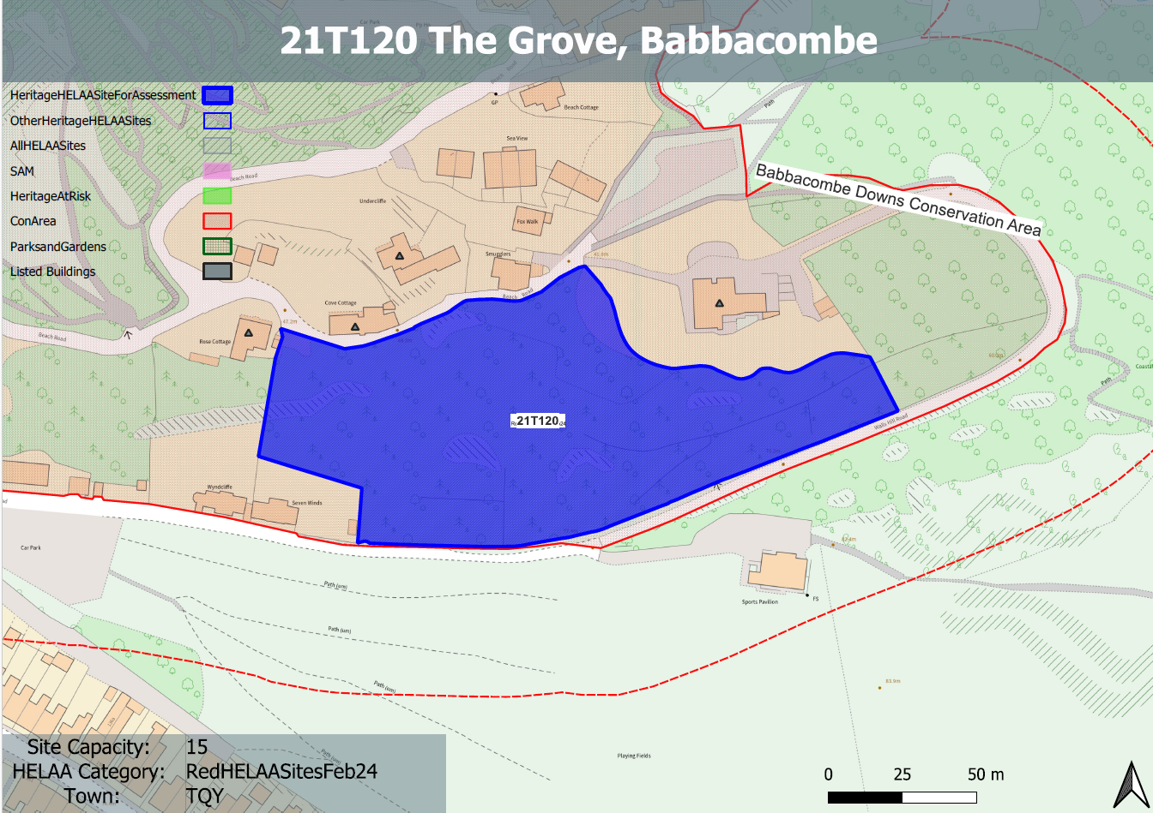
Site overview and heritage context:
Steeply wooded site accessed via Walls Hill Road and adjacent to Babbacombe Cricket Club.
The site sits within the Babbacombe Downs Conservation Area and a number of Grade II listed buildings can be found to the north.

Planning History:
None

Heritage Asset Affected by Allocation | Designation | Contributing Elements to Significance | Impact of Development on Significance | Mitigation Measures for any Identified Harm /Opportunities to Enhance Significance | Impact on Significance with Mitigation in place
Babbacombe Downs Conservation Area | Conservation Area | The special interest of the conservation area comprises its architectural and historic interest as a 19th century coastal hamlet with a wide extent and variety of open space and its relationship to the sea and the extensive tree cover and tree groups which act as an important foil to buildings, especially in the Beach Road area.  The site forms part of the recognized important tree cover and foil to buildings along Beach Road. It makes an important and positive contribution to the significance of the conservation area. | Development of the site of any quantum would involve a reduction in tree cover and an urbanization of the site. This would have a detrimental impact on one of the identified important characteristics of the conservation area and would therefore be detrimental to its significance. | No mitigation measures identified which would reduce the impact to a neutral level. | Less than substantial harm
Rose Cottage (W of site) | Grade II listed building | Small house. c1840s. Part of a group of picturesque small houses built on the steep wooded cliffside above Babbacombe beach.  The site forms part of the recognized important tree cover and foil to buildings along Beach Road. It makes an important and positive contribution to the significance of the asset. | Development of the site of any quantum would involve a reduction in tree cover and an urbanization of the site. This would have a detrimental impact on the significance of the asset. | No mitigation measures identified which would reduce the impact to a neutral level. | Less than substantial harm
Cliffside Cottage Hotel (N of site) | Grade II listed building | House. 2-phase. c1840s with later additions and alterations. Part of a group of picturesque small houses built on the steep wooded cliffside above Babbacombe beach.  The site forms part of the recognized important tree cover and foil to buildings along Beach Road. It makes an important and positive contribution to the significance of the asset. | Development of the site of any quantum would involve a reduction in tree cover and an urbanization of the site. This would have a detrimental impact on the significance of the asset. | No mitigation measures identified which would reduce the impact to a neutral level. | Less than substantial harm
Undercliff (N of site) | Grade II listed building | House. c1840s. The site forms part of the recognized important tree cover and foil to buildings along Beach Road. It makes an important and positive contribution to the significance of the asset. | Development of the site of any quantum would involve a reduction in tree cover and an urbanization of the site. This would have a detrimental impact on the significance of the asset. | No mitigation measures identified which would reduce the impact to a neutral level. | Less than substantial harm
The Grove (N of site) | Grade II listed building | House. c1840s. This house is one of a collection of picturesque small houses built on the steep, wooded cliffside above Babbacombe beach.  The site forms part of the recognized important tree cover and foil to buildings along Beach Road. It makes an important and positive contribution to the significance of the asset. | Development of the site of any quantum would involve a reduction in tree cover and an urbanization of the site. This would have a detrimental impact on the significance of the asset. | No mitigation measures identified which would reduce the impact to a neutral level. | Less than substantial harm

