Heritage Impact Assessment: Former Living Coasts, Beacon Hill, Torquay
HELAA2021 Ref: | 21T119
Site Address: | Former Living Coasts, Beacon Hill, Torquay
Site Area (ha): | 0.42
Site Yield: | 20
HIA Assessment

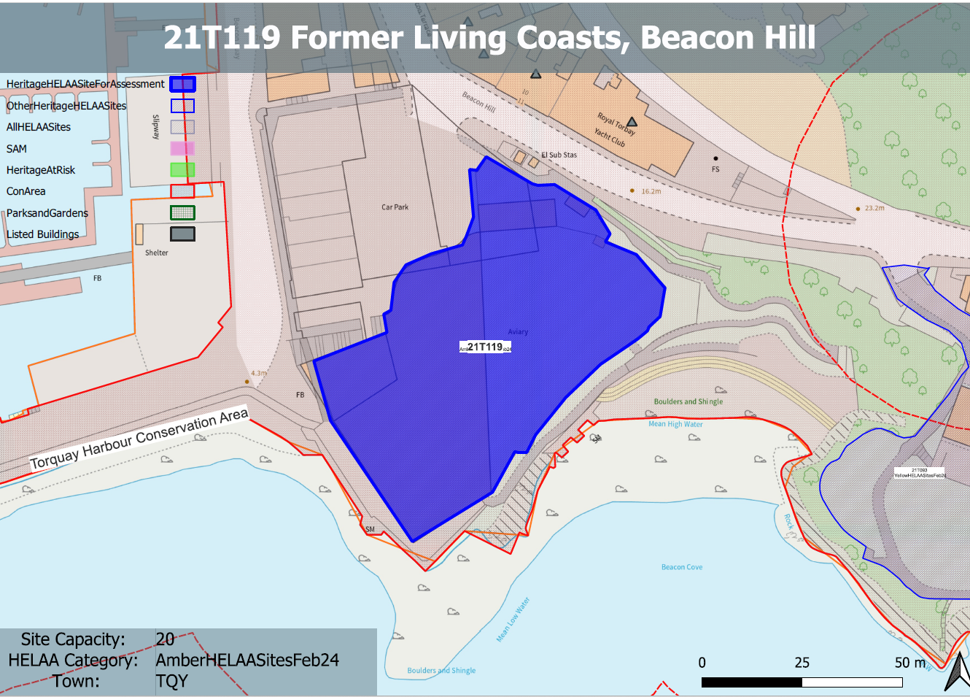

Site overview and heritage context:
Vacant Living Coasts Zoo on site of former Coral Island located on a headland on Beacon Quay. The site was originally Marine Spa which was a highly valued Victorian building but which was demolished and redeveloped in the 1960s. The most recent use was as a marine aviary and aquarium which closed in 2020.
The site is within the Torquay Harbour Conservation Area and several Grade II and Grade II* listed buildings are located nearby.

Planning History
Various relating to the previous uses on the site.

Heritage Asset Affected by Allocation | Designation | Contributing Elements to Significance | Impact of Development on Significance | Mitigation Measures for any Identified Harm /Opportunities to Enhance Significance | Impact on Significance with Mitigation in place
Torquay Harbour Conservation Area  Halden Pier (W of site)  D-Day embarkation slipways and adjoining section of quay wall (N of site)  South pier, including former barking oven (N of site)  2-8 Beacon Terrace (N of site)  9 Beacon Terrace, Royal Marina Court (N of site)  10 and 11 Beacon Terrace, Royal Marina Court (N of site)  Royal Torbay Yacht Club (N of site) | Conservation Area  Grade II listed building  Grade II* listed building  Grade II listed building  Grade II * listed building  Grade II listed building  Grade II listed building  Grade II listed building | The special interest of the conservation area derives from its historical interest through the growth of Torquay as a high-end resort town in the late 18th and 19th centuries and its association with Agatha Christie. Its architectural interest comprises its rich mix of architectural typologies which demonstrate the evolution of architectural fashion from the late 18th to the 20th centuries.  The site sits in a very prominent location within the harbour and once accommodated the Victorian Marine Spa before its demolition in the 1960s. it is recognized within the conservation area appraisal as being within significant views but within its current form is a detracting feature of the conservation area.  The site therefore currently has a detrimental impact on the significance of the asset but is an opportunity site.  Pier. 1867. Engineer JP Margery, contractor, James Mountstephen, patron, Sir Lawrence Palk.  An important component of the C19 harbour at Torquay.  The site sits within the immediate setting of the asset and in its current form has a detrimental impact on its significance.  .  2 slipways and adjoining section of quay wall. 1943. Extremely rare survivals, these slipways are possibly the best-surviving example of D-Day fabric in the country and form part of a significant group of listed structures.  The site sits within the wider setting of the asset and has a neutral impact on its significance.  South Pier. Part of the harbour improvements carried out 1803-1806.  The site sits within the wider setting of the asset and has a neutral impact on its significance.  Terrace of seven houses. 1833 by Jacob Harvey. A fine terrace of its date and a good example of the urbane designs of Jacob Harvey, who was responsible for the best early C19 housing in Torquay.  The site sits within the immediate setting of the asset and in its current form has a detrimental impact on its significance.  GV II Pair of terraced houses, c1830s by Jacob Harvey.  The site sits within the immediate setting of the asset and in its current form has a detrimental impact on its significance.  GV II Pair of terraced houses, c1830s by Jacob Harvey.  The site sits within the immediate setting of the asset and in its current form has a detrimental impact on its significance.  Club house, probably originally house. c1840s; C20 alterations.  The site sits within the immediate setting of the asset and in its current form has a detrimental impact on its significance. | Due to its prominent location, the residential development of the site which does not positively address the surrounding historic environment would have a further detrimental impact on the significance of the conservation area.  Due to its prominent location, the residential development of the site which does not positively address the surrounding historic environment would have a further detrimental impact on the significance of the asset.  The development of the site to accommodate 20 residential units would have a neutral impact on the significance of the asset.  The development of the site to accommodate 20 residential units would have a neutral impact on the significance of the asset.  Due to its prominent location, the residential development of the site which does not positively address the surrounding historic environment would have a further detrimental impact on the significance of the asset.  Due to its prominent location, the residential development of the site which does not positively address the surrounding historic environment would have a further detrimental impact on the significance of the asset.  Due to its prominent location, the residential development of the site which does not positively address the surrounding historic environment would have a further detrimental impact on the significance of the asset.  Due to its prominent location, the residential development of the site which does not positively address the surrounding historic environment would have a further detrimental impact on the significance of the asset. | The development of the site to accommodate 20 residential units could be achieved through sensitive design which responds positively to the constraints of the site and the surrounding historic environment.  This would have a positive impact on the significance of the asset.  The development of the site to accommodate 20 residential units could be achieved through sensitive design which responds positively to the constraints of the site and the surrounding historic environment.  This would have a positive impact on the significance of the asset.  n/a  n/a  The development of the site to accommodate 20 residential units could be achieved through sensitive design which responds positively to the constraints of the site and the surrounding historic environment.  This would have a positive impact on the significance of the asset.  The development of the site to accommodate 20 residential units could be achieved through sensitive design which responds positively to the constraints of the site and the surrounding historic environment.  This would have a positive impact on the significance of the asset.  The development of the site to accommodate 20 residential units could be achieved through sensitive design which responds positively to the constraints of the site and the surrounding historic environment.  This would have a positive impact on the significance of the asset.  The development of the site to accommodate 20 residential units could be achieved through sensitive design which responds positively to the constraints of the site and the surrounding historic environment.  This would have a positive impact on the significance of the asset. | Positive  Positive  Neutral  Neutral  Positive  Positive  Positive  Positive

