Heritage Impact Assessment: Land at Port Talland Farm, Torquay
HELAA2021 Ref: | 21T111
Site Address: | Land at Port Talland Farm, Torquay
Site Area (ha): | 3.18
Site Yield: | 30
HIA Assessment

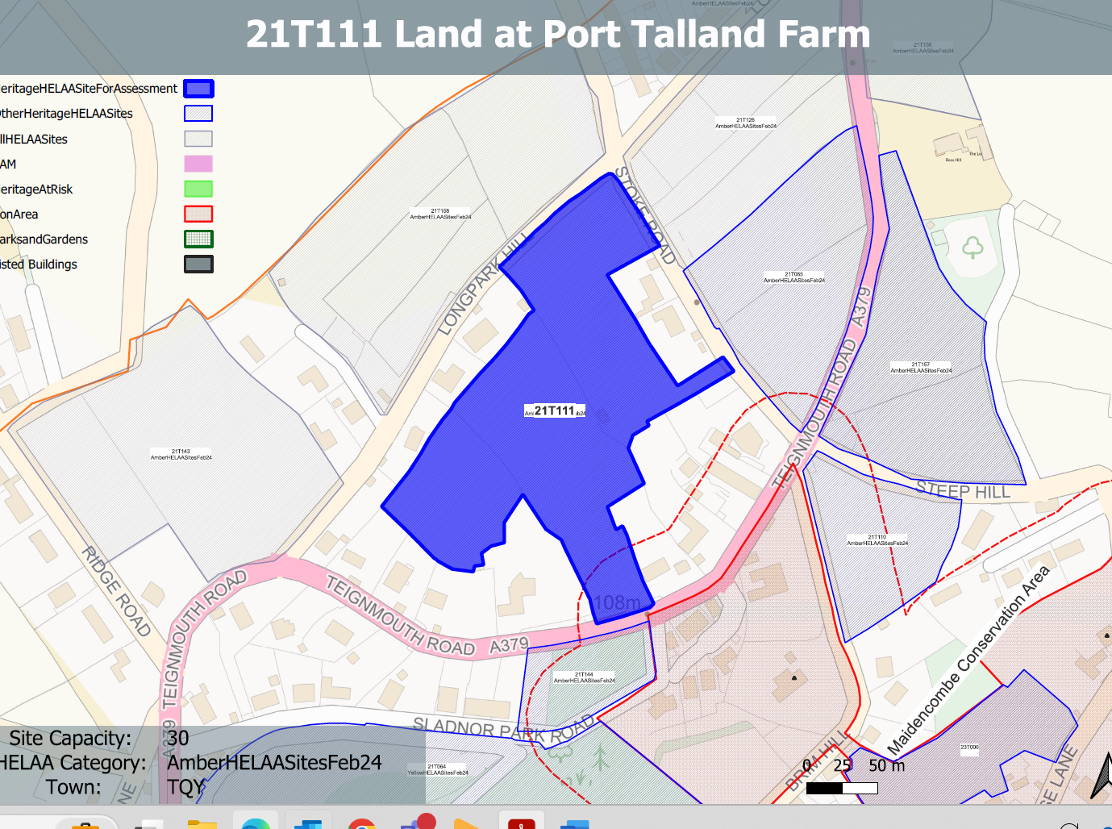
Site overview and heritage context:
Land at Port Talland Farm, w side of Teignmouth Road, Maidencombe. The site sits north of Teignmouth Road and just outside of the Maidencombe Conservation Area. It comprises a number of fields bounded by hedgerows and mature vegetation and is bounded by low density residential development.
The Maidencombe Conservation Area can be found to the south of the site along with one Grade II listed building.
Archaeology: Proximity to prehistoric or Romano-British settlement. Medieval field pattern. Requires programme of archaeological mitigation.

Planning History:
Various relating to development associated with surrounding residential uses.

Heritage Asset Affected by Allocation | Designation | Contributing Elements to Significance | Impact of Development on Significance | Mitigation Measures for any Identified Harm /Opportunities to Enhance Significance | Impact on Significance with Mitigation in place
Maidencombe Conservation Area (S of site)  Brimhill  (SW of site)  Maidencombe Farmhouse (SE of site) | Conservation Area  Grade II listed building  Grade II listed building | The conservation area comprises two distinct areas; the original settlement and historic hamlet, which is mostly grouped around Rock House Lane and Steep Hill, and a scattering of 19th century villas in landscaped grounds to the north. The steeply sloping wooded hillsides create an imposing skyline which encloses the  village, especially to the south and west including the large expanse of Sladnor Park.  The character of much of the conservation area hinges upon its ability to retain the  strong sense of geographical isolation and historic continuity in a setting of great natural  beauty and landscape importance. The landscape value of the conservation area and its rural surroundings is a key special characteristic. The site sits immediately to the north boundary of the conservation area and makes a positive contribution to its significance through its rural character.  Villa constructed in the 1830s. The site is separated from the asset through existing development is not considered to be within its setting.  It makes a limited contribution to its significance.  Farmhouse. Probably late C18. The site is separated from the asset through existing development is not considered to be within its setting.  It makes a limited contribution to its significance. | The development of the site to the proposed quantum would introduce a density of development alien to the character of the area and would have a clear detrimental impact on the rural character of the site and the rural setting of the conservation area. This would cause less than substantial harm to the significance of the asset.  Development of the site would have a negligible impact on the significance of the asset.  Development of the site would have a negligible impact on the significance of the asset. | A substantially reduced quantum of development which respects the surrounding pattern and low density of existing development and which sensitively addresses changes the rural character of the site through a landscape-led design approach, may mitigate the harm caused to the character of the conservation area to a neutral level.  n/a  n/a | Neutral  Neutral  Neutral

