Heritage Impact Assessment: Land North of Steep Hill, Maidencombe, Torquay
HELAA2021 Ref: | 21T110
Site Address: | Land at Teignmouth Road, Maidencombe, Torquay
Site Area (ha): | 0.87
Site Yield: | 20
HIA Assessment

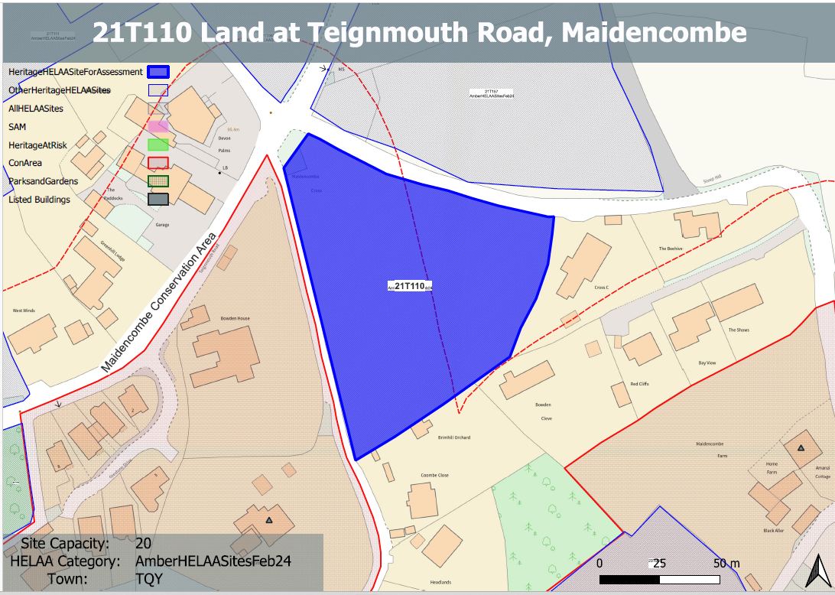
Site overview and heritage context:
Land south of Steep Hill and southeast of Teignmouth Road, Maidencombe Cross. The site rises steeply to the west and is laid to pasture. It is bounded on all sides by mature trees and existing residential development.
The site sits just outside but falls within the immediate setting of the Maidencombe Conservation Area and a selection of listed buildings found within it.

Planning History:
No planning history.

Heritage Asset Affected by Allocation | Designation | Contributing Elements to Significance | Impact of Development on Significance | Mitigation Measures for any Identified Harm /Opportunities to Enhance Significance | Impact on Significance with Mitigation in place
Maidencombe Conservation Area  Brimhill  (SW of site)  Maidencombe Farmhouse (SE of site) | Conservation Area  Grade II listed building  Grade II listed building | The conservation area comprises two distinct areas; the original settlement and historic hamlet, which is mostly grouped around Rock House Lane and Steep Hill, and a scattering of 19th century villas in landscaped grounds to the north. The steeply sloping wooded hillsides create an imposing skyline which encloses the  village, especially to the south and west including the large expanse of Sladnor Park.  The character of much of the conservation area hinges upon its ability to retain the  strong sense of geographical isolation and historic continuity in a setting of great natural  beauty and landscape importance. The landscape value of the conservation area and its rural surroundings is a key special characteristic. The site, sits immediately to the north and east of the boundary of the conservation area and makes a positive contribution to its significance.  Villa constructed in the 1830s. The site forms part of the rural and historic setting of the asset which makes a positive contribution to its significance.  Farmhouse. Probably late C18. The site forms part of the rural setting of the asset which makes a positive contribution to its significance. | The development of the site to the proposed quantum would introduce a density of development alien to the character of the area and would have a clear detrimental impact on the rural character of the site and the rural setting of the conservation area. This would cause less than substantial harm to the significance of the asset.  The development of the site to the proposed quantum would introduce a density of development alien to the character of the area and would have a clear detrimental impact on the rural character of the site. This would cause less than substantial harm to its significance.  The development of the site to the proposed quantum would introduce a density of development alien to the character of the area and would have a clear detrimental impact on the rural character of the site. This would cause less than substantial harm to its significance. | A substantially reduced quantum of development which respects the density of existing development and which sensitively addresses changes in levels within the site through a landscape-led design approach, may mitigate the harm caused to the character of the conservation area to a neutral level.  A substantially reduced quantum of development which respects the density of existing development and which sensitively addresses changes in levels within the site through a landscape-led design approach, may mitigate the harm caused to significance of the asset to a neutral level.  A substantially reduced quantum of development which respects the density of existing development and which sensitiv addresses changes in levels within the site through a landscape-led design approach, may mitigate the harm caused to significance of the asset to a neutral level. | Neutral  Neutral  Neutral

