Heritage Impact Assessment: R/O Edinburgh Villas, off McKay Avenue & Newton Road, Torquay
HELAA2021 Ref: | 21T095
Site Address: | R/O Edinburgh Villas, off McKay Avenue & Newton Road, Torquay
Site Area (ha): | 0.41
Site Yield: | 75
HIA Assessment

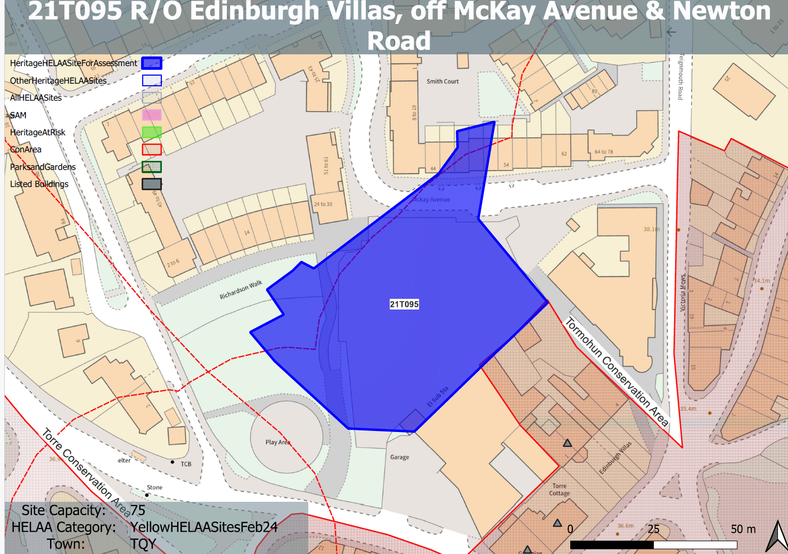
Site overview and heritage context:
Vacant site to the north of the Newton Road and to the south of the completed residential streets of Torre Marine, where there is an established access point from McKay Avenue. The site acts as a gateway to Torre and Torquay town centre in terms of its connectivity, prominence, and location. It is enclosed on three sides, but the southern side is highly visible from Newton Road and beyond.
The listed terrace of Edinburgh Villas sit to the south east and the site is adjacent to the Tormohun and Torre Conservation Areas.
Permission for the wider development has been implemented, the permission to construct the 61 sheltered units and office floor-space remains live in perpetuity and can be built out at any time.

Planning History
P/2010/1389: Redevelopment to form 75 assisted living extra care units with associated communal and care facilities, car parking, landscaping and servicing. Approved: 29.09.2011.
P/2012/1264: Development of site comprising 25 Retirement Living Apartments and 50 Assisted Living Extra Care Apartments with associated parking, landscaping and servicing and communal and care facilities. Approved: 20.02.2013.
P/2016/1047: Major outline application for construction of new building to provide up to 75 one and two bedroom apartments. Approved: 17.11.2017.
P/2022/0722: Erection of 72 extra care apartments (use class C3) with parking, communal lounges, courtyard garden and cafe on ground floor. Approved: 04.04.2023

Heritage Asset Affected by Allocation | Designation | Contributing Elements to Significance | Impact of Development on Significance | Mitigation Measures for any Identified Harm /Opportunities to Enhance Significance | Impact on Significance with Mitigation in place
Edinburgh Villas, 1-4, Brunswick Square  Torre Cottage, Brunswick Square  Georgian House (listed as Eagle Chinese restaurant)  Torre Conservation Area  Tormohun Conservation Area | Grade II listed building  Grade II listed building  Grade II listed building  Conservation Area  Conservation Area | 1830s pair of double-fronted houses now subdivided.  The setting of this asset is mainly from Upton Road. The rear of these assets is directly visible from the site and therefore the site makes a small contribution to the asset’s significance.  1835-45 house, one of a pair with ‘Georgian House’. The setting of this asset is mainly from Upton Road. The relationship with the site is interrupted by a modern industrial unit, and therefore makes a limited contribution to its significance  1835-45 house, one of a pair with ‘Torre Cottage’. The setting of this asset is mainly from Upton Road. The relationship with the site is interrupted by a modern industrial unit, and therefore makes a limited contribution to its significance  The site lies within a parcel of land on the edge of the Torre Conservation Area to the south within its boundary running east along Newton Road. The site is therefore considered to be within its setting and currently makes a natural contribution to its significance.  Tormohun Conservation Area envelopes Edinburgh Villas to the east and continues around to Newton Road and into East Street. The boundary also runs east of the site past McKay Avenue towards Teignmouth Road. The site is therefore considered to be within its setting and currently makes a natural contribution to its significance. | The site has approval for 73 use class C3 apartments where less than substantial harm was identified but outweighed by the public benefits of the development.  The site has approval for 73 use class C3 apartments where a limited degree of less than substantial harm was identified but outweighed by the public benefits of the development.  The site has approval for 73 use class C3 apartments where a limited degree of less than substantial harm was identified but outweighed by the public benefits of the development.  The site has approval for 73 use class C3 apartments where less than substantial harm was identified but outweighed by the public benefits of the development.  The site has approval for 73 use class C3 apartments where less than substantial harm was identified but outweighed by the public benefits of the development. | n/a  n/a  n/a  n/a  n/a | n/a  n/a  n/a  n/a  n/a

