Heritage Impact Assessment: Land off Seymour Road, Watcombe Park, Torquay
HELAA2021 Ref: | 21T083
Site Address: | Land off Seymour Road, Watcombe Park, Torquay
Site Area (ha): | 0.7
Site Yield: | 10
HIA Assessment

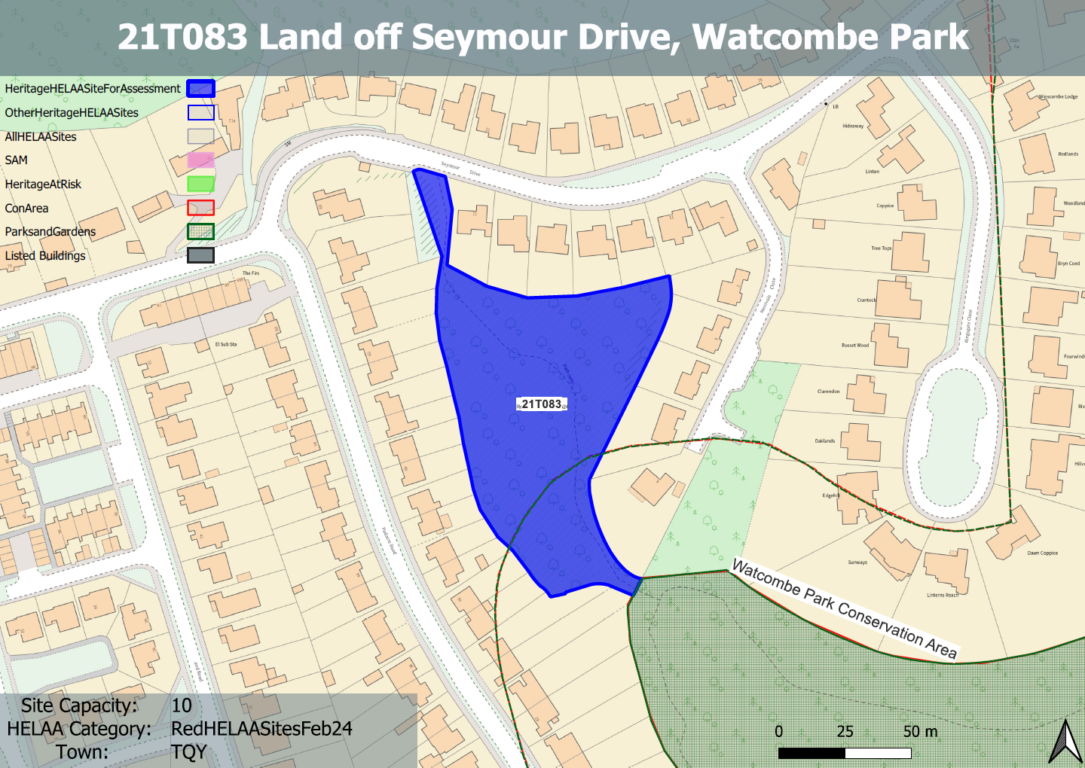
Site overview and heritage context:
The site has a steep topography, sloping from its highest point in the NE corner to the south and west. It is currently partly wooded and grassed and is publicly accessible from Seymour Drive to the north. A path runs through the site to the wooded area of Brunel woods to the SE.
It is bounded by 20th century development to the north, east and west. The Watcombe Park Conservation Area and the Watcombe Park and Brunel Manor borders the site to the SE.

Planning History:
No planning history.

Heritage Asset Affected by Allocation | Designation | Contributing Elements to Significance | Impact of Development on Significance | Mitigation Measures for any Identified Harm /Opportunities to Enhance Significance | Impact on Significance with Mitigation in place
Watcombe Park Conservation Area (SE of site)  Watcombe Park and Brunel Manor (SE of site) | Conservation Area  Registered Park and Garden – Grade II | The conservation area has demonstrable historic value through its association with Brunel, architectural value through the surviving historic built environment and artistic value through its designed landscape in association with Brunel Manor.  The site now forms a gateway to the asset from the NW. It forms part of an informal upper woodland walk which survives as a path through beech woods leading to the pedestrian gate to Seymour Drive.  The site therefore impacts on how the asset is experienced and is considered to be within its setting.  Its current undeveloped form allowing public access to the asset therefore makes a minor positive contribution to the asset’s significance.  The asset comprises formal and informal gardens and features associated with Brunel Manor. The asset has clear historic, artistic and evidential value as a 19th century designed landscape with associations with Brunel.  The site now forms a gateway to the asset from the NW. It forms part of an informal upper woodland walk which survives as a path through beech woods leading to the pedestrian gate to Seymour Drive.  The site therefore impacts on how the asset is experienced and is considered to be within its setting.  Its current undeveloped form allowing public access to the asset therefore makes a minor positive contribution to the asset’s significance. | The development of the site would have a detrimental impact on the existing open space and its relationship with the adjacent historic parkland. This would cause less than substantial harm to the significance of the conservation area.  The development of the site would have a detrimental impact on the existing open space and its relationship with the adjacent historic parkland. This would cause less than substantial harm to the significance of the RPG. | Although development of the site could allow for continued public access to the asset, the loss of the open character of the site as a result of any built development would still detrimentally impact on the ‘gateway’ to the asset and the way in which it is experienced. This would result in less than substantial harm to the significance of the conservation area.  Although development of the site could allow for continued public access to the asset, the loss of the open character of the site as a result of any built development would still detrimentally impact on the ‘gateway’ to the asset and the way in which it is experienced. This would result in less than substantial harm to the significance of the RPG. | Less than substantial harm  Less than substantial harm

