Heritage Impact Assessment: Debenhams, 10-14 The Strand, Torquay
HELAA2021 Ref: | 21T081
Site Address: | Debenhams, 10-14 The Strand, Torquay
Site Area (ha): | 0.17
Site Yield: | 15
HIA Assessment

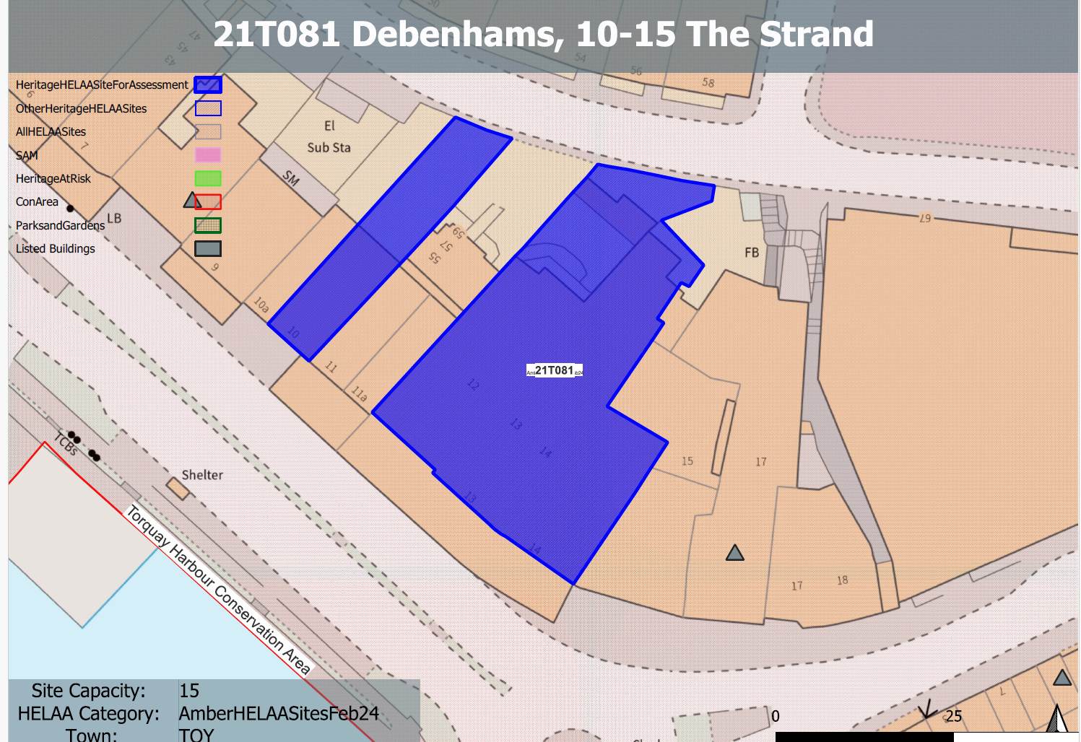
Site overview and heritage context:
The Debenhams site comprises a range of buildings situated to the north of The Strand, a wide street with a range of retail units, public houses and restaurants. It is attached to a two storey retail unit and three storey apartment building (55-59 The Terrace) set back from the street frontage to the west. Yates, a three storey public house, adjoins to the east.
The site steps up approximately 15m to the north towards The Terrace, a street with a mix of professional, commercial and residential properties.
The existing range of buildings comprises of four distinct facades with no.12 and 13 dating from 1960’s, no. 14 from the late 19th century, and the separate no. 10 dating from the mid-19th century. Each block reflects the original 19th century plot widths. The elevations and main retail frontage facing The Strand and no.10 are between two to three storeys high with the building stepping up to six storeys (relative to The Strand) along The Terrace. All three buildings are clad in a limestone material and render with glazed shopfronts and entrances below. The canopy to the front of the site dates (in its current form) from around the 1920s – 30s with mid and later 20th century alterations. It replaced an earlier fabric canopy which was supported on free standing columns.
The site is located within the Torquay Harbour Conservation Area and is in close proximity to a range of Grade II, II* listed buildings and a Grade I listed church.
With regards to archaeology, it is considered that the site is within a historic settlement core and therefore may require a programme of archaeological mitigation.

Planning History
P/2022/0806 – Redevelopment to create a mixed-use, including 5 commercial, business and service units (Use Class E), 16 two bed residential apartments (Use Class C3), residents parking court and public square – Approved 12.01.2023 – this covers on part of the site and excludes no.10 The Strand.

Heritage Asset Affected by Allocation | Designation | Contributing Elements to Significance | Impact of Development on Significance | Mitigation Measures for any Identified Harm /Opportunities to Enhance Significance | Impact on Significance with Mitigation in place
Torquay Harbour Conservation Area  Maples, 16 The Strand  No. 15 The Strand  Clock Tower, The Strand  Royal Bank of Scotland, 8 The Strand  Higher Terrace and attached front railings  Lloyds Bank, Vaughan Parade  1 Palk Street  3-15 Vaughan Parade | Conservation Area  Grade II listed building  Non-Designated Heritage Asset  Grade II listed building  Grade II listed building  Grade II listed building  Grade II listed building  Grade II listed building  Grade II listed building | The Debenhams Department Store is not a designated heritage asset and it is considered to have very limited architectural or heritage value. No 10 has some heritage value. The site has a whole makes a neutral contribution to the significance of the conservation area.  Circa 1900, The brick and terracotta facade is a prominent feature within the harbourside. Maples is separated from the site by Yates public house, the former Nat West Bank, 15 The Strand, but is still read in context with the site.  Part of an important building group with neighbouring buildings to the east. The site immediately borders this asset to the west and therefore has a direct and physical impact to its significance and setting.  Clock tower. 1902. Public subscription to commemorate Richard Mallock. The site has a close relationship the townscape setting of the clock tower.  Bank. 1893, by C R Grittle, chief architect at National Provincial Bank. Separated from the site by no.9 The Strand but is still read in context with the site.  Terrace of 9 houses. 1811 to the designs of Jacob Harvey. The earliest part of Sir Lawrence Palk's development of Torquay and are above the site to the north. The site is read in direct context with these assets and therefore makes a demonstrable contribution to their setting and significance.  A bank constructed c1900. The site forms part of the wider harbour setting of these assets which makes a positive contribution to their significance.  1831 by Jacon Harvey. The site forms part of the wider harbour setting of these assets which makes a positive contribution to their significance.  Terrace of 7 houses. 1831, to the designs of Jacob Harvey. The site forms part of the wider harbour setting of these assets which makes a positive contribution to their significance. | The specified yield could be achieved through the conversion of the existing buildings on the site and would have a neutral impact on the significance of this asset.  The specified yield could be achieved through the conversion of the existing buildings on the site and would have a neutral impact on the significance of this asset.  The specified yield could be achieved through the conversion of the existing buildings on the site and would have a neutral impact on the significance of this asset.  The specified yield could be achieved through the conversion of the existing buildings on the site and would have a neutral impact on the significance of this asset.  The specified yield could be achieved through the conversion of the existing buildings on the site and would have a neutral impact on the significance of this asset.  The specified yield could be achieved through the conversion of the existing buildings on the site and would have a neutral impact on the significance of this asset.  The specified yield could be achieved through the conversion of the existing buildings on the site and would have a neutral impact on the significance of this asset.  The specified yield could be achieved through the conversion of the existing buildings on the site and would have a neutral impact on the significance of this asset.  The specified yield could be achieved through the conversion of the existing buildings on the site and would have a neutral impact on the significance of this asset. | Improvement to the architectural treatment and external appearance of existing buildings on the site through sensitive conversion and/or replacement of existing buildings of a suitable scale and height could result in a positive impact to this asset.  Improvement to the architectural treatment and external appearance of existing buildings on the site through sensitive conversion and/or replacement of existing buildings of a suitable scale and height could result in a positive impact to this asset.  Improvement to the architectural treatment and external appearance of existing buildings on the site through sensitive conversion and/or replacement of existing buildings of a suitable scale and height could result in a positive impact to this asset.  Improvement to the architectural treatment and external appearance of existing buildings on the site through sensitive conversion and/or replacement of existing buildings of a suitable scale and height could result in a positive impact to this asset.  Improvement to the architectural treatment and external appearance of existing buildings on the site through sensitive conversion and/or replacement of existing buildings of a suitable scale and height could result in a positive impact to this asset.  Improvement to the architectural treatment and external appearance of existing buildings on the site through sensitive conversion and/or replacement of existing buildings of a suitable scale and height could result in a positive impact to this asset.  Improvement to the architectural treatment and external appearance of existing buildings on the site through sensitive conversion and/or replacement of existing buildings of a suitable scale and height could result in a positive impact to this asset.  Improvement to the architectural treatment and external appearance of existing buildings on the site through sensitive conversion and/or replacement of existing buildings of a suitable scale and height could result in a positive impact to this asset.  Improvement to the architectural treatment and external appearance of existing buildings on the site through sensitive conversion and/or replacement of existing buildings of a suitable scale and height could result in a positive impact to this asset. | Neutral/positive  Neutral/positive  Neutral/positive  Neutral/positive  Neutral/positive  Neutral/positive  Neutral/positive  Neutral/positive  Neutral/positive

