**Heritage Impact Assessment:** Seabury Hotel, 11 Manor Road, Torquay

|  |  |
| --- | --- |
| **HELAA2021 Ref:** | 21T080 |
| **Site Address:** | Seabury Hotel, 11 Manor Road, Torquay |
| **Site Area (ha):** | 0.18 |
| **Site Yield:** | 15 |
| **HIA Assessment** |  |

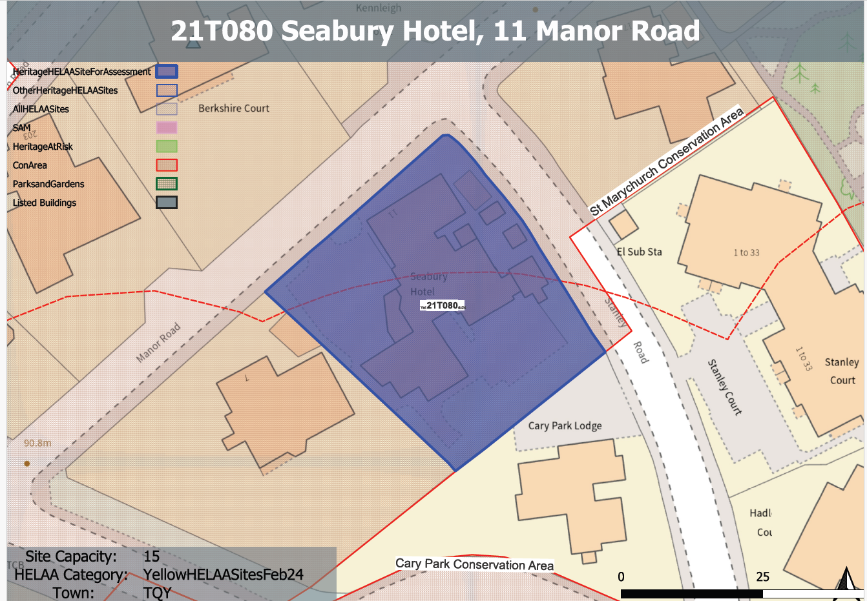

**Site overview and heritage context:**

The site is occupied by a Victorian Villa and its curtilage, sited at the corner of Manor Road and Stanley Road, Torquay. While the original building dates from 1830s-1860s, it has been extended by way of a number of more recent extensions that detract from its historic character to some extent.

The site is located within the St Marychurch Conservation Area. The St Marychurch Conservation Area Appraisal (CAA) does not identify the subject property as a key building within the conservation area, but draws attention to the prominent stone walls and mature trees along the plot boundaries. The site is in proximity to a Grade II listed building, namely No.205 St Marychurch Road which is opposite the site on the north-western side of Manor Road.

**Planning History**

P/2023/0721: Demolition of existing hotel building and erection of 14 residential apartments, and associated parking and landscaping. Approved 2/07/2024.

P/2022/0908: Demolition of the existing hotel building, erection of a self contained block of 21 flats with basement parking and associated works. Withdrawn 26/10/2022.

P/2021/0520: Change of use from hotel to 12 flats, including the demolition of existing extensions, and the erection of a new extension and new building. (as amended). Approved 18/03/2022.

|  |  |  |  |  |  |
| --- | --- | --- | --- | --- | --- |
| **Heritage Asset Affected by Allocation** | **Designation** | **Contributing Elements to Significance** | **Impact of Development on Significance** | **Mitigation Measures for any Identified Harm /Opportunities to Enhance Significance** | **Impact on Significance with Mitigation in place** |
| St Marychurch Conservation Area  205 St Marychurch Road  Seabury Hotel | Conservation Area  Grade II listed building  Non-designated heritage asset | The original villa on the site was constructed in the mid-19th century and is a typical example of its type built upon former agricultural/scrub land along the western approaches to St.Marychurch as it expanded into a suburb of Torquay.  The building itself has undergone insensitive alteration as a result of its conversion to a hotel in the later 20th century which has had a detrimental impact on its external and internal character and appearance, however, its original form and elements of architectural detailing remain legible and therefore its origins and contribution to the evolution and character of the area can still be read.  As a result, the building does make a positive contribution to the character and appearance of the St. Marychurch Conservation Area.  Villa constructed in the 1840s. It has demonstrable architectural and historic value and is recognised within the St. Marychurch Conservation Area Appraisal as having one of the few unspoiled frontages in the area.  The site can be found directly opposite on the other side of Manor Road and although the building is set back within the plot and is partially screen by a row of mature trees, the listed building and the application site can still be seen together in context. It is clear that the two sites share a visual and historic relationship between each other and other villas along Manor Road. The site therefore forms part of the asset’s setting and makes a minor positive contribution to its significance.  Detached villa in generous grounds, formerly residential use now vacant hotel. The building has undergone various extensions to accommodate additional rooms and spaces associated with its hotel use. Constructed mid-19th century and has some architectural and historic interest. Forms part of an informal group with a number of other villas of a similar age along Manor Road which denote this period of Victorian expansion. | Conversion of existing building would have neutral impact on significance of this asset. Wholesale demolition and rebuild would likely cause a degree of harm. Conversion of existing structure with limited external changes with elements of new build could have a neutral or detrimental impact dependent upon the proposed design of the new building elements.  Conversion of existing building would have neutral impact on significance of this asset. Wholesale demolition and rebuild would likely cause a degree of harm. Conversion of existing structure with limited external changes with elements of new build could have a neutral or detrimental impact dependent upon the proposed design of the new building elements.  Conversion of existing building would have neutral impact on significance of this asset. Wholesale demolition and rebuild would cause substantial harm. Conversion of existing structure with elements of new build could have a neutral or detrimental impact dependent upon the proposed design of the new building elements. | The significance of this asset could be enhanced through the sensitive conversion of the existing villa which included removal of detrimental 20th century additions and structures, coupled with sensitively designed new build within the ground.  The sensitive conversion of the existing villa which included removal of detrimental 20th century additions and structures, coupled with sensitively designed new build within the grounds would have a positive impact on the setting of this asset and would result in a neutral or minor enhancement to its significance.  The sensitive conversion of the existing villa which included removal of detrimental 20th century additions and structures, coupled with sensitively designed new build within the grounds would have a positive impact the significance of this asset. | Neutral/positive  Neutral/positive  Neutral/positive |