**Heritage Impact Assessment:** Seascape Hotel, 8-10 Tor Church Rd, Torquay

|  |  |
| --- | --- |
| **HELAA2021 Ref:** | 21T077 |
| **Site Address:** | Seascape Hotel, 8-10 Tor Church Rd, Torquay |
| **Site Area (ha):** | 0.21 |
| **Site Yield:** | 15 |
| **HIA Assessment** |  |

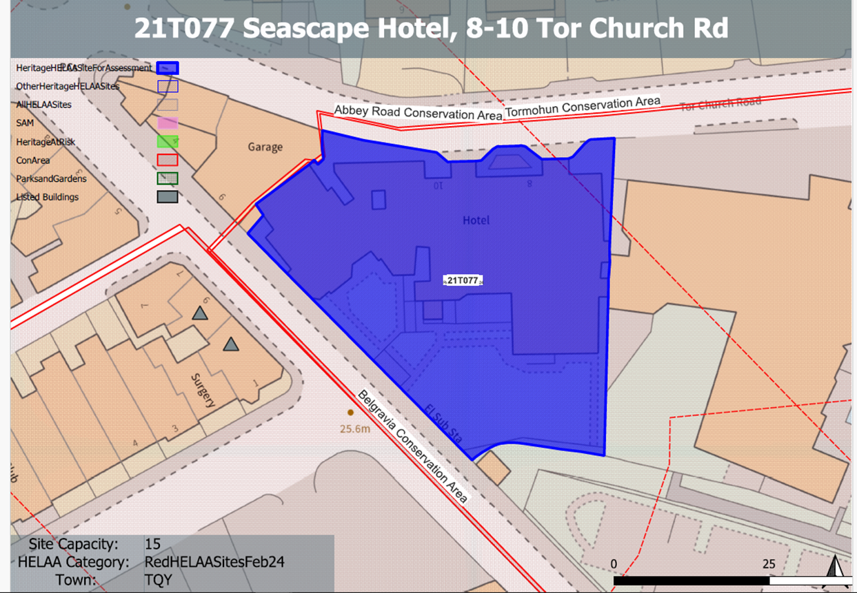

**Site overview and heritage context:**

The site forms part of a group of large villas built on a curving alignment at the junction of Abey Road and Tor Church Road, Torquay. There is a considerable change in ground levels within the site with the level of the southern elements of the site being approximately a storey below the ground levels on the norther boundary facing Tor Church Road.

The site comprises a number of adjoined but distinct building elements namely, the main villa and rear terrace with single storey extension, single storey side extension and 3 storey separate structure, now attached.

The site lies within the Abbey Road Conservation Area and abuts the neighbouring Belgravia and Tormohun Conservation Areas.

**Planning History**

P/2018/0910 - Application for Coaching Hotel (C1) with mixed use as residential (C3). Withdrawn – 27/09/2018

|  |  |  |  |  |  |
| --- | --- | --- | --- | --- | --- |
| **Heritage Asset Affected by Allocation** | **Designation** | **Contributing Elements to Significance** | **Impact of Development on Significance** | **Mitigation Measures for any Identified Harm /Opportunities to Enhance Significance** | **Impact on Significance with Mitigation in place** |
| Abbey Road Conservation Area  Tormohun Conservation Area (N and W of site)  Belgravia Conservation Area (S of site)  9 Tor Church Road (opposite site to N)  3 and 5 Tor Church Road (opposite site to NE)  9 Croft Road (W of site)  Mulberry House SW of site) | Conservation Area  Conservation Area  Conservation Area  Grade II listed building  Grade II listed building  Grade II listed building  Grade II listed building | The site is identified as a key building within the conservation which was originally constructed in the 1870s-80s as a paired villa.  The building has undergone some insensitive alterations and extensions but its original form and relationship with neighbouring villas along Tor Church Road can still be read. The site therefore makes a positive contribution to the significance of the conservation area.  The site sits within the urban setting of this asset and contributes to the overall quality of the historic environment within the area. It makes a minor positive contribution to its significance.  The site sits within the urban setting of this asset and contributes to the overall quality of the historic environment within the area. It makes a minor positive contribution to its significance.  1850s with later 19th century addition villa, now divided into apartments. The site sits within the urban setting of this asset and contributes to the overall quality of the historic environment within the area. It makes a minor positive contribution to its significance.  Pair of villas. c1840-1850. The site sits within the urban setting of this asset and contributes to the overall quality of the historic environment within the area. It makes a minor positive contribution to its significance.  Terraced house. Late 1860s. The site sits within the urban setting of this asset and contributes to the overall quality of the historic environment within the area. It makes a minor positive contribution to its significance.    House. Late 1860s. The site sits within the urban setting of this asset and contributes to the overall quality of the historic environment within the area. It makes a minor positive contribution to its significance. | The noted yield of 15 units could be adequately achieved through the conversion of the existing buildings which would have a neutral impact on the asset’s significance.  The noted yield of 15 units could be adequately achieved through the conversion of the existing buildings which would have a neutral impact on the asset’s significance.  The noted yield of 15 units could be adequately achieved through the conversion of the existing buildings which would have a neutral impact on the asset’s significance.  The noted yield of 15 units could be adequately achieved through the conversion of the existing buildings which would have a neutral impact on the asset’s significance.  The noted yield of 15 units could be adequately achieved through the conversion of the existing buildings which would have a neutral impact on the asset’s significance.  The noted yield of 15 units could be adequately achieved through the conversion of the existing buildings which would have a neutral impact on the asset’s significance.  The noted yield of 15 units could be adequately achieved through the conversion of the existing buildings which would have a neutral impact on the asset’s significance. | Sensitive conversion which included the removal of detrimental additions/extensions necessary for its hotel use would have a positive impact on the significance of the heritage asset.  Sensitive conversion which included the removal of detrimental additions/extensions necessary for its hotel use would have a neutral or minor positive or impact on the significance of the heritage asset.  Sensitive conversion which included the removal of detrimental additions/extensions necessary for its hotel use would have a neutral or minor positive or impact on the significance of the heritage asset.  Sensitive conversion which included the removal of detrimental additions/extensions necessary for its hotel use would have a neutral or minor positive or impact on the significance of the heritage asset  Sensitive conversion which included the removal of detrimental additions/extensions necessary for its hotel use would have a neutral or minor positive or impact on the significance of the heritage asset  Sensitive conversion which included the removal of detrimental additions/extensions necessary for its hotel use would have a neutral or minor positive or impact on the significance of the heritage asset  Sensitive conversion which included the removal of detrimental additions/extensions necessary for its hotel use would have a neutral or minor positive or impact on the significance of the heritage asset | Positive  Neutral/positive  Neutral/positive  Neutral/positive  Neutral/positive  Neutral/positive  Neutral/positive |