Bike Safety Check

It only takes a minute to check your bike once a week. It’ll cost you less in the long run too!

1. Rear derailleur - check top pivot bolt and jockey wheels are tight. Check to see if the cable is frayed and replace if necessary.
2. Brakes - inspect brake blocks for wear. See they line up with the wheel rim. Fit the brake blocks so that the front edge touches the rim first to avoid brake squeal. Check the pivot bolts are tight and cables are not frayed.
3. Cranks - should be tight. Chain-rings should be inspected for broken teeth and the bottom bracket for play.
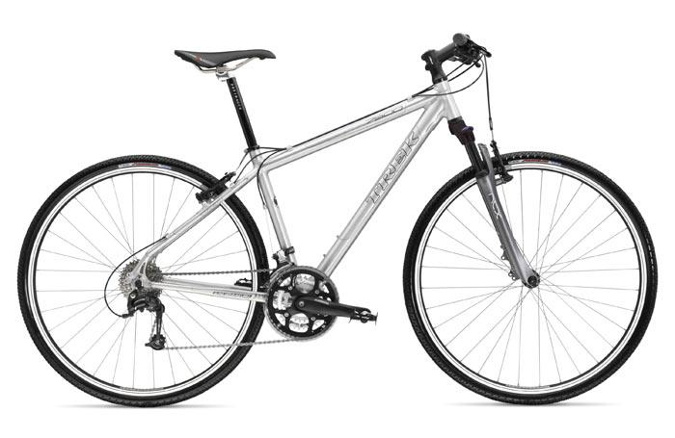
❺
❺
❻

❷
❷
❻
❶

❸
❹

4. Chain - clean and lubricate regularly, particularly in poor weather. A worn chain will wear the rest of the drive train components and those are much more costly than some oil or a new chain.
5. Handlebars and saddle - bolts should be tight, but do not use excessive force.
6. Tyres - check tyre pressures and look for damage especially along the side walls.

Use good quality oils and lubricants on your bike and always follow manufacturer recommendations as regards torque settings for bolts etc.

