Heritage Impact Assessment: Union Square Shopping Centre, Torquay
HELAA2021 Ref: | 21T075
Site Address: | Union Square Shopping Centre, Torquay
Site Area (ha): | 1.02
Site Yield: | 250
HIA Assessment

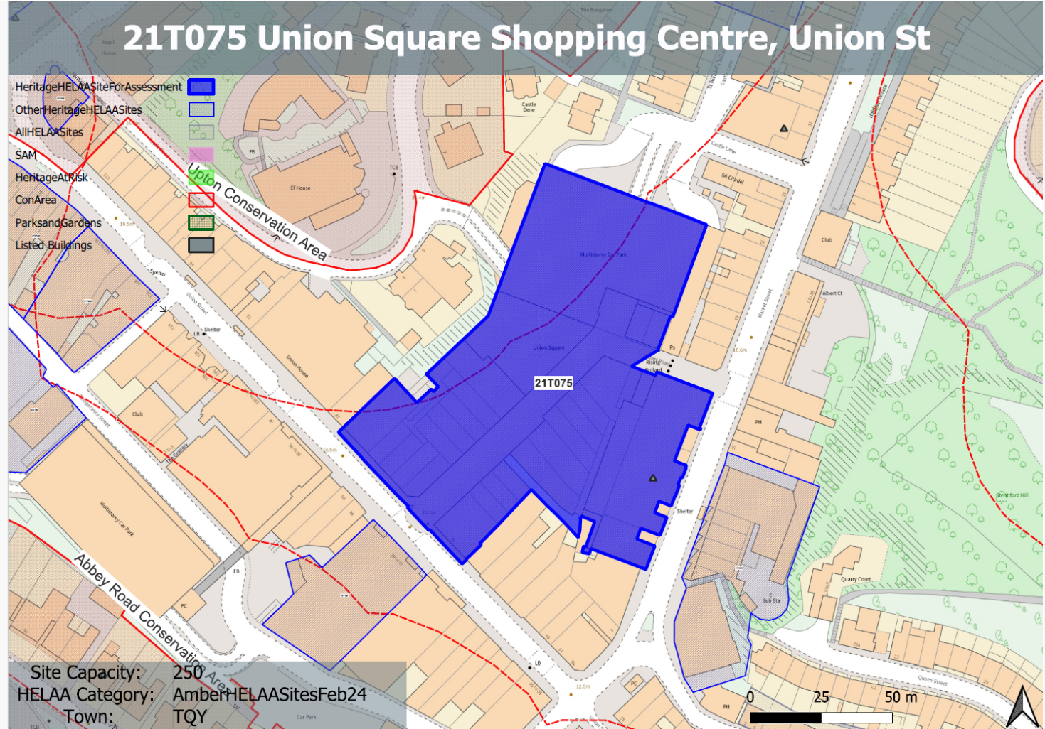
Site overview and heritage context:
Union Square is a large multi-let shopping centre located in the centre of Torquay, between Market Street and Union Street, arranged in a rough ‘L’ shape. Access to the inner mall is via an entrance facing Union Street, with an alternative access via Albert Road, located directly off Market Street.
The existing building comprises a number of retail units located on the ground floor facing into an open-air area covered by a fabric canopy. To the east of the site is the Union Square multistorey carpark which is accessed from Castle Road to the north-west and Castle Lane to the north.
The site experiences numerous changes in level and is constrained on all sides by existing built development and hard urban landscaping.
The site is not within a conservation area but is in close proximity to the Upton Conservation Area to the Northwest, the Warberries Conservation Area to the East and the Abbey Road Conservation Area to the South.
The Market building within the site is a Grade II listed building. A number of other listed buildings are nearby to the site.

Planning History
The site as a whole has a varied planning history relating to the individual retail units.

Heritage Asset Affected by Allocation | Designation | Contributing Elements to Significance | Impact of Development on Significance | Mitigation Measures for any Identified Harm /Opportunities to Enhance Significance | Impact on Significance with Mitigation in place
Upton Conservation Area (to NE of site)  Warberries Conservation Area (to E of site)  Abbey Road Conservation Area (to S of site)  Torquay Market  12-30 Castle Road (to N of site)  The Old Sessions House (to NE of the site) | Conservation Area  Conservation Area  Conservation Area  Grade II listed building  Grade II listed building  Grade II listed building | The existing multistorey carpark and shopping centre makes a minor negative contribution to the setting and significance of this heritage asset.  The existing multistorey carpark and shopping centre makes a limited contribution to the setting and significance of this heritage asset  The existing multistorey carpark and shopping centre makes a limited contribution to the setting and significance of this heritage asset  Pannier Market building of 1852 to the designs of John Tapley Harvey with alterations of 1909. Has demonstrable architectural, historic, evidential and communal value all of which result in being an asset of medium significance.  Terrace of 10 house, circa late 19th century. The existing site currently makes a limited contribution to the setting and significance of this heritage asset  1873-1876 to the designs of Harbottle, with police quarters and cells. The existing multistorey carpark makes a minor negative contribution to the setting and significance of this heritage asset. | The development of the site to achieve 250 units may result in a building of a height and scale which could harm the significance of this asset.  The development of the site to achieve 250 units may result in a building of a height and scale which could result in minor harm the significance of this asset.  The development of the site to achieve 250 units may result in a building of a height and scale which could result in minor harm the significance of this asset.  The development of the site to achieve 250 units has the potential to cause harm to the listed building depending on the specific scheme proposed.  The development of the site to achieve 250 units may result in a building of a height and scale which could result in minor harm the significance of this asset.  The development of the site to achieve 250 units may result in a building of a height and scale which could result in minor harm the significance of this asset. | A reduction in the yield and the sensitive design of the development which is of a suitable scale and height could have a positive impact on the significance of this asset.  A reduction in the yield and the sensitive design of the development which is of a suitable scale and height could have a neutral or minor positive impact on the significance of this asset.  A reduction in the yield and the sensitive design of the development which is of a suitable scale and height could have a neutral or minor positive impact on the significance of this asset.  The market building should not be considered for conversion and should retain its original and existing use. A reduced yield and sensitive development including enhanced public realm around the market and the removal of harmful development attached to the building would have a positive impact on the significance of the building.  A reduction in the yield and the sensitive design of the development which is of a suitable scale and height could have a neutral or minor positive impact on the significance of this asset.  A reduction in the yield and the sensitive design of the development which is of a suitable scale and height could have a neutral or minor positive impact on the significance of this asset. | Positive  Neutral/positive  Neutral/positive  Positive  Neutral/positive  Neutral/positive

