**Heritage Impact Assessment:** Central Cinema, 29 Abbey Rd, Torquay

|  |  |
| --- | --- |
| **HELAA2021 Ref:** | 21T071 |
| **Site Address:** | Central Cinema, 29 Abbey Rd, Torquay |
| **Site Area (ha):** | 0.07 |
| **Site Yield:** | 12 |
| **HIA Assessment** |  |

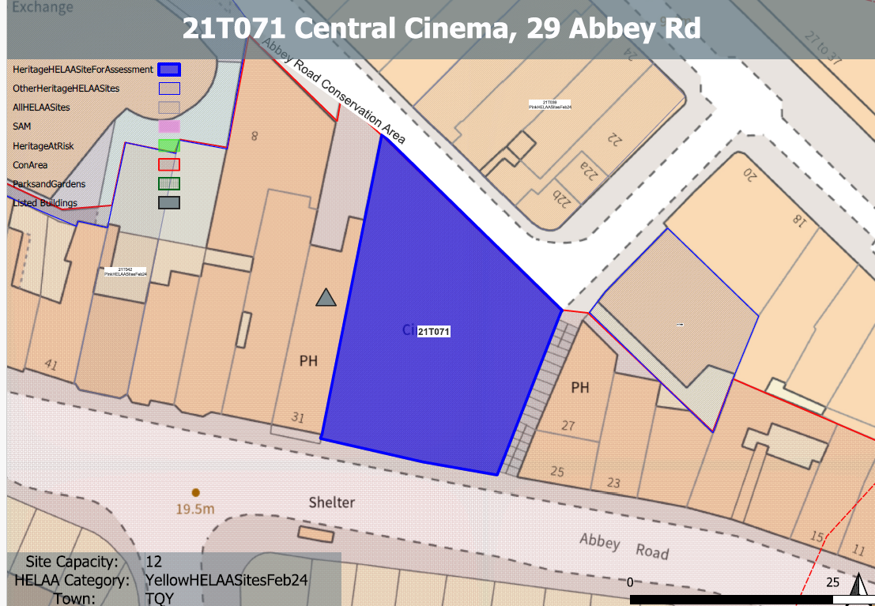

**Site overview and heritage context:**

The site includes the former Central cinema which is a 4 storey building identified as a key building within the Abbey Road Conservation Area.

The main entrance is located off Abbey Road, however, the site can also be accessed from the alley steps to the side and from the lower level at the rear. The rear of the building appears to be four storeys in height due to highly elevated grounds at the front. A stepped alley cuts the Abbey Road terrace through and forms public access to the central Union Street. The building fills the plot tightly and forms a strong feature on the street scene from both the front and the rear aspect.

The history of the building is told through its appearance, form and the complex layout. The property evolved through the years starting with the first conversion of the Assembly Rooms into an early stage theatre, called Royal Lyceum Theatre by Frank Matcham in 1871. This was later redesigned by the renowned theatre Architect, C. J. Phipps and was successfully opened as The Royal Theatre in 1880. It was converted to a cinema in 1933 and is now back in community use as the Royal Lyceum Theatre once again.

A Grade II listed building neighbours the site along Abbey Road to the west.

P/2022/0731 - Change of use from cinema to theatre, community art centre and office space with accompanying alterations. Approved: 15/12/2022

|  |  |  |  |  |  |
| --- | --- | --- | --- | --- | --- |
| **Heritage Asset Affected by Allocation** | **Designation** | **Contributing Elements to Significance** | **Impact of Development on Significance** | **Mitigation Measures for any Identified Harm /Opportunities to Enhance Significance** | **Impact on Significance with Mitigation in place** |
| Abbey Road Conservation Area  Former Falcon Public House (immediately W of site) | Conservation Area  Grade II listed building | The site is indicated in the Abbey Road Conservation Area Appraisal as ‘other key buildings of architectural importance which make a significant contribution to townscape’. It makes a positive contribution to the significance of the conservation area, both through its architectural value but also its historic and communal value as a historic theatre serving the area.  Mid- 19th century former public house, recent use as a children’s entertainment area. Is a prominent feature within the street scene due to its current colour, condition and striking architectural features. The site adjoins this asset to the east and forms part of its immediate urban setting and adds to the quality of the surrounding historic environment. It makes a minor positive contribution to its significance. | Although residential conversion could potentially be achieved with minimal external alteration, this more intensive use would likely have a detrimental impact on historic fabric and would result in the loss of a cultural asset open to public use. Residential use would also lead to potential future pressure on the site which may lead to external changes which would dilute the architectural value of the building.  The residential conversion of the site would therefore likely result in some harm to the significance of the conservation area.  Although residential conversion could potentially be achieved with minimal external alteration, its conversion may lead to future pressures for external changes which would dilute the quality of the historic environment in this area. This could have a minor detrimental impact on the urban setting of the asset which makes a contribution to its significance. | A potential part residential conversion of the site which allowed the retention of a cultural/public use would mitigate some harm caused by the wholesale residential conversion. This would involve a significantly reduced quantum of housing.  If this was coupled with the reinstatement of lost historic detailing, such as windows and the original glazed canopy, then the development could have a neutral impact on the significance of this asset.  Proposed development which involved the reinstatement of lost historic detailing, such as windows and the original glazed canopy, would improve the quality of the surrounding historic environment and the urban setting of the asset and would result in a neutral to minor positive impact on the significance of this asset. | Neutral  Neutral/minor positive |