Heritage Impact Assessment: Former Magistrates Court, Union Street, Torquay
HELAA2021 Ref: | 21T070
Site Address: | Former Magistrates Court, Union Street, Torquay
Site Area (ha): | 0.12
Site Yield: | 10
HIA Assessment

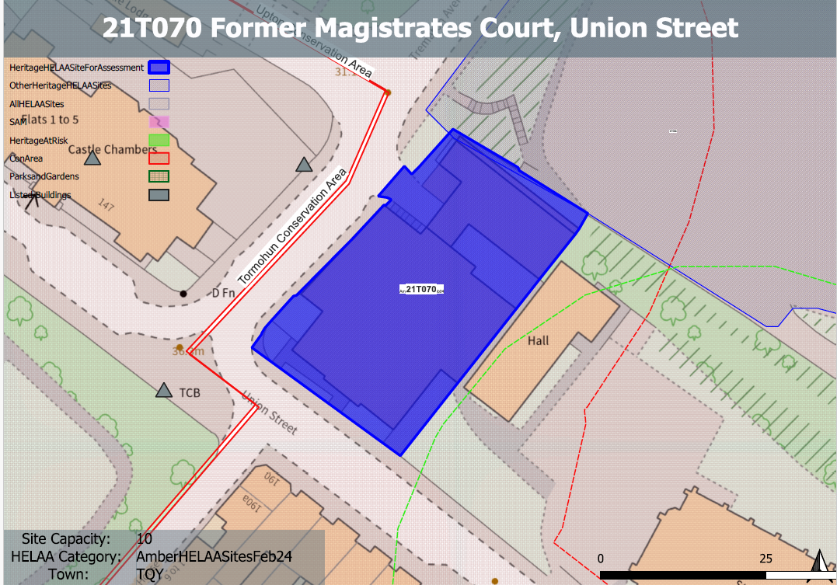
Site overview and heritage context:
The former Magistrates Court, located on the corner of Union Street with Trematon Avenue, west of Grade 2* St Mary Magdalene’s Church and south of the Town Hall Car Park.
The principal element of the existing building fronts Union Street and is a stone finished two-storey flat-roofed building with an element of under-build evident along Trematon Avenue, responding the drop in levels. There is a secondary element in the form of a linked annex, which is brick finished elevated single-storey element set over parking spaces.
The building sits within the Upton Conservation Area and dates from between 1870 and 1904, initially being a school building. In addition to the church the site also forms part of the immediate setting to the Grade 2 Listed Castle Chambers to the east across Trematon Avenue

Planning History:
P/2022/0969: Conversion of the former Magistrates Court to form 14 residential apartments, including partial demolition, the provision of an additional floor, and external changes including the provision of balconies, terraces, and associated car parking, bike parking and bin storage. Approved: 15/12/20225
P/2021/0266: Change of use from former Magistrates Court to 10 residential apartments & associated facilities, including amendments to windows, doors and external staircases, and the addition of rooflights. Application withdrawn 04/08/2021.

Heritage Asset Affected by Allocation | Designation | Contributing Elements to Significance | Impact of Development on Significance | Mitigation Measures for any Identified Harm /Opportunities to Enhance Significance | Impact on Significance with Mitigation in place
Upton Conservation Area  Tormohun Conservation Area (W and SW of site)  Railings, Walls and Drinking Fountain (NW of site)  Castle Chambers (W of site)  K6 Telephone Kiosk (SW of site)  Parish Church of St. Mary Magdalene (SE of site)  Boundary Wall and Gate Piers South of Parish Church of St Mary Magdalene | Conservation Area  Conservation Area  Grade II listed building  Grade II listed building  Grade II listed building  Grade II* listed building  Grade II listed building | This former school and law building is not identified as a building of merit in the Upton Conservation Area Appraisal, however it is considered a positive contributor to the townscape, where its stone finish and utilitarian form sits comfortably with the buildings of merit in the area. The buildings merit is however weakened by a modern window stock, rooftop clutter, and the beginnings of general disrepair.  The site sits within the urban setting of this asset and contributes to the overall quality of the historic environment within the area. It makes a minor positive contribution to its significance.  Railings and walls south-west, south-east and north-east of Castle Chambers including drinking fountain. Dating from 1892-93, contemporary with the rebuilding of the hospital. The site sits within the urban setting of this asset and contributes to the overall quality of the historic environment within the area. It makes a minor positive contribution to its significance  Hospital, used as County court and now in residential use. 1850 in origin, with alterations dating from 1892-93. The site sits within the urban setting of this asset and contributes to the overall quality of the historic environment within the area. It makes a minor positive contribution to its significance  Telephone kiosk. Type K6. Designed 1935 by Sir Giles Gilbert Scott. The site sits within the urban setting of this asset and contributes to the overall quality of the historic environment within the area. It makes a neutral to minor positive contribution to its significance.  Parish church. 1843-9 to the designs of A Salvin, contractor Jacob Harvey; altered and partly re-fitted under GG Scott 1881-2. The site sits within the urban setting of this asset and presents a rather utilitarian face to the car parking area for the church. It makes a neutral contribution to its overall significance.  Boundary walls to south side of church. Late C19. The site sits within the urban setting of this asset and makes a neutral contribution to its overall significance. | The conversion of the existing building would likely have a neutral or minor positive impact on the significance of this asset as recognised within approved application P/2022/0969.  The conversion of the existing building would likely have a neutral or minor positive impact on the significance of this asset as recognised within approved application P/2022/0969.  The conversion of the existing building would likely have a neutral or minor positive impact on the significance of this asset as recognised within approved application P/2022/0969.  The conversion of the existing building would likely have a neutral or minor positive impact on the significance of this asset as recognised within approved application P/2022/0969.  The conversion of the existing building would likely have a neutral or minor positive impact on the significance of this asset as recognised within approved application P/2022/0969.  The conversion of the existing building would likely have a neutral or minor positive impact on the significance of this asset as recognised within approved application P/2022/0969.  The conversion of the existing building would likely have a neutral or minor positive impact on the significance of this asset as recognised within approved application P/2022/0969. | The sensitive conversion of the existing building, the improvement of the building’s condition and removal of detrimental additions/extensions would have a positive impact on the asset’s significance.  The sensitive conversion of the existing building, the improvement of the building’s condition and removal of detrimental additions/extensions would have a minor positive impact on the asset’s significance.  The sensitive conversion of the existing building, the improvement of the building’s condition and removal of detrimental additions/extensions would have a minor positive impact on the asset’s significance.  The sensitive conversion of the existing building, the improvement of the building’s condition and removal of detrimental additions/extensions would have a minor positive impact on the asset’s significance.  The sensitive conversion of the existing building, the improvement of the building’s condition and removal of detrimental additions/extensions would have a neutral or minor positive impact on the asset’s significance.  The sensitive conversion of the existing building, the improvement of the building’s condition and removal of detrimental additions/extensions would have a minor positive impact on the asset’s significance.  The sensitive conversion of the existing building, the improvement of the building’s condition and removal of detrimental additions/extensions would have a minor positive impact on the asset’s significance. | Positive  Minor Positive  Minor Positive  Minor Positive  Neutral/minor positive  Minor positive  Minor positive

