Heritage Impact Assessment: Land off Teignmouth Road, Maidencombe, Torquay
HELAA2021 Ref: | 21T065
Site Address: | Land off Teignmouth Road , Maidencombe, Torquay
Site Area (ha): | 1.55
Site Yield: | 40
HIA Assessment

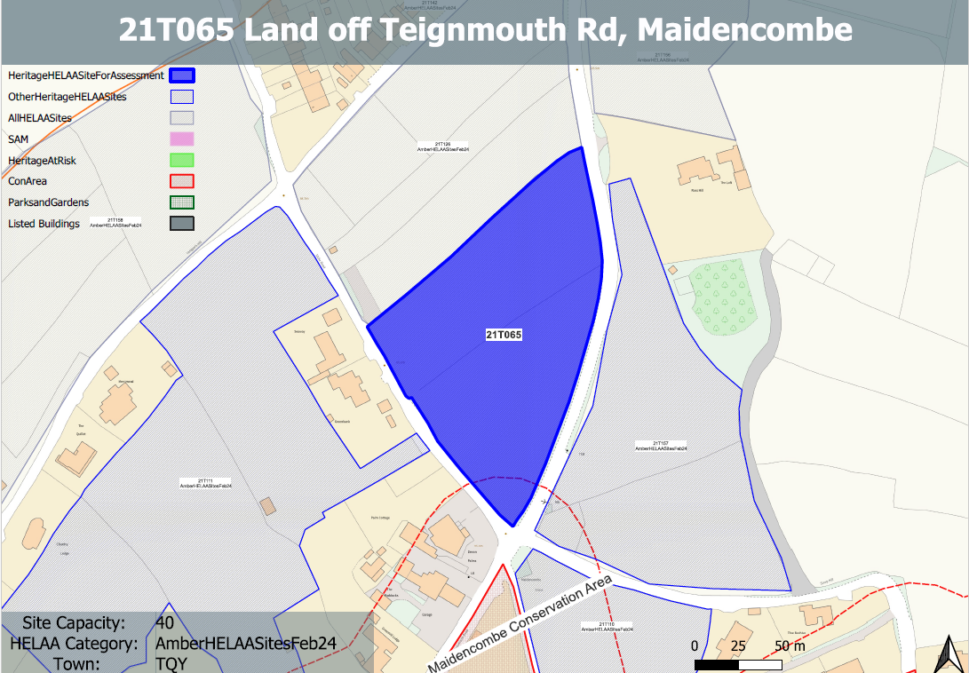
Site overview and heritage context:
Fields west of A379 and northeast of Stoke Road, Maidencombe. The site is not flat and rises to the north.
The site sits outside but falls within the rural setting of the Maidencombe Conservation Area.
It has some archaeological potential, being in close proximity to a prehistoric or Romano-British settlement. The area also contains medieval field patterns.

Planning History:
No planning history.

Heritage Asset Affected by Allocation | Designation | Contributing Elements to Significance | Impact of Development on Significance | Mitigation Measures for any Identified Harm /Opportunities to Enhance Significance | Impact on Significance with Mitigation in place
Maidencombe Conservation Area | Conservation Area | The conservation area comprises two distinct areas; the original settlement and historic hamlet, which is mostly grouped around Rock House Lane and Steep Hill, and a scattering of 19th century villas in landscaped grounds to the north. The steeply sloping wooded hillsides create an imposing skyline which encloses the  village, especially to the south and west including the large expanse of Sladnor Park.  The character of much of the conservation area hinges upon its ability to retain the  strong sense of geographical isolation and historic continuity in a setting of great natural  beauty and landscape importance. The landscape value of the conservation area and its rural surroundings is a key special characteristic. The site, sits to the north of the conservation area and makes a minor positive contribution to its significance in its undeveloped form. | The development of the site and the urban spread of the settlement would have a detrimental impact on the rural character of the conservation area. This would cause less than substantial harm to the significance of the asset. | A substantially reduced quantum of development of the northern parcel of land only which takes a low density and landscape-led or ‘agricultural’ design approach, and which retains the rural character of the site may reduce the harm caused to the character of the conservation area to a neutral level. | Neutral

