Heritage Impact Assessment: Sladnor Park, Maidencombe, Torquay
HELAA2021 Ref: | 21T064
Site Address: | Sladnor Park, Maidencombe, Torquay
Site Area (ha): | 21.9
Site Yield: | 120
HIA Assessment

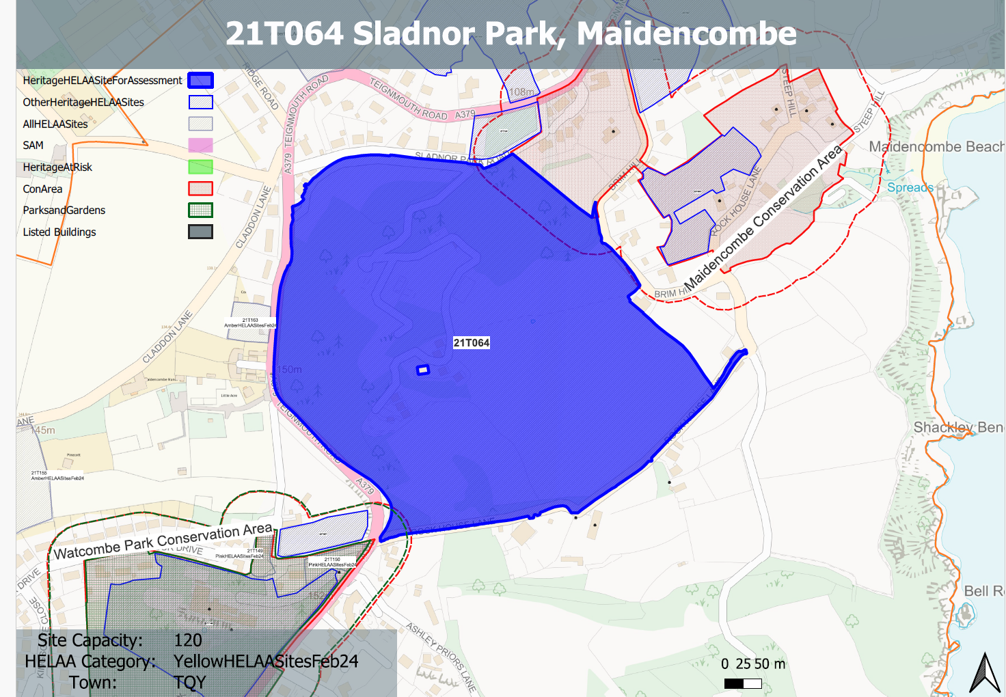
Site overview and heritage context:
Sladnor Park is the site of a former country estate that held a Victorian manor house dating from the 1830/40s. The site evolved into a holiday camp post war with linear low-laying chalet development added to the south and east of the manor house, accompanied by recreational facilities including a pool and tennis court.
Following the closure of the holiday camp in the late 1980s the manor house was lost to fire damage and was, together with the chalets, removed to the foundations.
The site is approximately 22 hectares in size and is bounded to the north by Sladnor Park Road, the east by Brim Hill, the south by Rock House Lane and the west by the Teignmouth Road. The high point of the site is to the west adjacent to the Teignmouth Road with the low point to the east adjacent to Brim Hill. The level difference from the high point to the low point is approximately 100 metres.
In regard to the current character of the site there is extensive woodland to the western and northern areas of the site, with open fields to the eastern and southern areas.
There are a number of designated heritage assets nearby. To the east lies the Maidencombe Conservation Area, which includes the small hamlet mostly grouped around Rock House Lane and Steep Hill. The Conservation Area does extend north towards the Torquay-Teignmouth Road to include a scattering of 19th century villas in landscaped grounds. Within the conservation area there are 5 listed buildings, all grade II, four of which sit in the core of the historic hamlet around the village green.
The fifth, an early-Victorian villa, sits above the hamlet off Brim Hill. In regard to non-designated heritage assets within the site sit 8 pairs of ‘Scandinavian’ style timber lodges.
With regards to archaeology, there is the potential for medieval remains to be present within the site along with the archaeological remains of Sladnor Manor and associated structures.

Planning History:
P/2018/1053 - Demolition of existing pairs of chalets (with the exception of one pair) and the development of a Continuing Care Retirement Community comprising the erection of buildings to accommodate 43 assisted living units and 116 close care units, associated health and wellness facilities, staff facilities, internal roads, surface and underground car parking (including associated engineering operations), footpaths, ancillary buildings, landscaping, drainage works and associated infrastructure. The proposal includes a temporary access on Rock House Lane as well as works to the existing folly. – Refused: 07 January 2021
P/2020/0315 - Completion of a 188 unit 'retirement village', associated healthcare, leisure and restaurant facilities, retention of three pairs of existing lodges, landscaping and parking, pursuant to P/2008/1418/PA and P/2009/0240/MRM. Allowed at appeal 05 April 2022. This gives the site an established extant permission.

Heritage Asset Affected by Allocation | Designation | Contributing Elements to Significance | Impact of Development on Significance | Mitigation Measures for any Identified Harm /Opportunities to Enhance Significance | Impact on Significance with Mitigation in place
Maidencombe Conservation Area (NE of site)  Watcombe Park and Brunel Manor (SW of site)  Watcombe Park Conservation Area  (SW of site)  Gate Piers at entrance to Rock House (S of site)  Rock House  (S of site)  Gazebo to the garden to the east of Rock House  (S of site)  Brimhill  (N of site)  Court House  (N of site)  Maidencombe Farmhouse  (N of site)  The Thatched Tavern Public House  (N of site)  Little Thatch  (N of site)  ‘The Folly’  (within site)  Sladnor Park and remains of built structures  (within site)  Holiday lodges | Conservation Area  Registered Park and Garden  Conservation Area  Grade II listed building  Grade II listed building  Grade II listed building  Grade II listed building  Grade II listed Building  Grade II listed building  Grade II listed building  Grade II listed building  Non-designated heritage asset  Non-designated heritage asset  Non-designated heritage asset | The conservation area lies to the east of the site and comprises two distinct areas; the original settlement and historic hamlet, which is mostly grouped around Rock House Lane and Steep Hill, and a scattering of 19th century villas in landscaped grounds to the north. The steeply sloping wooded hillsides create an imposing skyline which encloses the  village, especially to the south and west including the large expanse of Sladnor Park.  The character of much of the conservation area hinges upon its ability to retain the  strong sense of geographical isolation and historic continuity in a setting of great natural  beauty and landscape importance. The landscape value of the conservation area and its rural surroundings is a key special characteristic. The site, as a historic parkland which has experienced some later development to facilitate its use as a holiday park continues to make a positive contribution to the setting and significance of the conservation area.  Mid C19 parkland, arboretum and gardens laid out by Isambard Kingdom Brunel and his head gardener with many principal feature surviving. The southernmost tip of the site is approximately 20m from the northern boundary of the RPG. Although seen in context together at this particular point, the site makes a limited contribution to the asset’s significance.  Conservation area incorporating Brunel Manor and its historic parkland and elements of the settlement of Watcombe, including Mayfield School. The southernmost tip of the site is approximately 20m from the northern boundary of the RPG. Although seen in context together at this particular point, the site makes a limited contribution to the asset’s significance.  Mid 19th century gate piers to Rock House with which is has group value. The site make a negligible contribution to the significance of this asset.  Mid 19th century villa with Edwardian alterations, has group value with associated gate piers. The site sits below the asset to the north and is separated by Rock House Lane and a band of mature vegetation which runs along the southern boundary of the site. The site forms part of the rural and historic setting of the asset and makes a minor positive contribution to its significance.  Mid 19th century sandstone gazebo associated with Rock House. Has group value with Rock House and associated gate piers. The site make a negligible contribution to the significance of this asset.  Villa constructed in the 1830s. The site forms part of the rural and historic setting of the asset and makes a minor positive contribution to its significance.  Late 16th century house, extended and altered in the 20th century. The site forms part of the rural and historic setting of the asset and makes a minor positive contribution to its significance.  Late 18th century farmhouse. The site forms part of the rural and historic setting of the asset and makes a minor positive contribution to its significance.  18th century house with likely earlier core, constructed as a house but now in use as a public house. The site forms part of the rural and historic setting of the asset and makes a minor positive contribution to its significance.  18th century house. The site forms part of the rural and historic setting of the asset and makes a minor positive contribution to its significance.  Folly constructed in the 1830s in association with Sladnor Manor and its parkland. A length of castellated 'gothick' walling and a gazebo, built as a folly within the grounds of the vanished Sladnor Park. Gazebo believed to have originally been built to be habitable.  1830s parkland associated with the now demolished Sladnor Manor. An interesting example of a mid 19th-century gentleman’s landscaped park by Revd Webb, dating from early in the period when coastal scenery was becoming valued.  Holiday lodges designed by Mervyn Seal. Of architectural value with Swedish style cantilever, geometric timber frame and box steel structures. The value of the group as a whole is significant in expressing the Park’s former function as a holiday village and is an historically important building typology. The lodges have a certificate of immunity from listing which expires 09 November 2028. | Although views from within the conservation area to the site are limited, the development of the site to the quantum identified would have a detrimental impact on the isolated, rural character of the area which is key component of the significance of the conservation area. The development of the site would also detrimentally impact on the relationship between the historic parkland and the conservation area. This would result in less than substantial harm to the significance of the conservation area.  Development of the site would likely not be perceptible from this asset and therefore any impact on its significance is likely to be negligible.  Development of the site would likely not be perceptible from this asset and therefore any impact on its significance is likely to be negligible.  Development of the site would have a negligible impact on the asset’s significance.  Development on the site could have an impact on the rural setting of the asset, the degree of impact would be dependent on the scale, massing, appearance and layout of the proposal along with any associated infrastructure. This is likely to cause a degree of less than substantial harm to its significance.  Development of the site would have a negligible impact on the asset’s significance.  Development on the site could have an impact on the rural setting of the asset, the degree of impact would be dependent on the scale, massing, appearance and layout of the proposal along with any associated infrastructure. This is likely to cause a degree of less than substantial harm to its significance.  Development on the site could have an impact on the rural setting of the asset, the degree of impact would be dependent on the scale, massing, appearance and layout of the proposal along with any associated infrastructure. This is likely to cause a degree of less than substantial harm to its significance.  Development on the site could have an impact on the rural setting of the asset, the degree of impact would be dependent on the scale, massing, appearance and layout of the proposal along with any associated infrastructure. This is likely to cause a degree of less than substantial harm to its significance.  Development on the site could have an impact on the rural setting of the asset, the degree of impact would be dependent on the scale, massing, appearance and layout of the proposal along with any associated infrastructure. This is likely to cause a degree of less than substantial harm to its significance.  Development on the site could have an impact on the rural setting of the asset, the degree of impact would be dependent on the scale, massing, appearance and layout of the proposal along with any associated infrastructure. This is likely to cause a degree of less than substantial harm to its significance.  Development on the site could have an impact on the rural setting of the asset and its relationship within the historic parkland in which it sits, the degree of impact would be dependent on the scale, massing, appearance and layout of the proposal along with any associated infrastructure. This is likely to cause a degree of less than substantial harm to its significance.  Development on the site to the quantum specified would fundamentally and permanently alter the established character of the parkland and its historical relationship with the surrounding historic environment. This would cause substantial harm to the parkland as an NDHA.  Development on the site would likely put pressure on these assets which would result in their demolition. This would result in substantial harm as a result of their total loss. Were they to be retained then development within their parkland setting would result in less than substantial harm to their significance. | A reduced quantum of development, coupled with a landscape-led scheme of low density housing may reduce the visual prominence of built development within the site. However, a degree of intervention into the rural setting of the conservation area would still likely remain and the historic relationship between the historic parkland and the conservation area would still be harmed. A degree of less than substantial harm to the significance of the conservation area would still remain, albeit at a lesser scale.  n/a  n/a  n/a  A reduced quantum of development, coupled with a landscape-led scheme of low density housing may reduce the visual prominence of built development within the site. However, a degree of intervention into the rural setting of the asset would still likely remain. A minor degree of less than substantial harm to the significance of the asset would still remain, albeit at a lesser scale.  n/a  A reduced quantum of development, coupled with a landscape-led scheme of low density housing may reduce the visual prominence of built development within the site. However, a degree of intervention into the rural setting of the asset would still likely remain. A minor degree of less than substantial harm to the significance of the asset would still remain, albeit at a lesser scale.  A reduced quantum of development, coupled with a landscape-led scheme of low density housing may reduce the visual prominence of built development within the site. However, a degree of intervention into the rural setting of the asset would still likely remain. A minor degree of less than substantial harm to the significance of the asset would still remain, albeit at a lesser scale.  A reduced quantum of development, coupled with a landscape-led scheme of low density housing may reduce the visual prominence of built development within the site. However, a degree of intervention into the rural setting of the asset would still likely remain. A minor degree of less than substantial harm to the significance of the asset would still remain, albeit at a lesser scale.  A reduced quantum of development, coupled with a landscape-led scheme of low density housing may reduce the visual prominence of built development within the site. However, a degree of intervention into the rural setting of the asset would still likely remain. A minor degree of less than substantial harm to the significance of the asset would still remain, albeit at a lesser scale.  A reduced quantum of development, coupled with a landscape-led scheme of low density housing may reduce the visual prominence of built development within the site. However, a degree of intervention into the rural setting of the asset would still likely remain. A minor degree of less than substantial harm to the significance of the asset would still remain, albeit at a lesser scale.  Development on the site would a detrimental impact on the setting of this NDHA, however, the repair and agreement of an ongoing management programme for the asset and a scheme which promoted greater accessibility to the asset would be considered to be a heritage benefit which could mitigate the harm caused to its significance.  Even a reduction in the quantum of development, coupled with a low density landscape-led scheme would result in considerable harm to the former parkland as a NDHA. Greater accessibility and interpretation of the site and the existing archaeological remains could be considered a heritage benefit, however, substantial harm to the NDHA is likely to remain.  The retention of the lodges, possibly as holiday-lets, coupled with an ongoing management programme for their future sustainable use would be considered a heritage benefit. Development within their setting would still cause a degree of less than substantial harm, however, this could be mitigated through layout and design of the development to result in potentially only minor harm being caused. | Less than substantial harm  Neutral  Neutral  Neutral  Less than substantial harm  Neutral  Less than substantial harm  Less than substantial harm  Less than substantial harm  Less than substantial harm  Less than substantial harm  Neutral  Substantial harm  Less than substantial harm

