**Heritage Impact Assessment:** Bancourt Hotel, Avenue Road, Torquay

|  |  |
| --- | --- |
| **HELAA2021 Ref:** | 21T054 |
| **Site Address:** | Bancourt Hotel, Avenue Road, Torquay |
| **Site Area (ha):** | 0.17 |
| **Site Yield:** | 10 |
| **HIA Assessment** |  |

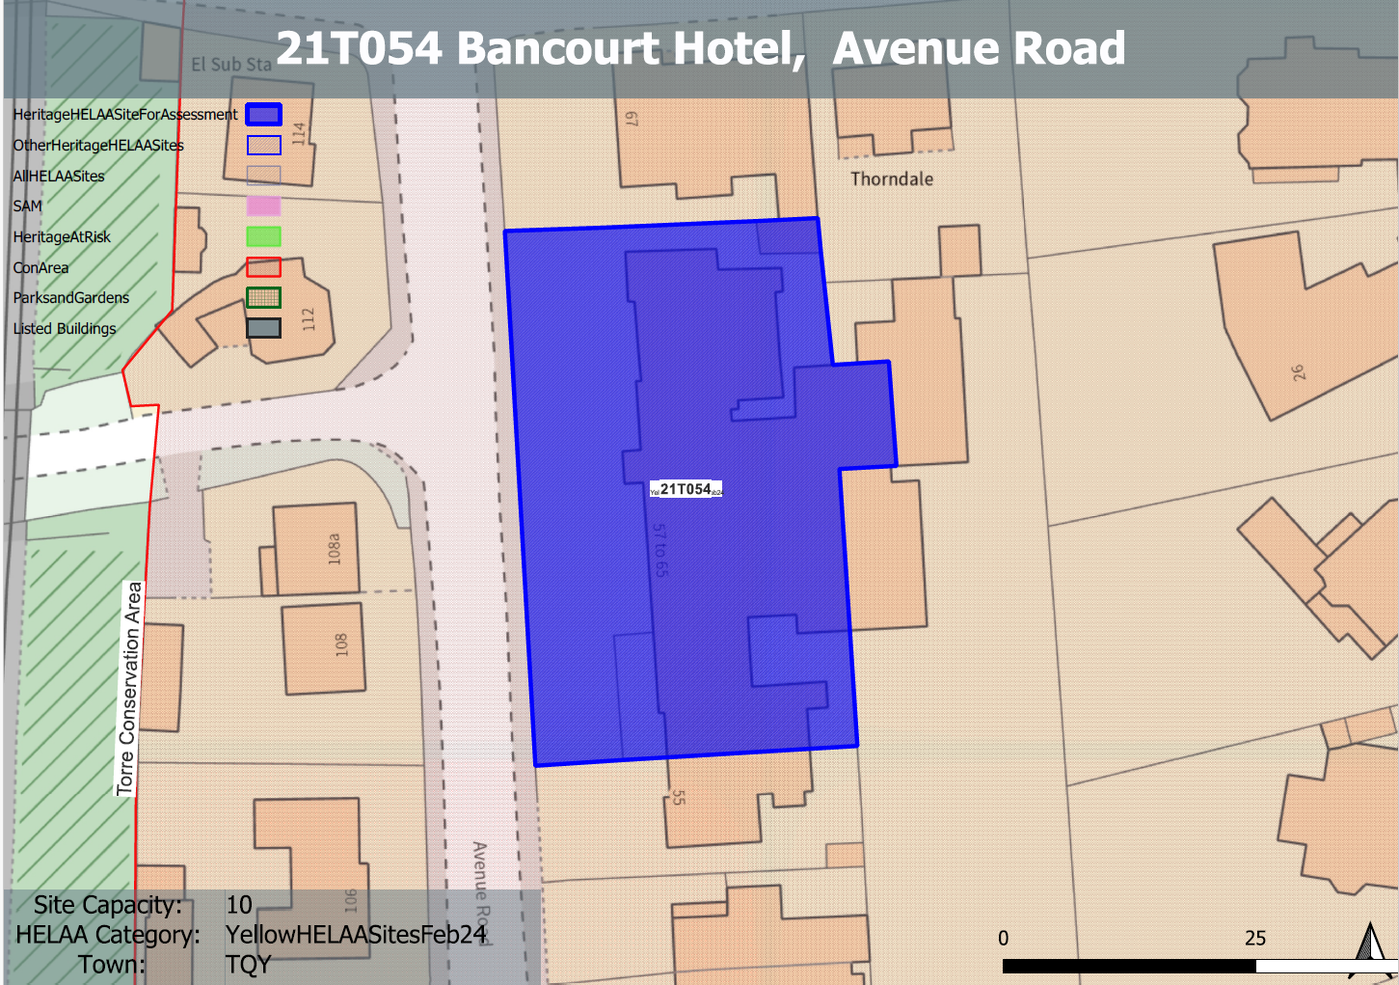

**Site overview and heritage context:**

The site is relatively level and is found on the east side of Avenue Road within the Torre Conservation Area, it is accessed directly from Avenue Road.

The building on the site is believed to date from the 20th century and is not identified as a key building within the conservation area due to it having limited architectural value. The site is currently vacant.

**Planning History:**

Various related to its hotel use.

|  |  |  |  |  |  |
| --- | --- | --- | --- | --- | --- |
| **Heritage Asset Affected by Allocation** | **Designation** | **Contributing Elements to Significance** | **Impact of Development on Significance** | **Mitigation Measures for any Identified Harm /Opportunities to Enhance Significance** | **Impact on Significance with Mitigation in place** |
| Torre Conservation Area | Conservation Area | The Torre Conservation Area significance predominantly derives from its overall planned layout from the late 1850s onwards and its resultant attractive townscape and associated vistas, building groups and survival of architectural detailing and street furniture. The site is not identified as making a positive contribution to the significance of the conservation area. | The redevelopment of the site which is a sensitive to its historic surroundings with regards to scale, massing, layout and overall design would enhance the character and appearance of the site and would make a positive contribution to the significance of the conservation area. | n/a | Minor positive |