Heritage Impact Assessment: Dainton Storage Yard (Torre Station), Torquay
HELAA2021 Ref: | 21T053
Site Address: | Dainton Storage Yard (Torre Station), Torquay
Site Area (ha): | 1.37
Site Yield: | 30
HIA Assessment

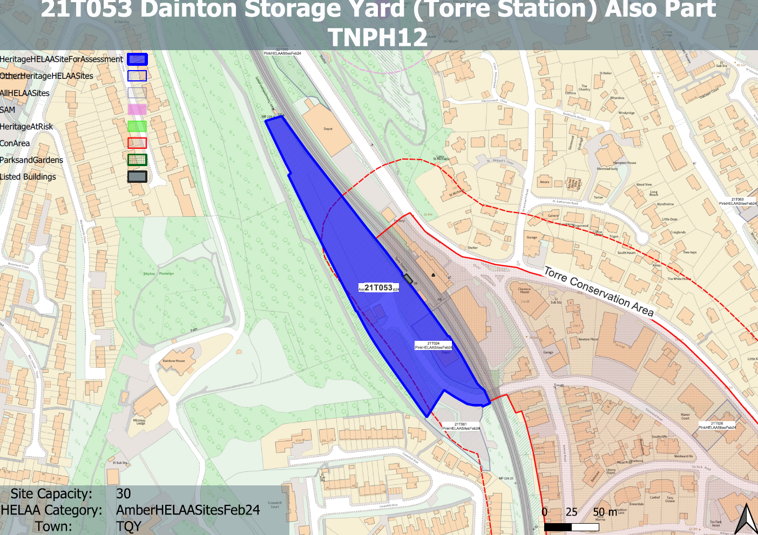
Site overview and heritage context:
Land located to the west of Torre Station and the railway line. The site is enclosed by woodland to the west and north and residential development to the south. The railway line forms a hard barrier to the east.
The site is adjacent to the boundary of the Torre Conservation Area which is found to the east. Torre railway station, which is a Grade II listed building is also immediately adjacent to the site to the east.

Planning History
Various relating to its ongoing use as a self storage.

Heritage Asset Affected by Allocation | Designation | Contributing Elements to Significance | Impact of Development on Significance | Mitigation Measures for any Identified Harm /Opportunities to Enhance Significance | Impact on Significance with Mitigation in place
Torre Conservation Area (E of site)  Torre Signal Box (E of site)  Torre Railway Station including footbridge (E of site) | Conservation Area  Grade II listed building  Grade II listed building. | The special interest of the conservation area is characterized by significant views out of the area to Chapel Hill near Torre Station, the mid 19th century townscape and resultant vista and surviving elements of the historic built environment.  The site sits within the wider setting of the conservation but makes a limited contribution to its significance.  Torre Signal Box, erected in 1921, designated for its architectural interest, intactness and group value with Torre Railway Station and footbridge.  The site sits within the immediate setting of the asset and historic mapping shows there to be structures on the site which were potentially associated with the use of the railway.  The site therefore makes a positive contribution to the significance of the asset, although this has been diluted through the loss of the historic structures on the site and its current use.  Station. 1848 for Brunel's South Devon Railway, enlarged 1882.  The site sits within the immediate setting of the asset and historic mapping shows there to be structures on the site which were potentially associated with the use of the railway.  The site therefore makes a positive contribution to the significance of the asset, although this has been diluted through the loss of the historic structures on the site and its current use. | View of Chapel Hill to the north and the associated landscape are important characteristics of the conservation area and make a positive contribution to its significance. Development of the site to the quantum stated could be achieved through sensitive design which maintains the verdant backdrop of the site when looking west. This would have a neutral impact on the significance of the asset.  Development of the site to the quantum stated could be achieved through sensitive design which references the former uses of the site and its potential historic relationship with the railway. This could have a neutral to minor positive impact on its significance.  Development of the site to the quantum stated could be achieved through sensitive design which references the former uses of the site and its potential historic relationship with the railway. This could have a neutral to minor positive impact on its significance. | n/a  n/a  n/a | Neutral  Neutral/minor positive  Neutral/minor positive

