Heritage Impact Assessment: Former Bowling Green, Lymington Road, Torquay
HELAA2021 Ref: | 23T001
Site Address: | Former Bowling Green, Lymington Road, Torquay
Site Area (ha): | 0.26
Site Yield: | 10
HIA Assessment

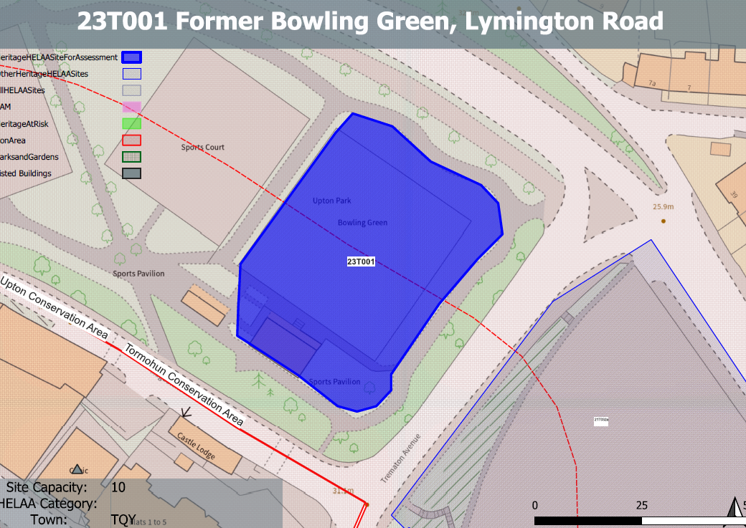
Site overview and heritage context:
The site is located within the Upton Conservation Area and close to the boundary of the Tormohun Conservation Area. It comprises a relatively flat parcel of land which is currently in recreational use as a bowling green.
A number of Grade II listed buildings can be found in an elevated position to the south of the site.

Planning History:
No relevant planning history.

Heritage Asset Affected by Allocation | Designation | Contributing Elements to Significance | Impact of Development on Significance | Mitigation Measures for any Identified Harm /Opportunities to Enhance Significance | Impact on Significance with Mitigation in place
Upton Conservation Area  Tormohun Conservation Area (S of site)  Railings, Walls and Drinking Fountain (S of site)  Castle Chambers (S of site)  The Keep, Castle Chambers (SW of site) | Conservation Area  Conservation Area  Grade II listed building  Grade II listed building  Grade II listed building | The site is an open space which was historically undeveloped but formed part of an early 20th century recreation ground which still maintains this original use. This area of open space forms part of a central spine running through the northern half of the conservation area which acts as a visual reminder of the historical evolution of the town of Torquay.  The site makes a positive contribution to the conservation area through its undeveloped state and recreational use.  The site sits within the urban setting of this asset and is an is an open space which was historically undeveloped but formed part of an early 20th century recreation ground which still maintains this original use. The areas of open space remain legible from the conservation area and are a visual reminder of the historical evolution of the town of Torquay.  The site therefore makes a positive contribution to the significance of the asset.  Railings and walls south-west, south-east and north-east of Castle Chambers including drinking fountain. Dating from 1892-93, contemporary with the rebuilding of the hospital and linked to its construction and use. The site sits within the urban setting of this asset and makes a minor positive contribution to its significance to the asset and the other group of assets associated with the former hospital.  Hospital, used as County court and now in residential use. 1850 in origin, with alterations dating from 1892-93. The site sits within the urban setting of this asset and may have had a historic relationship with the hospital, being an open space which could have been fortuitously enjoyed by patients or used to aid recovery.  The site is therefore considered to make a positive contribution to the significance of the asset.  Former dispensary associated with the hospital, constructed 1878. The building has a shared group value with Castle Chambers.  The site sits within the urban setting of the asset and forms part of the surrounding historic environment and is visual reminder of the evolution and layout of the town of Torquay. It therefore makes a minor positive contribution to the significance of the asset. | Development of the site would permanently remove open space which is a significant component of the area’s character. This would cause less than substantial harm to its significance as a heritage asset.  Development of the site would permanently remove open space which acts as a visual reminder of the historical evolution of the town of Torquay. This would cause less than substantial harm to its significance as a heritage asset.  The redevelopment of the site to the quantum proposed would have a minor detrimental impact on the significance of the asset and the group value of nearby assets associated with the former hospital use.  Development of the site would permanently remove open space which may have a historical relationship with the former use of the asset. This would cause less than substantial harm to its significance as a heritage asset.  The redevelopment of the site to the quantum proposed would have a minor detrimental impact on the significance of the asset and the group value of nearby assets associated with the former hospital use. | No mitigation measures can be identified to alleviate the harm caused by the loss of open space and its historic recreational use.  No mitigation measures can be identified to alleviate the harm caused by the loss of open space  No mitigation measures can be identified to alleviate the harm caused by the loss of open space  No mitigation measures can be identified to alleviate the harm caused by the loss of open space  No mitigation measures can be identified to alleviate the harm caused by the loss of open space | Less than substantial harm  Less than substantial harm.  Less than substantial harm.  Less than substantial harm  Less than substantial harm

