Heritage Impact Assessment: Go Kart/Park & Ride Site, Dartmouth Road, Churston
HELAA2021 Ref: | 23BCG001
Site Address: | Go Kart/Park & Ride Site, Dartmouth Road, Churston
Site Area (ha): | 3.61
Site Yield: | 20
HIA Assessment

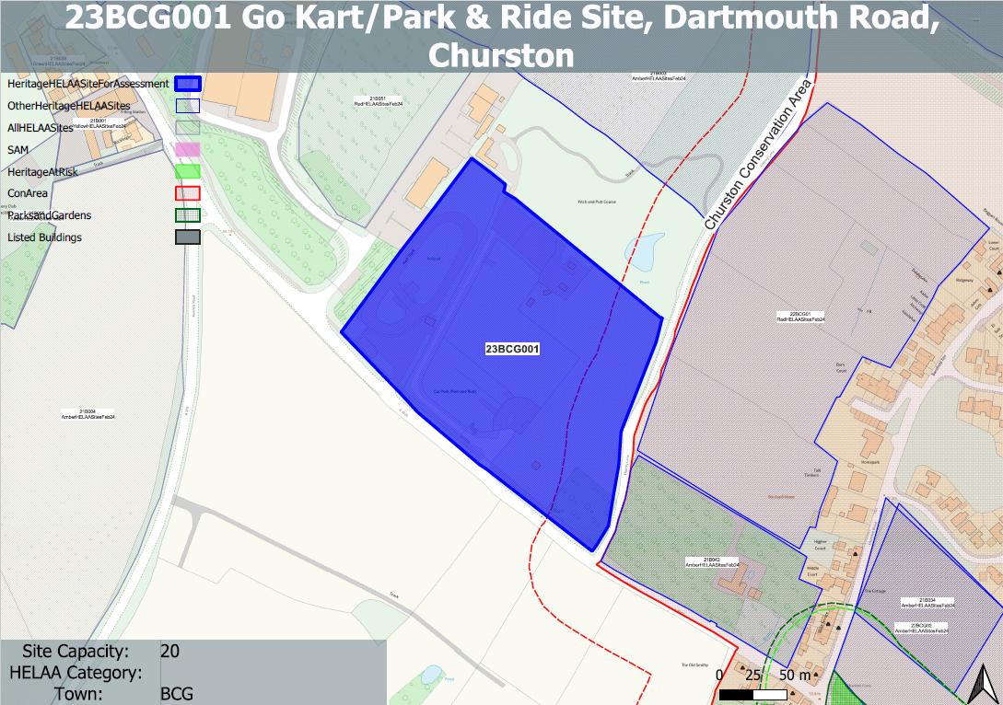
Site overview and heritage context:
Go Kart course, park and ride site and ‘Battlefield Live’ outdoor adventure site to the north of Dartmouth Road.
Site is adjacent planned medieval settlement tenement strips and therefore may have archaeological potential.
The site is adjacent to the Churston Ferrers Conservation Area to the east and is nearby to a number of other designated heritage assets

Planning History:
Various relating to the use of the various areas of the site.

Heritage Asset Affected by Allocation | Designation | Contributing Elements to Significance | Impact of Development on Significance | Mitigation Measures for any Identified Harm /Opportunities to Enhance Significance | Impact on Significance with Mitigation in place
Churston Ferrers Conservation Area (E of site) | Conservation Area | The conservation area has a ‘traditional English Village’ character set within a distinct rural setting in-between the settlements of Galmpton and Brixham. It contains a high concentration of listed buildings for a small settlement.  The site forms part of the rural setting of the conservation area as a result of its largely undeveloped form which makes a contribution to its significance. | The development of the site would have a demonstrable impact on the open, rural character of the site and the wider rural setting of the conservation area. This could cause ‘less than substantial’ harm to its significance. | A landscape-led approach which retained an open and rural character to the site when experienced from within the conservation area and in views of the conservation area could have a neutral impact on its significance. | Neutral
Lower Court (Terrace) including gate and pier to the SW (NE of site) | Grade II listed building | Terrace of 3 estate cottages. Mid C19. The site forms part of the wider rural area but makes a limited contribution to the significance of the asset. | The development of the site would have a demonstrable impact on the open, rural character of the site and the wider rural setting of the area, however, this would have a neutral impact on the significance of the asset. | n/a | Neutral
John’s Cottage Ridgeway including gate piers to NE (NE of site) | Grade II listed building | Mirrored pair of cottages. Mid C19. Abutting side wall of Ridgeway (to right) are 2 stone rubble gate piers. The site forms part of the wider rural area but makes a limited contribution to the significance of the asset. | The development of the site would have a demonstrable impact on the open, rural character of the site and the wider rural setting of the area; however, this would have a neutral impact on the significance of the asset. | n/a | Neutral
Higher Court (Terrace) including gate piers at No 1 (E of site) | Grade II listed building | Terrace of 4 estate cottages. Mid C19. Subsidiary features: at left-hand end of terrace the entrance to No.1 has 2 stone and rubble gate piers with caps built of stones on edge. The site forms part of the rural setting of the asset as a result of its largely undeveloped form which makes a contribution to its significance. | The development of the site would have a demonstrable impact on the open, rural character of the site and the wider rural setting of the asset. This could cause ‘less than substantial’ harm to its significance. | A landscape-led approach which retained an open and rural character to the site when experienced from the asset and when viewing the asset could have a neutral impact on its significance. | Neutral
West Terrace (E of site) | Grade II listed building | Terrace of 6 estate cottages. Mid/late C19. The site forms part of the wider rural area but makes a limited contribution to the significance of the asset. | The development of the site would have a demonstrable impact on the open, rural character of the site and the wider rural setting of the area, however, this would have a neutral impact on the significance of the asset. | n/a | Neutral
1-6 West Terrace front gardens, walls, gates, gate piers and railings (E of site) | Grade II listed building | 6 sets of red-brick gate piers with a single pier at the right-hand end. Mid C19, has group value with principal building. The setting of the asset is confined to its immediate surroundings and relationship with the principal building. The site makes a limited contribution to the asset’s significance. | The development of the site would have a neutral impact on the asset’s significance. | n/a | Neutral
Nos 1 and 2 including gate piers and garden wall facing Brixham Road (SE of site) | Grade II listed building | Pair of cottages built as a single range. Probably C18/C19 remodelling of an earlier building. The building occupies an important corner site, relating to groups of listed buildings in both Brixham and Churston Roads. It is shown as a single house on the Churston Ferrers tithe map of 1839. The site forms part of the wider rural area but makes a limited contribution to the significance of the asset. | The development of the site would have a demonstrable impact on the open, rural character of the site and the wider rural setting of the area, however, this would have a neutral impact on the significance of the asset. | n/a | Neutral
The Old Smithy including front garden wall, railing, gate and gate piers (S of site) | Grade II listed building | Smith's house, now a private dwelling. Dated 1870. The site forms part of the rural setting of the asset as a result of its largely undeveloped form which makes a contribution to its significance. | The development of the site would have a demonstrable impact on the open, rural character of the site and the wider rural setting of the asset. This could cause ‘less than substantial’ harm to its significance. | A landscape-led approach which retained an open and rural character to the site when experienced from within the conservation area and in views of the conservation area could have a neutral impact on its significance. | Neutral
Crossways Cottage, Orchard Cottage (S of site) | Grade II listed building | Pair of semi-detached houses, possibly a single farmhouse extended and sub-divided. Possibly C17, altered C18/C19. The site forms part of the rural setting of the asset as a result of its largely undeveloped form which makes a contribution to its significance | The development of the site would have a demonstrable impact on the open, rural character of the site and the wider rural setting of the asset. This could cause ‘less than substantial’ harm to its significance | A landscape-led approach which retained an open and rural character to the site when experienced from within the conservation area and in views of the conservation area could have a neutral impact on its significance. | Neutral
Ye Old Forge (S of site) | Grade II listed building | Forge, stable and cart shed, now a house. Probably c1870. The setting of the asset is largely confined to its immediate surroundings and relationship with surrounding assets. The site makes a limited contribution to the asset’s significance. | The development of the site would have a neutral impact on the asset’s significance. | n/a | Neutral
The Old School House (S of site) | Grade II listed building | School and schoolmaster's house, now 2 houses. Dated 1864. The site forms part of the wider rural area but makes a limited contribution to the significance of the asset. | The development of the site would have a demonstrable impact on the open, rural character of the site and the wider rural setting of the area, however, this would have a neutral impact on the significance of the asset. | n/a | Neutral
Front garden walls, gate, gate piers and railings at the Old School House (S of site) | Grade II listed building | Garden walls, gate, gate piers, and railings. 1864. The setting of the asset is confined to its immediate surroundings and relationship with the principal building. The site makes a limited contribution to the asset’s significance. | The development of the site would have a neutral impact on the asset’s significance. | n/a | Neutral

