Heritage Impact Assessment: Adj Tithe Barn Cottage, Watcombe Beach Road Torquay
HELAA2021 Ref: | 22T010
Site Address: | Adj Tithe Barn Cottage, Watcombe Beach Road Torquay
Site Area (ha): | 0.96
Site Yield: | 15
HIA Assessment

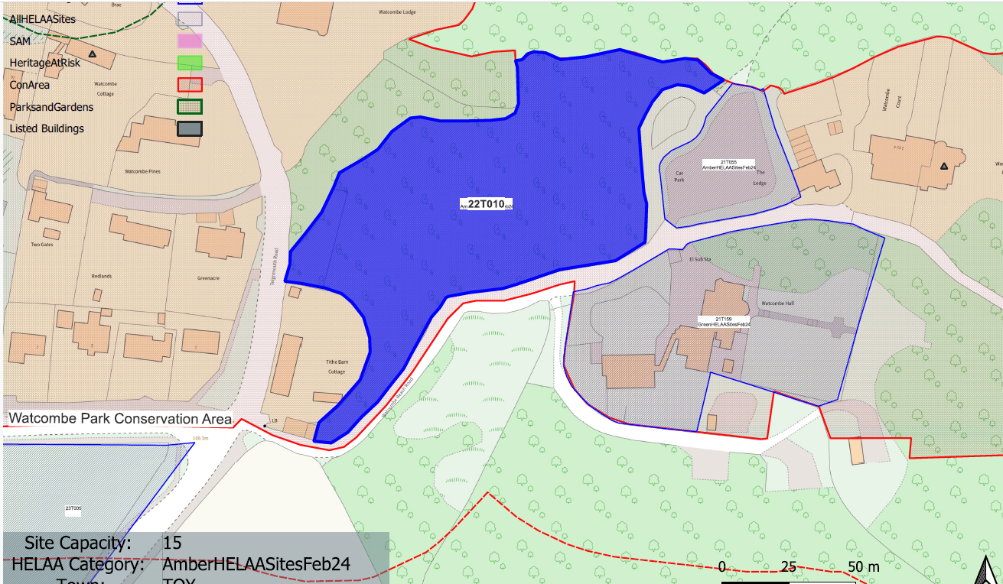
Site overview and heritage context:
Open green space sloping down towards the Watcombe Beach Car Park to the east. The site is semi-managed with significant tree cover and managed pathways. It is bounded on all sides by mature vegetation.
It is within the Watcombe Park Conservation Area and the Grade II listed building ‘Washington House’ is located around 30m to the east of the site, and the Grade II listed building ‘Lantern House and Watcombe Lodge’ is located around 130m to the northwest of the site.
The Historic Environment Record Monument identifies there being clay pits associated with Watcombe Potteries located immediately to the west of the site.

Planning History:
Various relating to Tithe Barn Cottage SW of the site.

Heritage Asset Affected by Allocation | Designation | Contributing Elements to Significance | Impact of Development on Significance | Mitigation Measures for any Identified Harm /Opportunities to Enhance Significance | Impact on Significance with Mitigation in place
Watcombe Park Conservation Area  Washington House (E of site)  Lantern House, Watcombe Lodge (N of site)  Watcombe Cottage (NW of site) | Conservation Area  Grade II listed building  Grade II listed building  Grade II listed building | The conservation area has demonstrable historic value through its association with Brunel, architectural value through the surviving historic built environment and artistic value through its designed landscape in association with Brunel Manor.  The site is a large area of open space which forms part of the rural character of the area and makes a positive contribution to the significance of the asset.  Shown on OS map as Watcombe House. Villa. 1858. Forms part of a loose-knit group of early-mid 19th century villas, some with service wings, to the southeast of Watcombe Park.  The site forms part of the rural setting of the asset which makes a positive contribution to its significance.  Villa, divided into two. c1860, on the east side of Teignmouth Road, built into the hillside. Forms part of a loose-knit group of early-mid 19th century villas, some with service wings, to the southeast of Watcombe Park.  The site forms part of the rural setting of the asset which makes a positive contribution to its significance.  Chapel, now house. Built for IK Brunel as part of his estate at Watcombe Park, now Brunel Manor (qv). c1866 but converted soon after Brunel's death to a cottage with extension to west. Forms part of a loose-knit group of early-mid 19th century villas, some with service wings, to the southeast of Watcombe Park.  The site is part of the wider setting of the asset but due to the location of the asset, makes a limited contribution to its significance. | The development of the site to the stated quantum would have a detrimental impact on the existing open space within the site and would dilute its rural character. It would also detrimentally impact on the historic pattern of development within this part of the conservation area which is for large villas located within substantial plots. This would cause less than substantial harm to the significance of the conservation area.  The development of the site to the stated quantum would have a detrimental impact on the existing open space within the site and would dilute its rural character. It would also detrimentally impact on the historic pattern of development within this area which is for large villas located within substantial plots. This would cause less than substantial harm to the significance of the asset.  The development of the site to the stated quantum would have a detrimental impact on the existing open space within the site and would dilute its rural character. It would also detrimentally impact on the historic pattern of development within this area which is for large villas located within substantial plots. This would cause less than substantial harm to the significance of the asset.  The development of the site to the stated quantum would have a detrimental impact on the existing open space within the site and would dilute its rural character. It would also detrimentally impact on the historic pattern of development within this area which is for large villas located within substantial plots. However, this would only have a neutral impact on the significance of the asset. | A reduction in the quantum of development to one or two dwellings set within substantial grounds which would retain the rural character of the site could reduce the level of harm to result in a neutral impact.  A reduction in the quantum of development to one or two dwellings set within substantial grounds which would retain the rural character of the site could reduce the level of harm to result in a neutral impact.  A reduction in the quantum of development to one or two dwellings set within substantial grounds which would retain the rural character of the site could reduce the level of harm to result in a neutral impact.  n/a | Neutral  Neutral  Neutral  Neutral

