Which bike is right for your commuter journey?

Any bicycle will get you to your destination, but if you are looking for a new bike to commute on, which is best for your circumstances.

- think about your ride - all smooth tarmac or some country lanes to negotiate?
- do you want to use the bike with your family at the weekends or is it strictly for commuting?
- are you carrying work around with you - a laptop perhaps?
- are you likely to ride all year round - rain or shine?

Electric: good for short distance and the less-fit or physically able rider.
Tourer: comes with mudguards/pannier rack. Great for serious commuter and keeping clean.
29 inch Flat-bar road bike: Fast, good riding position for use in traffic.
Race bike: very quick and could cover big distances without leaving you too tired.
26 inch Flat-bar road bike: good for a mixed route and light as well.
Folding: great for short commutes and you can stash it by your desk if necessary.

Mountain bike: good if you use a byway to get to work. Tyre choice is important if using on road.

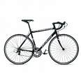
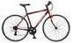
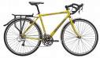
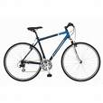
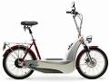
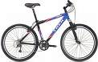
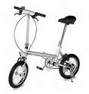
Distance: as far as you like!
+: fast and light.
-: at the mercy of the weather, slightly fragile.
Distance: as far as you like!
+: tough, can carry heavy loads.
-: looks, image.
Distance: any
+: good visibility.
-: not quite as tough as a 26 inch bike.
Distance: any
+: comfort, good riding position.
-: not as quick as a racing bike
Distance: any
+: tough, good riding position
-: slow on road
Distance: up to five miles.
+: less effort
-: recharging, heavy if battery flat!
Distance: up to three miles.
+: small, easy storage.
-: slow.

