Heritage Impact Assessment: Torbay Hospital, Torquay
HELAA2021 Ref: | 22T002
Site Address: | Torbay Hospital, Torquay
Site Area (ha): | 19.62
Site Yield: | 50
HIA Assessment

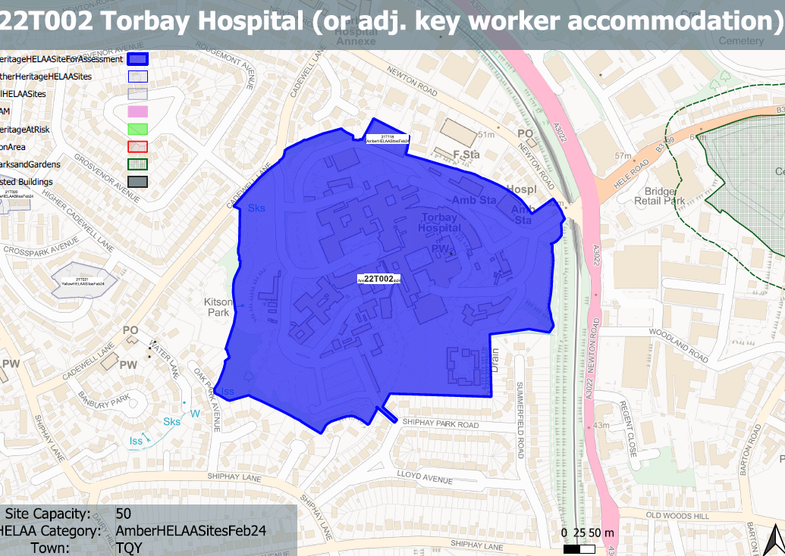
Site overview and heritage context:
The larger Torbay Hospital site on the western outskirts of Torbay near to the residential areas of Shiphay and Edginswell and is occupied by a large number of building associated with the use of the site as the principal hospital for the surrounding area.
The site sits in an elevation position and is a prominent feature in the local area. Buildings on the site are a variety of heights, scales and ages.
Central to the site is the original hospital building constructed in the mid 19th century and later expanded. This is considered a non-designated heritage asset. Also within the site is the Grade II listed Torbay Hospital Chapel.

Planning History:
Various planning history related to the use of the hospital

Heritage Asset Affected by Allocation | Designation | Contributing Elements to Significance | Impact of Development on Significance | Mitigation Measures for any Identified Harm /Opportunities to Enhance Significance | Impact on Significance with Mitigation in place
Torbay Hospital Chapel  Original Torbay Hospital Building | Grade II listed building  Non-designated heritage asset | Chapel associated with the use of the hospital, believed to be constructed in the late 1920s in a late 17th century puritan style. It has clear architectural, historic and communal value.  Originally constructed in the mid 19th century and later extended, the original hospital wing retains much of its architectural detailing and form and sites centrally as a focal point within the site. It has a tangible relationship with the nearby chapel and has clear architectural, historic and communal value. | Redevelopment of the parts of the site could be achieved within existing structures or within areas of the site which have a limited relationship with the asset. This would have a neutral impact on its significance.  Redevelopment of the parts of the site could be achieved within existing structures or within areas of the site which have a limited relationship with the asset. This would have a neutral impact on its significance. | The sensitive redevelopment of the site could be used to improve the quality of the built environment surrounding the asset which could further reveal the significance of the asset.  The sensitive redevelopment of the site could be used to improve the quality of the built environment surrounding the asset which could further reveal the significance of the asset. This coupled with the potential sensitive conversion of this element of the site, could be used as an opportunity to secure its long-term future whilst retaining its values as a non-designated heritage asset. | Enhancement  Enhancement

