Heritage Impact Assessment: Part Elberry Farm, Broadsands
HELAA2021 Ref: | 22BCG003a
Site Address: | Part Elberry Farm, Broadsands
Site Area (ha): | 1.74
Site Yield: | 20
HIA Assessment

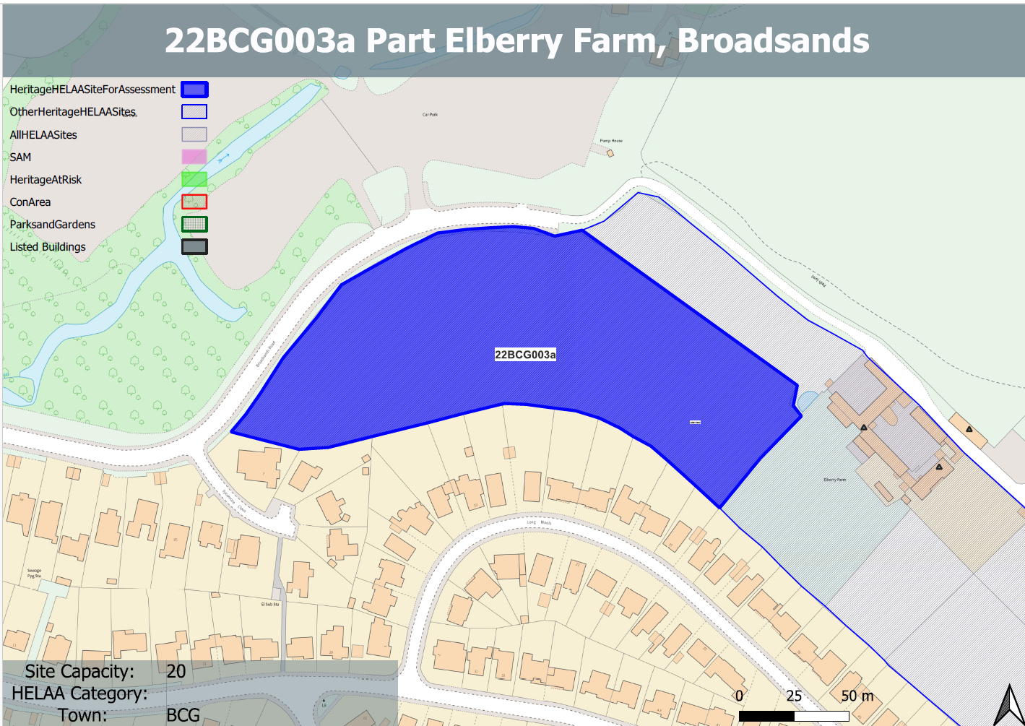
Site overview and heritage context:
A large open field in agricultural use, relatively level across the site with the land being elevated above Broadsands Road to the north and west.
The site is bounded by hedgerow, which backs onto residential gardens to the south and Broadsands Road to the west. Immediately to the north and east of the site are the grounds of Elberry Farm, a Grade II listed farmstead which is in use also a bed and breakfast.
The site has a small access to Broadsands Road in the SW corner of the plot.

Planning History:
No relevant planning history

Heritage Asset Affected by Allocation | Designation | Contributing Elements to Significance | Impact of Development on Significance | Mitigation Measures for any Identified Harm /Opportunities to Enhance Significance | Impact on Significance with Mitigation in place
Elberry Farmhouse including front garden walls (E of site) | Grade II listed building | Farmhouse mid 19th century with principal elevation facing SE towards a walled garden. The house is part of a planned layout including 2 courtyards of farm buildings and a cart shed. The site appears to have a historical and physical connection with the Elberry farmstead and therefore makes a clear contribution to its significance. | The introduction of built development on the site which has a physical and historical relationship with the asset would cause less than substantial harm to its significance. | A reduced quantum of development sited and limited to the SW corner of the site with an appropriate landscape buffer provided to the asset may reduce the level of harm caused. However, any development on the site would represent an encroachment on the historical agricultural setting of the asset which would be harmful to its significance. | Less than substantial harm
Farm buildings to NE and NW of Elberry Farmhouse including walls, gates and piers (E of site) | Grade II listed building | Farm buildings mid 19th century. he farmstead, including its farmhouse and cart shed is an interesting example of a planned layout not often found in Devon, particularly in so good a state of preservation. It occupies an important position on a public path close to Broadsands Beach and is clearly visible from Broadsands Road. The site appears to have a historical and physical connection with the Elberry farmstead and therefore makes a clear contribution to its significance. | The introduction of built development on the site which has a physical and historical relationship with the asset would cause less than substantial harm to its significance. | A reduced quantum of development sited and limited to the SW corner of the site with an appropriate landscape buffer provided to the asset may reduce the level of harm caused. However, any development on the site would represent an encroachment on the historical agricultural setting of the asset which would be harmful to its significance. | Less than substantial harm
Cart Shed immediately NE of Elberry Farmhouse (NE of site) | Grade II listed building | Open fronted cart shed, mid 19th century. The cart shed is functionally related to the farmstead, in which the house and farm buildings form a tightly-knit layout | The introduction of built development on the site which has a physical and historical relationship with the asset would cause less than substantial harm to its significance. | A reduced quantum of development sited and limited to the SW corner of the site with an appropriate landscape buffer provided to the asset may reduce the level of harm caused. However, any development on the site would represent an encroachment on the historical agricultural setting of the asset which would be harmful to its significance. | Less than substantial harm

