**Heritage Impact Assessment:** Land East of Ferrers Green

|  |  |
| --- | --- |
| **HELAA2021 Ref:** | 22BCG002 |
| **Site Address:** | Land Eest of Ferrers Green |
| **Site Area (ha):** | 6.66 |
| **Site Yield:** | 30 |
| **HIA Assessment** |  |

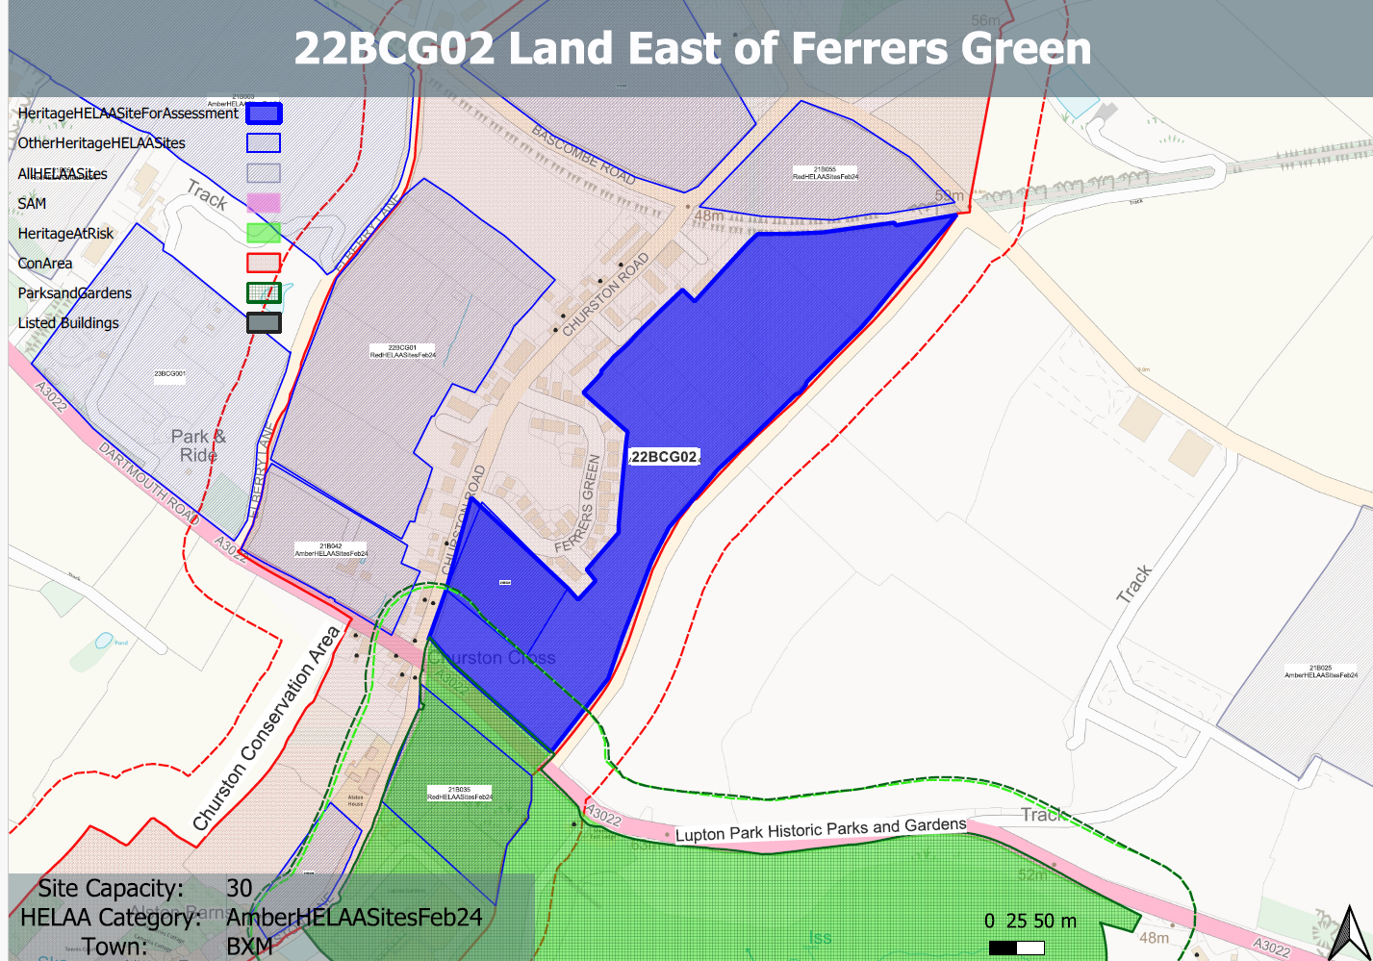 **Site overview and heritage context:**

Fields adjoining the rear of properties on Ferrers Green and Churston Road. The site is currently laid to pasture and separated into individual fields by mature hedgerows and vegetation.

The site includes modern enclosures adapting medieval fields and is within planned medieval settlement tenement strips and therefore has high archaeological potential.

The site is within the Churston Ferrers Conservation Area and is nearby to a number of other designated heritage assets

**Planning History:**

No relevant planning history

|  |  |  |  |  |  |
| --- | --- | --- | --- | --- | --- |
| **Heritage Asset Affected by Allocation** | **Designation** | **Contributing Elements to Significance** | **Impact of Development on Significance** | **Mitigation Measures for any Identified Harm /Opportunities to Enhance Significance** | **Impact on Significance with Mitigation in place** |
| Churston Ferrers Conservation Area | Conservation Area | The conservation area has a ‘traditional English Village’ character set within a distinct rural setting in-between the settlements of Galmpton and Brixham. It contains a high concentration of listed buildings for a small settlement.  The site represents former medieval tenement strips which make a clear contribution to the historical and archaeological value of the conservation area as well as its rural characteristics. | The development of the site to the quantum stated would have a demonstrable impact on the open, rural character of the site and the wider conservation area and would likely significantly dilute the readability of the former medieval tenement strips, although this has been diluted through the presence of the Ferrers Grn and other 20th century development. This would cause ‘less than substantial’ harm to its significance. | Any built development on the site would have a demonstrable impact on the open, rural character of the site, the readability of the former medieval tenement strips and the wider conservation area. This would cause ‘less than substantial’ harm to its significance. This is unlikely to be mitigated to the point where harm can be removed. | Less than substantial harm. |
| Avenue Terrace 1-7, Churston Road (W of site) | Grade II listed building | A row of mid 19th century estate cottages. The site includes former medieval tenement strips which denote the historical evolution of the village of which the asset forms a part. The site therefore makes a positive contribution to its significance. | The development of the site to the quantum stated would have a demonstrable impact on the open, rural character of the site and would likely significantly dilute the readability of the former medieval tenement strips although this has been diluted through the presence of the Ferrers Grn and other 20th century development. This would cause ‘less than substantial’ harm to the significance of the asset. | Any built development on the site would have a demonstrable impact on the open, rural character of the site and the readability of the former medieval tenement strips. This would cause ‘less than substantial’ harm to its significance. This is unlikely to be mitigated to the point where harm can be removed. | Less than substantial harm. |
| Myrtle Cottage (W of site) | Grade II listed building | Mid 19th century cottage. The site includes former medieval tenement strips which denote the historical evolution of the village of which the asset forms a part. The site therefore makes a positive contribution to its significance. | The development of the site to the quantum stated would have a demonstrable impact on the open, rural character of the site and would likely significantly dilute the readability of the former medieval tenement strips although this has been diluted through the presence of the Ferrers Grn and other 20th century development. This would cause ‘less than substantial’ harm to the significance of the asset. | Any built development on the site would have a demonstrable impact on the open, rural character of the site and the readability of the former medieval tenement strips. This would cause ‘less than substantial’ harm to its significance. This is unlikely to be mitigated to the point where harm can be removed. | Less than substantial harm. |
| Lower Court (Terrace) including gate and pier to the SW (W of site) | Grade II listed building | Terrace of 3 estate cottages. Mid C19. The site includes former medieval tenement strips which denote the historical evolution of the village of which the asset forms a part. The site therefore makes a positive contribution to its significance. | The development of the site to the quantum stated would have a demonstrable impact on the open, rural character of the site and would likely significantly dilute the readability of the former medieval tenement strips although this has been diluted through the presence of the Ferrers Grn and other 20th century development. This would cause ‘less than substantial’ harm to the significance of the asset | Any built development on the site would have a demonstrable impact on the open, rural character of the site and the readability of the former medieval tenement strips. This would cause ‘less than substantial’ harm to its significance. This is unlikely to be mitigated to the point where harm can be removed | Less than substantial harm. |
| John’s Cottage Ridgeway including gate piers to NE (W of site) | Grade II listed building | Mirrored pair of cottages. Mid C19. Abutting side wall of Ridgeway (to right) are 2 stone rubble gate piers. The site includes former medieval tenement strips which denote the historical evolution of the village of which the asset forms a part. The site therefore makes a positive contribution to its significance. | The development of the site to the quantum stated would have a demonstrable impact on the open, rural character of the site and would likely significantly dilute the readability of the former medieval tenement strips although this has been diluted through the presence of the Ferrers Grn and other 20th century development. This would cause ‘less than substantial’ harm to the significance of the asset | Any built development on the site would have a demonstrable impact on the open, rural character of the site and the readability of the former medieval tenement strips. This would cause ‘less than substantial’ harm to its significance. This is unlikely to be mitigated to the point where harm can be removed | Less than substantial harm. |
| Higher Court (Terrace) including gate piers at No 1 (W of site) | Grade II listed building | Terrace of 4 estate cottages. Mid C19. Subsidiary features: at left-hand end of terrace the entrance to No.1 has 2 stone and rubble gate piers with caps built of stones on edge. The site forms part of the immediate setting of the asset and the former medieval tenement strips denote the historical evolution of the village of which the asset forms a part. The site therefore makes a positive contribution to its significance | The development of the site to the quantum stated would have a demonstrable impact on the open, rural character of the site and would likely significantly dilute the readability of the former medieval tenement strips although this has been diluted through the presence of the Ferrers Grn and other 20th century development. This would cause ‘less than substantial’ harm to the significance of the asset | Any built development on the site would have a demonstrable impact on the open, rural character of the site and the readability of the former medieval tenement strips. This would cause ‘less than substantial’ harm to its significance. This is unlikely to be mitigated to the point where harm can be removed | Less than substantial harm. |
| West Terrace (W of site) | Grade II listed building | Terrace of 6 estate cottages. Mid/late C19. The site forms part of the immediate rural setting of the asset and the former medieval tenement strips denote the historical evolution of the village of which the asset forms a part. The site therefore makes a positive contribution to its significance. | The development of the site to the quantum stated would have a demonstrable impact on the open, rural character of the site and would likely significantly dilute the readability of the former medieval tenement strips although this has been diluted through the presence of the Ferrers Grn and other 20th century development. This would cause ‘less than substantial’ harm to the significance of the asset | Any built development on the site would have a demonstrable impact on the open, rural character of the site and the readability of the former medieval tenement strips. This would cause ‘less than substantial’ harm to its significance. This is unlikely to be mitigated to the point where harm can be removed | Less than substantial harm. |
| 1-6 West Terrace front gardens, walls, gates, gate piers and railings (W of site) | Grade II listed building | 6 sets of red-brick gate piers with a single pier at the right-hand end. Mid C19, has group value with principal building. The setting of the asset is confined to its immediate surroundings and relationship with the principal building. The site makes a limited contribution to the asset’s significance. | The development of the site would have a neutral impact on the asset’s significance. | n/a | Neutral |
| Nos 1 and 2 including gate piers and garden wall facing Brixham Road (SW of site) | Grade II listed building | Pair of cottages built as a single range. Probably C18/C19 remodelling of an earlier building. The building occupies an important corner site, relating to groups of listed buildings in both Brixham and Churston Roads. It is shown as a single house on the Churston Ferrers tithe map of 1839. The site forms part of the immediate rural setting of the asset and the former medieval tenement strips denote the historical evolution of the village of which the asset forms a part. The site therefore makes a positive contribution to its significance. | The development of the site to the quantum stated would have a demonstrable impact on the open, rural character of the site and would likely significantly dilute the readability of the former medieval tenement strips although this has been diluted through the presence of the Ferrers Grn and other 20th century development. This would cause ‘less than substantial’ harm to the significance of the asset | Any built development on the site would have a demonstrable impact on the open, rural character of the site and the readability of the former medieval tenement strips. This would cause ‘less than substantial’ harm to its significance. This is unlikely to be mitigated to the point where harm can be removed | Less than substantial harm. |
| The Old Smithy including front garden wall, railing, gate and gate piers (SW of site) | Grade II listed building | Smith's house, now a private dwelling. Dated 1870. The site is somewhat separated from the asset, however, the contribution of the site in its undeveloped form to the historical evolution of the village in which the asset is a part of does make a contribution to the historic value of the asset and therefore its significance. | The development of the site to the quantum stated would have a demonstrable impact on the open, rural character of the site and would likely significantly dilute the readability of the former medieval tenement strips although this has been diluted through the presence of the Ferrers Grn and other 20th century development. This would cause ‘less than substantial’ harm to the significance of the asset. | Any built development on the site would have a demonstrable impact on the open, rural character of the site and the readability of the former medieval tenement strips. This would cause ‘less than substantial’ harm to its significance. This is unlikely to be mitigated to the point where harm can be removed | Less than substantial harm. |
| Crossways Cottage, Orchard Cottage (SW of site) | Grade II listed building | Pair of semi-detached houses, possibly a single farmhouse extended and sub-divided. Possibly C17, altered C18/C19. The contribution of the site in its undeveloped form to the historical evolution of the village in which the asset is a part of does make a contribution to the historic value of the asset and therefore its significance. It also forms part of its wider rural setting. | The development of the site to the quantum stated would have a demonstrable impact on the open, rural character of the site and would likely significantly dilute the readability of the former medieval tenement strips although this has been diluted through the presence of the Ferrers Grn and other 20th century development. This would cause ‘less than substantial’ harm to the significance of the asset. | Any built development on the site would have a demonstrable impact on the open, rural character of the site and the readability of the former medieval tenement strips. This would cause ‘less than substantial’ harm to its significance. This is unlikely to be mitigated to the point where harm can be removed | Less than substantial harm. |
| Ye Old Forge (SW of site) | Grade II listed building | Forge, stable and cart shed, now a house. Probably c1870. The setting of the asset is largely confined to its immediate surroundings and relationship with surrounding assets. The site makes a limited contribution to the asset’s significance. | The development of the site would have a neutral impact on the asset’s significance. | n/a | Neutral |
| The Old School House (SW of site) | Grade II listed building | School and schoolmaster's house, now 2 houses. Dated 1864. The contribution of the site in its undeveloped form to the historical evolution of the village in which the asset is a part of does make a contribution to the historic value of the asset and therefore its significance. It also forms part of its wider rural setting. | The development of the site to the quantum stated would have a demonstrable impact on the open, rural character of the site and would likely significantly dilute the readability of the former medieval tenement strips although this has been diluted through the presence of the Ferrers Grn and other 20th century development. This would cause ‘less than substantial’ harm to the significance of the asset. | Any built development on the site would have a demonstrable impact on the open, rural character of the site and the readability of the former medieval tenement strips. This would cause ‘less than substantial’ harm to its significance. This is unlikely to be mitigated to the point where harm can be removed | Less than substantial harm. |
| Front garden walls, gate, gate piers and railings at the Old School House (SW of site) | Grade II listed building | Garden walls, gate, gate piers, and railings. 1864. The setting of the asset is confined to its immediate surroundings and relationship with the principal building. The site makes a limited contribution to the asset’s significance. | The development of the site would have a neutral impact on the asset’s significance. | n/a | Neutral |
| Lupton Park (S of site) | Grade II* Historic Park and Garden | A late C18 parkland landscape and mid C19 formal gardens associated with a late C18 mansion remodelled in the mid C19. A mid C20 country house designed by Oswald Milne is set in mid C20 formal gardens within the park. The site forms part of the wider setting of the asset which makes a minor positive contribution to its significance. | The development of the site to the quantum stated would have a demonstrable impact on the open, rural character of the site which could cause a degree of ‘less than substantial’ harm to the significance of the asset. | A reduction in the quantum of development and the siting of any built form and associated infrastructure away from the southern parcel of the site may reduce the level of harm to the asset to the point where it would have a neutral impact. | Neutral |