Heritage Impact Assessment: Oxen/Freshwater Cove, Brixham
HELAA2021 Ref: | 22B002
Site Address: | Oxen/Freshwater Cove, Brixham
Site Area (ha): | 1.82
Site Yield: | Employment
HIA Assessment

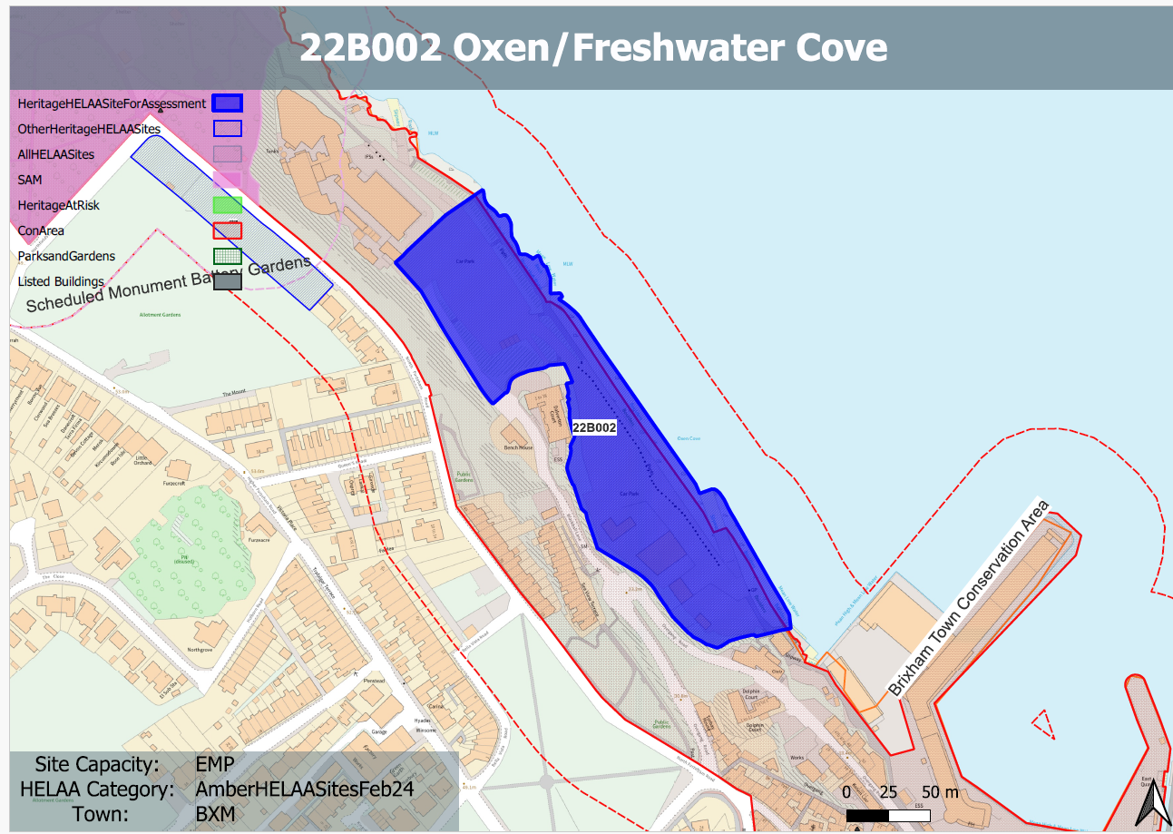
Site overview and heritage context:
The site comprises the Oxen Cove car park and various buildings used for storage. The South West Coast Path runs along the eastern boundary of the site running north to south. The sea is in close proximity to the east, to the west is a substantial cliff face, Brixham port can be found to the south.
The site was formally a quarry and is within the Brixham Town Conservation Area, the Brixham Battery Gardens, a Scheduled Monument can be found to the north of the site.

Planning History:
Various relating to the existing uses on the site.

Heritage Asset Affected by Allocation | Designation | Contributing Elements to Significance | Impact of Development on Significance | Mitigation Measures for any Identified Harm /Opportunities to Enhance Significance | Impact on Significance with Mitigation in place
Brixham Town Conservation Area  Brixham Battery Gardens (N of site) | Conservation Area  Scheduled Monument | The conservation area evidences the origins of Brixham Town as a  small fishing port and naval supply station, and its rapid growth in the 19th century. It is notable for the number of surviving 18th, 19th and early 20th-century terraces. There are many other  attractive historic buildings which tell the story of Brixham’s industrial past and its evolution over the course of the 19th century.  The site sits inside of the conservation and is identified as an important green space.  The monument includes the standing and below ground remains of the World War II Emergency Battery set up in 1940 to protect the Brixham harbourage, and the remains of an earlier 19th century practice battery.  The site forms part of the wider coastal setting of the asset but makes a neutral impact on its significance. | The development of the site for employment uses would likely have a detrimental impact to the conservation area if development imposes upon the South West Coast Path, the open space and the legibility of the historic quarries on the site. This would likely result in less than substantial harm to the significance of the conservation area.  The development of the site for employment uses would have a neutral impact on the significance of the asset. | Sensitive development which maintains open space within the site, safeguards the South West Coast Path and retains the legibility of the former quarrying would likely reduce the impact of the development to a neutral level.  n/a | Neutral  Neutral

