Heritage Impact Assessment: Land North of Steep Hill, Maidencombe, Torquay
HELAA2021 Ref: | 21T157
Site Address: | Land North of Steep Hill, Maidencombe, Torquay
Site Area (ha): | 1.62
Site Yield: | 15
HIA Assessment

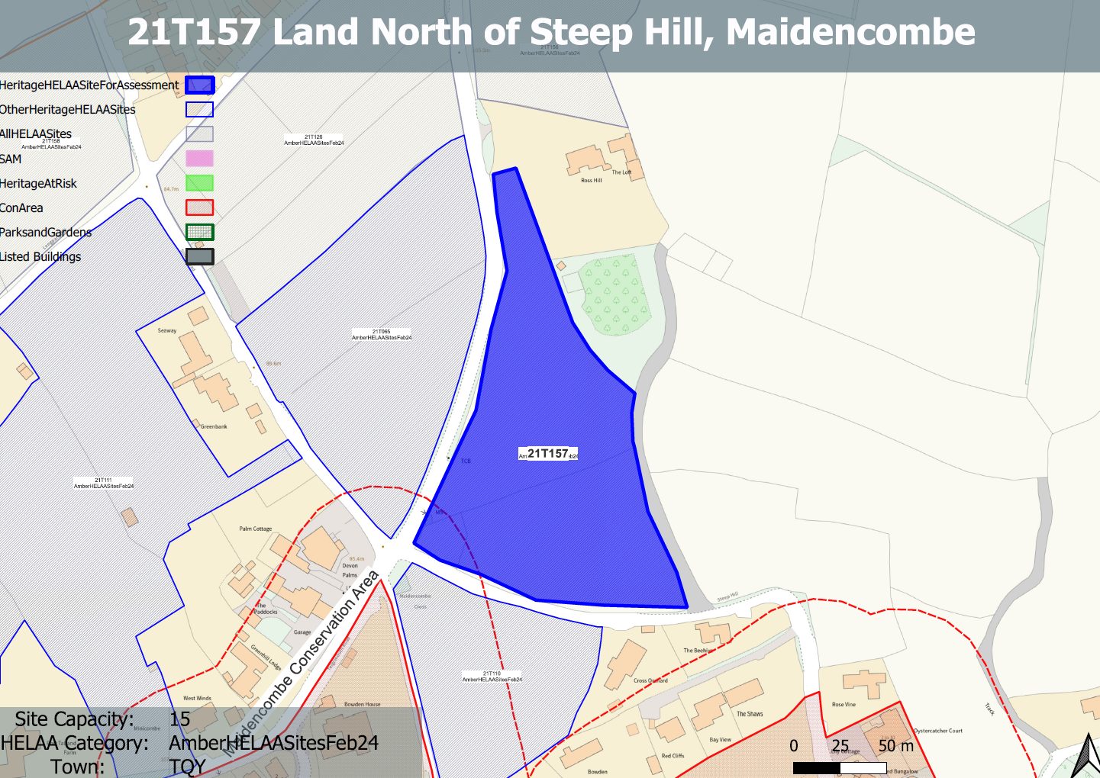
Site overview and heritage context:
The site is a piece of undeveloped land on the northern edge of Maidencombe to the north of Steep Hill and east of Teignmouth Road. The site is split into 2 distinct parts separated by an established hedgerow running east to west. The southern parcel of the site is steeply sloped up to a ridge north of the bisecting hedgerow. The northern parcel of the site has a gentler slope with the its highest point being on the northern boundary.
The site sits outside but fall within the rural setting of the Maidencombe Conservation Area and a selection of listed buildings found within it.

Planning History:
No planning history.

Heritage Asset Affected by Allocation | Designation | Contributing Elements to Significance | Impact of Development on Significance | Mitigation Measures for any Identified Harm /Opportunities to Enhance Significance | Impact on Significance with Mitigation in place
Maidencombe Conservation Area  Brimhill  (W of site) | Conservation Area  Grade II listed building | The conservation area comprises two distinct areas; the original settlement and historic hamlet, which is mostly grouped around Rock House Lane and Steep Hill, and a scattering of 19th century villas in landscaped grounds to the north. The steeply sloping wooded hillsides create an imposing skyline which encloses the  village, especially to the south and west including the large expanse of Sladnor Park.  The character of much of the conservation area hinges upon its ability to retain the  strong sense of geographical isolation and historic continuity in a setting of great natural  beauty and landscape importance. The landscape value of the conservation area and its rural surroundings is a key special characteristic. The site, sits to the north of the conservation area and makes a minor positive contribution to its significance.  Villa constructed in the 1830s. The site forms part of the wider rural and historic setting of the asset and makes a limited contribution to its significance. | The development of the site and the urban spread of the settlement would have a detrimental impact on the rural character of the conservation area. This would cause less than substantial harm to the significance of the asset.  Development on the site could have a small impact on the rural setting of the asset, the degree of impact would be dependent on the scale, massing, appearance and layout of the proposal along with any associated infrastructure. This may cause a very minor degree of harm to its significance. | A substantially reduced quantum of development of the northern parcel of land only which takes a landscape-led or ‘agricultural’ design approach, and which is largely hidden from its surroundings may mitigate the harm caused to the character of the conservation area to a neutral level.  A small quantum of development on the northern parcel of the land would likely mitigate the small level of harm to the point where the development would have a neutral impact to the asset. | Neutral  Neutral

