Heritage Impact Assessment: Torquay Golf Club, Torquay
HELAA2021 Ref: | 21T147
Site Address: | Torquay Golf Club, Torquay
Site Area (ha): | 31.2
Site Yield: | 250
HIA Assessment

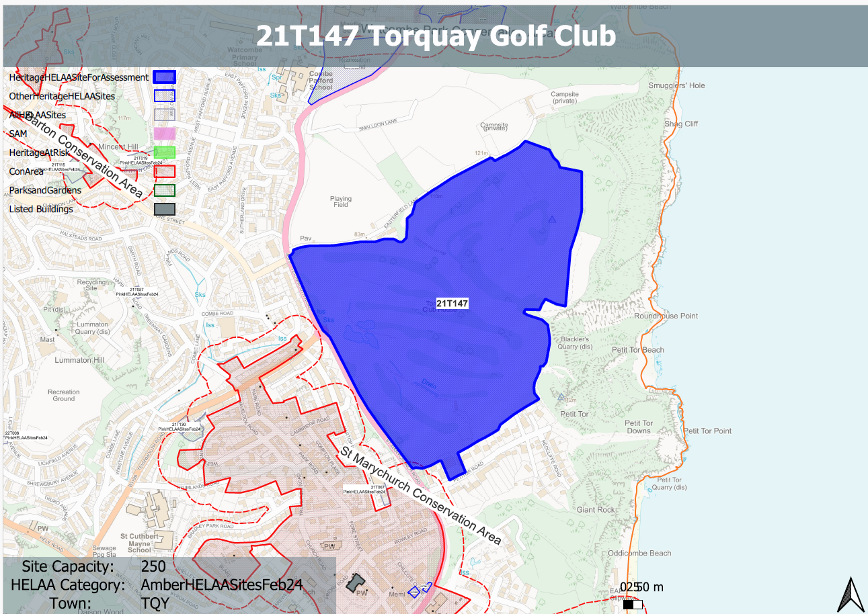
Site overview and heritage context:
Torquay Golf Course to the west of St Marychurch/Teignmouth Road, and north of Petitor Road. The site has historically remain undeveloped and was formally a race course.
The site is located to the east of the St Marychurch Conservation Area and sits above it in a slightly elevated position. In addition, a number of listed buildings are in relative proximity to the site, namely along Teignmouth Road and Fore Street to the west.

Planning History
None relevant

Heritage Asset Affected by Allocation | Designation | Contributing Elements to Significance | Impact of Development on Significance | Mitigation Measures for any Identified Harm /Opportunities to Enhance Significance | Impact on Significance with Mitigation in place
St Marychurch Conservation Area (W of site)  1-11 Palk Place (W of site)  15 Fore Street (W of site)  19 Fore Street (W of site)  21 Fore Street (W of site) | Conservation Area  Grade II listed building  Grade II listed building  Grade II listed building  Grade II listed building | The special interest of the conservation comprises the planned developments of 1860 onwards and prominent landmarks, the mid C19 terraced housing, historic street furniture surviving historic fabric and detailing and its elevated setting with significant outward views.  The site forms part of the rural setting to the east of the conservation area which acts as a landscape buffer between it and the sea. Parts of the site were formally a race course which had a close relationship with the town.  The site in its undeveloped form makes a positive contribution to the significance of the conservation area.  Flats, formerly public house, skittle alley and service wing. Circa mid C19. The site forms part of the wider setting of the asset and denotes the edge of settlement, it makes a neutral contribution to its significance.  Farmhouse, now house. Late C17. The site forms part of the wider setting of the asset and denotes the edge of settlement, it makes a neutral contribution to its significance.  Small house, originally one build with No.21 (qv), adjoining at left. Probably C18 or earlier in origin. The site forms part of the wider setting of the asset and denotes the edge of settlement, it makes a neutral contribution to its significance.  Small house, originally one build with No.19 (qv), adjoining at right. Probably C17 or earlier in origin. The site forms part of the wider setting of the asset and denotes the edge of settlement, it makes a neutral contribution to its significance. | Development of the site to the quantum proposed would have a clear impact on the open character of the site and its landscape value. This would cause less than substantial harm to the significance of the conservation area.  Development of the site would have a neutral impact on the significance of the asset.  Development of the site would have a neutral impact on the significance of the asset.  Development of the site would have a neutral impact on the significance of the asset.  Development of the site would have a neutral impact on the significance of the asset. | A substantial reduction in the quantum of development located towards the western and southern boundaries of the site which is designed to respect the surrounding historic environment and maintain the landscape value of the site may mitigate the impact to the conservation area to a neutral level.  n/a  n/a  n/a  n/a | Neutral  Neutral  Neutral  Neutral  Neutral

