Heritage Impact Assessment: Waste Land R/O Castle Circus House, Torquay
HELAA2021 Ref: | 21T146
Site Address: | Waste Land R/O Castle Circus House, Torquay
Site Area (ha): | 0.22
Site Yield: | 30
HIA Assessment

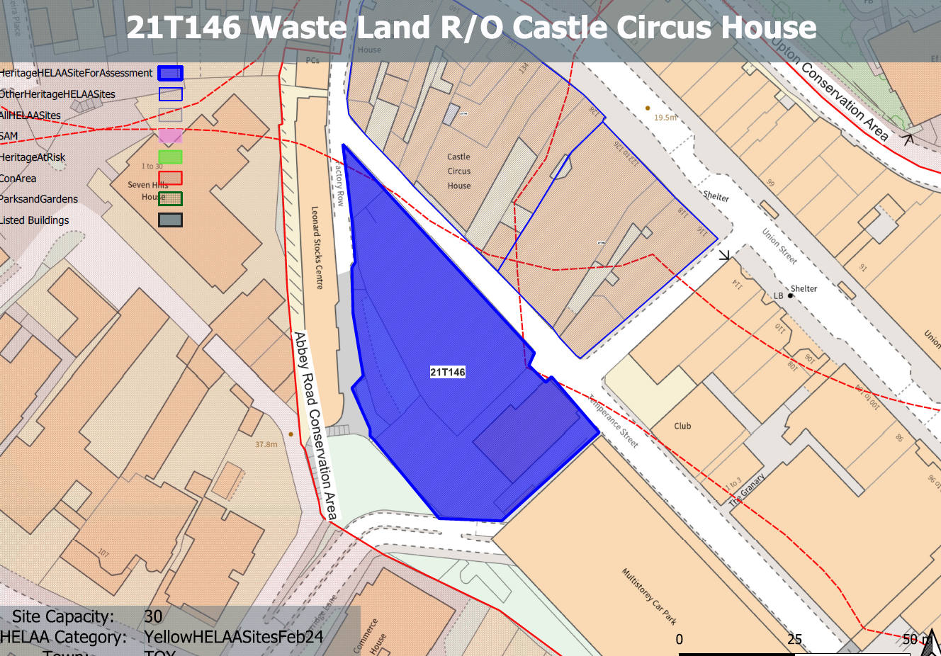
Site overview and heritage context:
The site is an irregular shaped area of land adjacent to Temperance Street and the junction with Factory Row., The site is relatively level but also includes a raised area of land adjacent to Factory Row. The surrounding land rises steeply to the west leading to Abbey Road which results in a considerable difference in ground levels between the site and surrounding areas to the west.
It currently comprises an area of hardstanding used for private parking incorporating the Torbay Community Café and Help Hub, a two-storey building fronting Temperance Street.
The site is constrained to the west by a significant change in ground levels and associated retaining structures and to all other sides by existing built development and hard urban landscaping.
The boundary to the Abbey Road Conservation Area can be found outside of the site to the west and the Upton Conservation Area is located to the north along Union Street. 2, Tor Hill Road is a Grade II listed building found to the north of the site along Factory Row.
There are potential industrial remains on the site which may be of some archaeological value.

Planning History:
P/2009/0174 - Formation of multi-agency training and enterprise centre with vehicle access/pedestrian access (in outline) – Approved 21/05/2009
Heritage Asset Affected by Allocation | Designation | Contributing Elements to Significance | Impact of Development on Significance | Mitigation Measures for any Identified Harm /Opportunities to Enhance Significance | Impact on Significance with Mitigation in place
Abbey Road Conservation Area (S and W of site)  Upton Conservation Area (N of site)  2 Tor Hill Road (N of site) | Conservation Area  Conservation Area  Grade II listed building | The conservation area is characterised by its preserved 19th century street layout and surviving elements of the historic built environment. The site sites outside of the conservation area and currently makes a neutral contribution to its urban setting and thereby its significance.  The site forms part of the urban setting of the conservation area but makes a limited contribution to its significance.  House and shop dating from the 1840s. Although the site is in relative close proximity, due to the surrounding built environment, it makes a limited contribution to its setting and therefore its significance. | The development of the site of a scale, massing and height similar to its surroundings (2/3 storeys) would have a neutral impact on the significance of the conservation area.  The development of the site of a scale, massing and height similar to its surroundings (2/3 storeys) would have a neutral impact on the significance of the conservation area.  The development of the site of a scale, massing and height similar to its surroundings (2/3 storeys) would have a neutral impact on the significance of the conservation area.  . | The sensitive development of the site which further reveled its industrial archaeology would improve the setting of the conservation area and would result in a minor enhancement to its significance.  n/a  n/a | Minor enhancement  Neutral  Neutral

