**Heritage Impact Assessment:** Former New Look, 70-82 Union Street, Torquay

|  |  |
| --- | --- |
| **HELAA2021 Ref:** | 21T141 |
| **Site Address:** | Former New Look, 70-82 Union Street, Torquay |
| **Site Area (ha):** | 0.15 |
| **Site Yield:** | 20 |
| **HIA Assessment** |  |

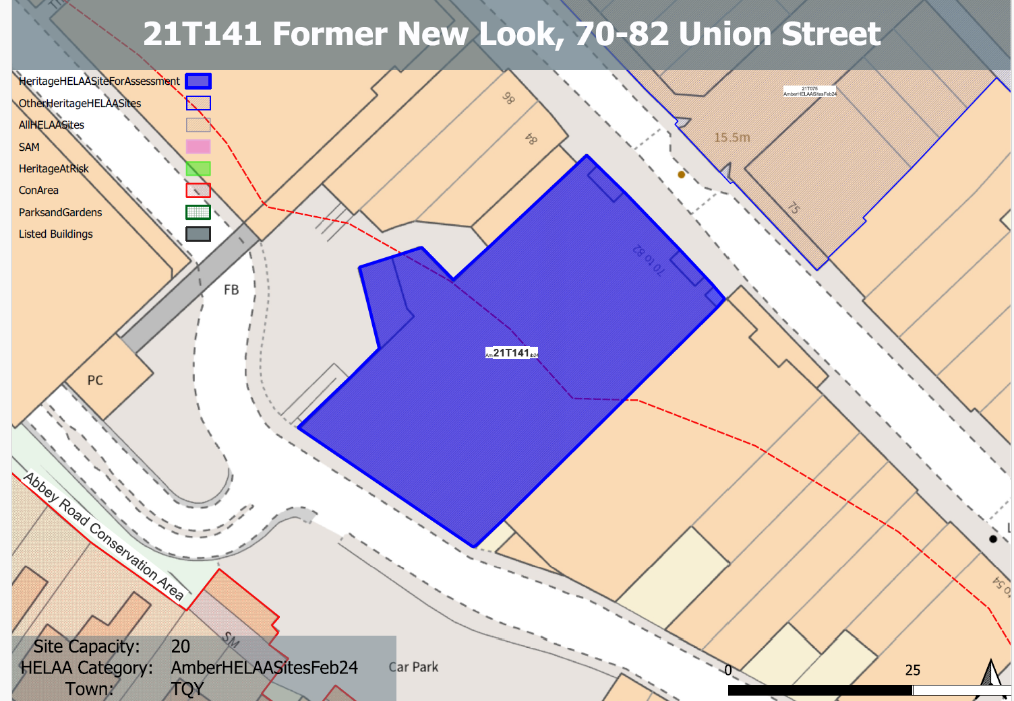 **Site overview and heritage context:**

The site can be found on the western side of Union Street, north of Market Street. The existing building on the site dates from the 2nd half of the 20th century and is in retail use (currently vacant). The modern retail premises on the site is typical of such development found within the area and presents a bold façade to Union Street and the entrance to the Union Square shopping centre opposite the site to the east, and a large, relatively blank elevation to the north and west.

Lower Union Lane is to the rear of the site which provides access to nearby car parking areas

The site is not within a designated conservation area, however, the boundary to the Abbey Road Conservation Area can be found approximately 30m to the West.

**Planning History:**

Various applications relating to the retail use of the site.

|  |  |  |  |  |  |
| --- | --- | --- | --- | --- | --- |
| **Heritage Asset Affected by Allocation** | **Designation** | **Contributing Elements to Significance** | **Impact of Development on Significance** | **Mitigation Measures for any Identified Harm /Opportunities to Enhance Significance** | **Impact on Significance with Mitigation in place** |
| Abbey Road Conservation Area (W of site) | Conservation Area | The site forms part of the urban setting of the conservation area. The massing, scale and poor architectural treatment of the building, specifically with regards to its west elevation makes a limited detrimental impact to the setting of adjacent properties within the conservation area. The site therefore has a limited detrimental impact on the asset’s significance. | Conversion to residential use with limited external alterations would have a neutral impact on the significance of the asset. | The improvement of the architectural treatment and visual appearance of the building, specifically to the west elevation would have a minor positive impact on the significance of the nearby conservation area. | Minor positive |