Heritage Impact Assessment: Castle Circus House and adj buildings, Union St, Torquay
HELAA2021 Ref: | 21T140
Site Address: | Castle Circus House and adj buildings, Union St, Torquay
Site Area (ha): | 0.2
Site Yield: | 30
HIA Assessment

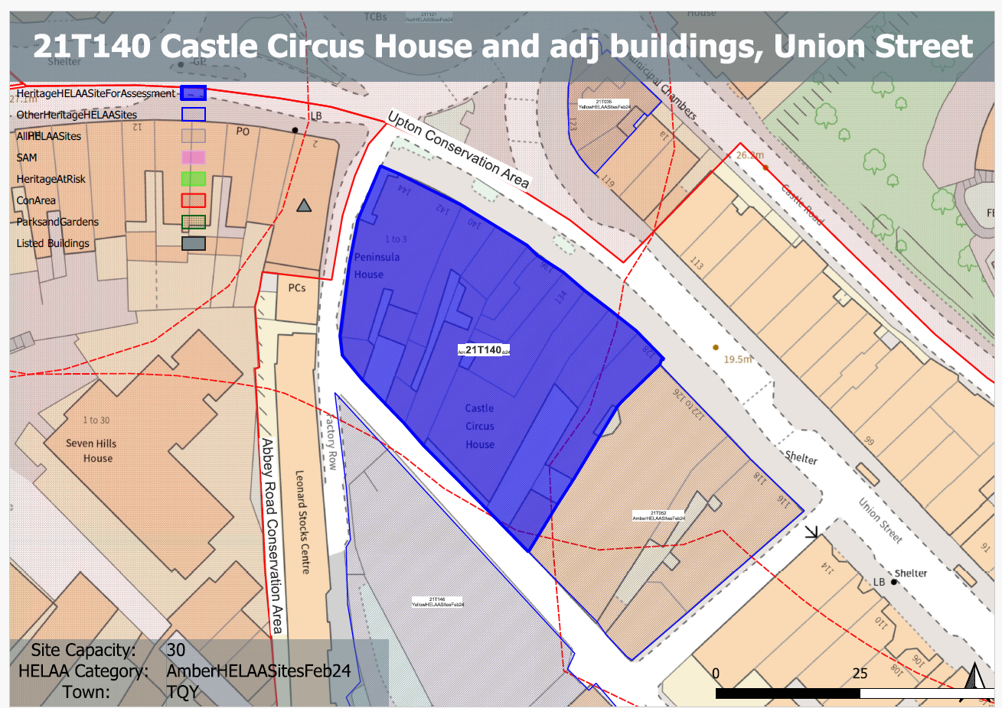
Site overview and heritage context:
A block of buildings in Torquay’s town centre, located between Union Street, Factory Row, and Temperance Street. The northeastern elevations form part of the retail frontage onto Union Street.
The site is within the setting of Tormohun, Abbey Road, and Upton Conservation Areas. Nearby listed buildings include the Grade II Listed Town Hall (30m to the northwest), the Grade II Listed 2 Tor Hill Road (10m to the west), and the Grade II* Listed St Mary Magdalene’s Church.

Planning History:
P/2023/1084 - Conversion of 1st and 2nd floors to two flats- 138 Union Street Torquay TQ2 5QB – APPROVED 10/04/2024

Heritage Asset Affected by Allocation | Designation | Contributing Elements to Significance | Impact of Development on Significance | Mitigation Measures for any Identified Harm /Opportunities to Enhance Significance | Impact on Significance with Mitigation in place
Abbey Road Conservation Area (S and W of site)  Upton Conservation Area (N of site)  2 Tor Hill Road (N of site)  Electric House (N of site)  The Town Hall (N of site)  5 no. lamp posts to south of Town Hall (N of site)  Parish Church of St Mary Magdalene (N of site)  Boundary wall and gate piers south of parish church of St Mary Magdalene | Conservation Area  Conservation Area  Grade II listed building  Grade II listed building  Grade II listed building  Grade II listed buildings  Grade II* listed building  Grade II listed building | The conservation area is characterised by its preserved 19th century street layout and surviving elements of the historic built environment. The site sites outside of the conservation area and currently makes a neutral contribution to its urban setting and thereby its significance.  The conservation area is characterized by surviving 19th century development, the historic street layout and surviving historic fabric and detailing. The site sits outside of the conservation area but makes a positive contribution to its significance through its surviving historic built form.  House and shop dating from the 1840s. The site forms part of the immediate urban setting of the asset and makes a positive contribution to its significance through its surviving historic built form.  Electricity showrooms and office. 1935. The site forms part of the immediate urban setting of the asset and makes a positive contribution to its significance through its surviving historic built form.  Town hall. 2 phases. First phase was the Carnegie Public Library, 1906-7, to the designs of Thomas Davison of London; contractor RE Narracott of Stoke Gabriel. Second phase of Town Hall with committee rooms etc, 1910-11. The site forms part of the immediate urban setting of the asset and makes a positive contribution to its significance through its surviving historic built form.  Lamposts. Probably contemporary with the 1910-1911 town hall. An attractive example of historic street furniture. Group value with the town hall. The site forms part of the immediate urban setting of the asset and makes a positive contribution to its significance through its surviving historic built form.  Parish church. 1843-9 to the designs of A Salvin. The site sits within the wider urban setting of the asset and makes a neutral impact on its significance.  Boundary walls to south side of church. Late C19. The site sits within the wider urban setting of the asset and makes a neutral impact on its significance. | The development of the site of a scale, massing and height similar to its surroundings (2/3 storeys) and which respects the surrounding historic environment would have a neutral impact on the significance of the conservation area.  The demolition of the existing buildings on the site to accommodate the quantum of development proposed would result in the loss of surviving elements of the historic environment which would cause less than substantial harm to the significance of the conservation area.  The demolition of the existing buildings on the site to accommodate the quantum of development proposed would result in the loss of surviving elements of the historic environment which would cause less than substantial harm to the significance of the asset.  The demolition of the existing buildings on the site to accommodate the quantum of development proposed would result in the loss of surviving elements of the historic environment which would cause less than substantial harm to the significance of the asset.  The demolition of the existing buildings on the site to accommodate the quantum of development proposed would result in the loss of surviving elements of the historic environment which would cause less than substantial harm to the significance of the asset.  The demolition of the existing buildings on the site to accommodate the quantum of development proposed would result in the loss of surviving elements of the historic environment which would cause less than substantial harm to the significance of the asset.  Development of the site would have a neutral impact on the significance of the asset.  Development of the site would have a neutral impact on the significance of the asset.  . | n/a  The sensitive conversion of existing buildings on the site and the improvement of their current condition and quality of shhopfronts to accommodate the proposed quantum of development would result in a positive impact to the conservation area.  The sensitive conversion of existing buildings on the site and the improvement of their current condition and quality of shhopfronts to accommodate the proposed quantum of development would result in a positive impact to the significance of the asset.  The sensitive conversion of existing buildings on the site and the improvement of their current condition and quality of shhopfronts to accommodate the proposed quantum of development would result in a neutral to positive impact to the significance of the asset.  The sensitive conversion of existing buildings on the site and the improvement of their current condition and quality of shhopfronts to accommodate the proposed quantum of development would result in a neutral to positive impact to the significance of the asset.  The sensitive conversion of existing buildings on the site and the improvement of their current condition and quality of shhopfronts to accommodate the proposed quantum of development would result in a neutral to positive impact to the significance of the asset.  n/a  n/a | Neutral  Positive  Positive  Neutral to positive  Neutral to positive  Neutral to positive  Neutral  Neutral

