Heritage Impact Assessment: Grand Hotel Garage Site, Torquay
HELAA2021 Ref: | 21T138
Site Address: | Grand Hotel Garage Site, Torquay
Site Area (ha): | 0.08
Site Yield: | 10
HIA Assessment

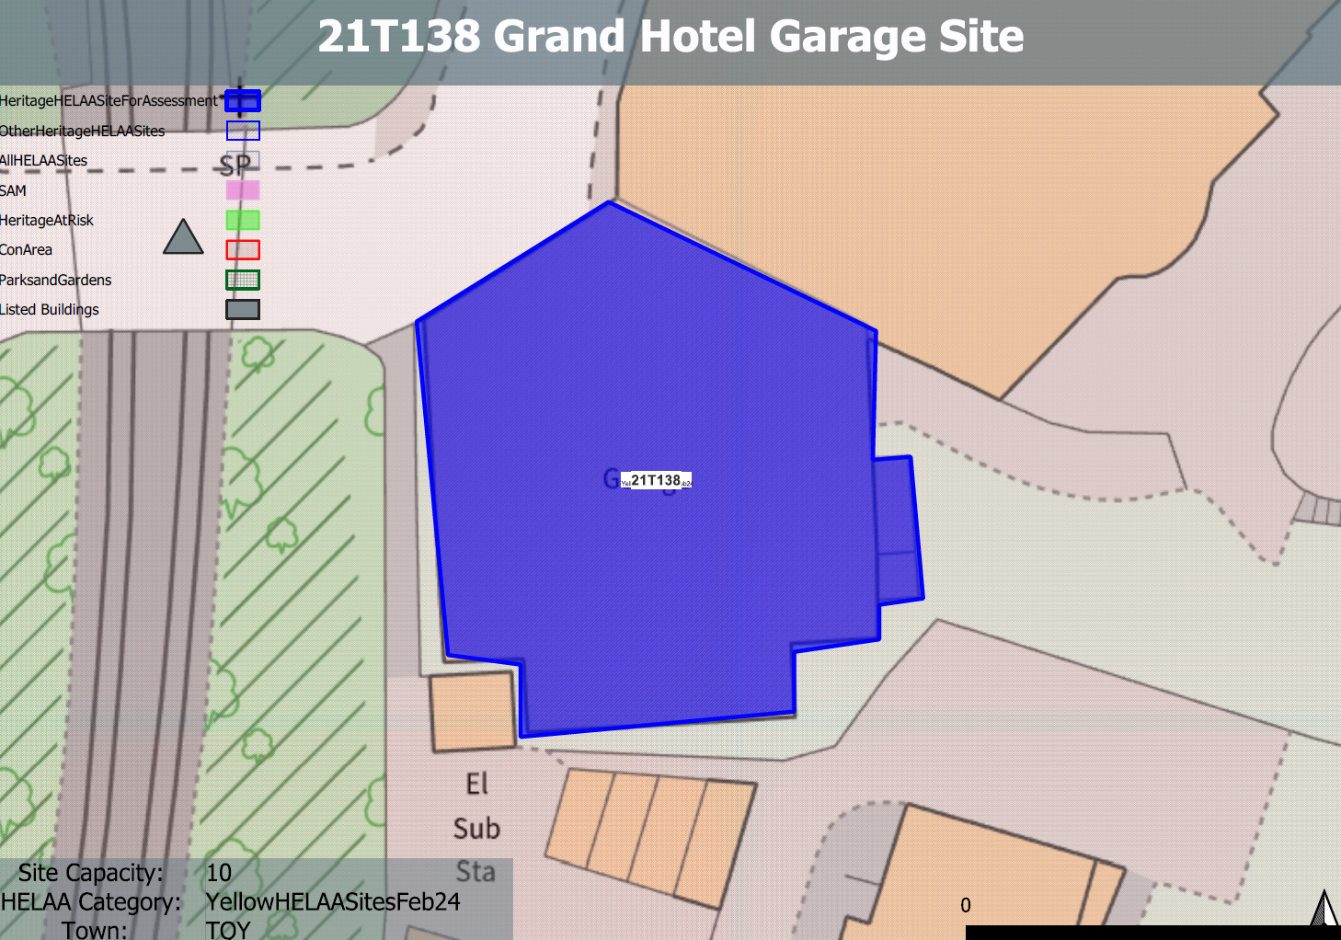
Site overview and heritage context:
The site comprises a garage and valet service ancillary to the Grand Hotel to which it is attached. The structure is single storey with a single wide vehicular access from Hennapyn Road which runs alongside the railway track. The site is a prominent feature within the Chelston Conservation Area and is adjacent to the Grade II listed Hennapyn Road Bridge.

Planning History:
P/1990/0943 - Demolition Of Existing Garage Adjacent To Hotel – Refused: 24/07/1990

Heritage Asset Affected by Allocation | Designation | Contributing Elements to Significance | Impact of Development on Significance | Mitigation Measures for any Identified Harm /Opportunities to Enhance Significance | Impact on Significance with Mitigation in place
Chelston Conservation Area  Hennapyn Road Bridge, immediately south of Torquay Station (immediately W of site) | Conservation Area  Grade II listed building | The building on the site is an early 20th century garage serving the Edwardian Grand Hotel. It is identified as part of a group of key buildings which make a significant contribution to the townscape and is recognised as a significant landmark within the conservation area character appraisal. It makes a clear positive contribution to the asset’s significance.  The listed road bridge is identified as a feature of special interest within the conservation area which has demonstrable architectural value. The site has a close relationship with the bridge and the road across it makes a positive contribution to its significance. | The redevelopment of the site to residential use would sever the historic relationship between the site and the adjoining hotel and would result in the potential loss of a key building and important landmark within the conservation area. This would cause a moderate degree of less than substantial harm to the significance of the asset as a whole.  The redevelopment of the site to residential use would sever the historic relationship between the site and the road bridge and would potentially result in the loss of a key component of the surrounding historic built environment of the asset. This would cause a degree of less than substantial harm to its significance. | Partial redevelopment of the site which involved the retention of the façade and some elements of ancillary use associated with the hotel may reduce some of the harm caused to the significance of the asset. However, this is unlikely to be achievable due to the constrained nature of the site. As a result, a degree of harm would likely remain to the conservation area.  Partial redevelopment of the site which involved the retention of the façade and sensitive development behind may reduce some of the harm caused to the significance of the asset. However, this is unlikely to be achievable due to the constrained nature of the site. As a result a small degree of harm may remain to the asset | Less than substantial harm.  Less than substantial harm

