Heritage Impact Assessment: Stantor Barton, Torquay
HELAA2021 Ref: | 21T137
Site Address: | Stantor Barton, Torquay
Site Area (ha): | 99.99
Site Yield: | 300
HIA Assessment

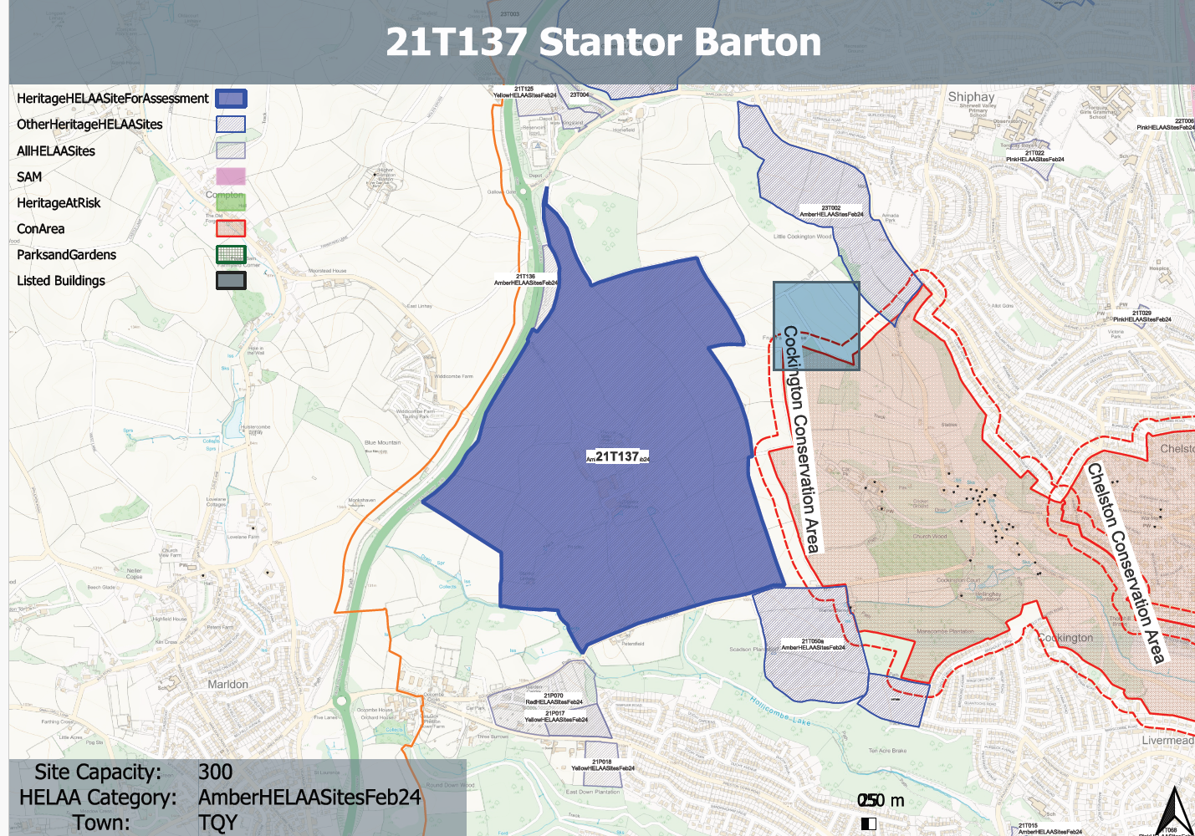
Site overview and heritage context:
Open fields to the west of Torquay and the east of Hellevoetsluis Way (Torquay Ring Road). The small hamlet of Stantor Cottages is accessed via a narrow lane. The land is part of a wider valley system and not flat.
The site lies outside but nearby to the boundaries of the Cockington Conservation Area which contains a number of listed buildings of varying grades.
Archaeology: Site includes Bronze Age funerary site. Also medieval manor/farmstead. Requires pre-determination assessment and evaluation to inform design and programme of archaeological mitigation.

Planning History:
None

Heritage Asset Affected by Allocation | Designation | Contributing Elements to Significance | Impact of Development on Significance | Mitigation Measures for any Identified Harm /Opportunities to Enhance Significance | Impact on Significance with Mitigation in place
Cockington Conservation Area (E of site) | Conservation Area | The special interest of the conservation area comprises its architectural and historic interest as an estate village within an attractive self-contained valley, the presence of historic landscape features and surviving historic fabric.  Parts of the site form part of the wider rural setting of the conservation area with its rural characteristics making a positive contribution to the significance of the conservation area. | Development of the site, especially towards the eastern and southern boundaries would impact on the open rural character of the site and would likely impact on the landscape value of the conservation area and the approaches to the asset and the contribution this makes to the asset’s significance.  This would likely cause less than substantial harm to its significance. | A potential reduced quantum of development which was focused on the western elements of the site away from areas of raised land and ridgeline to the east, and which took a landscape-led approach to its design could reduce the level of harm caused to the significance of the conservation area to a neutral impact. | Neutral
Cockington Court (E of site) | Grade II* listed building | Mansion set in its own landscaped grounds, C16 origins.  Parts of the site form part of the wider rural setting of the asset with its rural characteristics making a positive contribution to the significance of the asset. | Development of the site, especially towards the eastern and southern boundaries would impact on the open rural character of the site and would likely impact on the landscape value of the area and the approaches to the asset and the contribution this makes to the asset’s significance.  This would likely cause less than substantial harm to its significance. | A potential reduced quantum of development which was focused on the western elements of the site away from areas of raised land and ridgeline to the east, and which took a landscape-led approach to its design could reduce the level of harm caused to the significance of the asset to a neutral impact. | Neutral
Stables and coach house adjoining to north west of Cockington Court (E of site) | Grade II listed building | Stables and coach house serving Cockinton Court (qv), now used as workshops. Early C19 with some C20 alterations.  Parts of the site form part of the wider rural setting of the asset with its rural characteristics making a positive contribution to the significance of the asset. | Development of the site, especially towards the eastern and southern boundaries would impact on the open rural character of the site and would likely impact on the landscape value of the area and the approaches to the asset and the contribution this makes to the asset’s significance.  This would likely cause less than substantial harm to its significance. | A potential reduced quantum of development which was focused on the western elements of the site away from areas of raised land and ridgeline to the east, and which took a landscape-led approach to its design could reduce the level of harm caused to the significance of the asset to a neutral impact. | Neutral
Garden walls and adjoining to north west of Cockington Court (E of site) | Grade II listed building | Walls enclosing rose garden to rear of Cockington Court, Late C17-early C18.  Parts of the site form part of the wider rural setting of the asset with its rural characteristics making a positive contribution to the significance of the asset and the landscape value of the surroundings. | Development of the site, especially towards the eastern and southern boundaries would impact on the open rural character of the site and would likely impact on the landscape value of the area and the approaches to the asset and the contribution this makes to the asset’s significance.  This would likely cause less than substantial harm to its significance. | A potential reduced quantum of development which was focused on the western elements of the site away from areas of raised land and ridgeline to the east, and which took a landscape-led approach to its design could reduce the level of harm caused to the significance of the asset to a neutral impact. | Neutral
Church of St. George and St. Mary (E of site) | Grade II* listed building | Parish church set in landscaped grounds of nearby Cockington Court (qv). Early C13 origins but most of fabric is C14 or C15. Restoration 1882-3 by Hine and Odgers and 1916-20 by Charles Nicholson (architect) and Herbert Read (restoration of screen)  Parts of the site form part of the wider rural setting of the asset with its rural characteristics making a positive contribution to the significance of the asset and the landscape value of the surroundings. | Development of the site, especially towards the eastern and southern boundaries would impact on the open rural character of the site and would likely impact on the landscape value of the area and the approaches to the asset and the contribution this makes to the asset’s significance.  This would likely cause less than substantial harm to its significance. | A potential reduced quantum of development which was focused on the western elements of the site away from areas of raised land and ridgeline to the east, and which took a landscape-led approach to its design could reduce the level of harm caused to the significance of the asset to a neutral impact. | Neutral

