Heritage Impact Assessment: Shedden Hall Hotel, Shedden Hill, Torquay
HELAA2021 Ref: | 21T124
Site Address: | Shedden Hall Hotel, Shedden Hill, Torquay
Site Area (ha): | 0.27
Site Yield: | 11
HIA Assessment

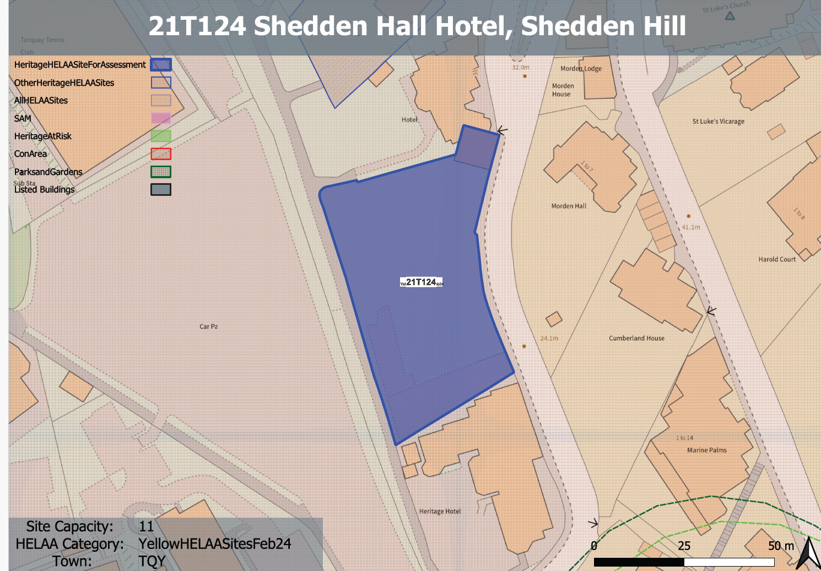
Site overview and heritage context:
Set on the western side of Shedden Hill overlooking the public car park this is the site of the former Shedden Hall Hotel, a Victorian Villa that was demolished following significant fire damage in early 2019.
It now sits as a cleared site except for a minor section of building in the top corner of the site that abuts the adjacent plot/building. The site is heavily vegetated with scrub/bramble growth. Within the lower part of the site there is a large mature Turkey Oak tree.
The site’s topography drops significantly from east to west from the public pavement towards the landscaped border with a public footpath and across to the car park.
The site is within the Belgravia Conservation Area and approximately 65m to the northeast of the site is the Grade II* listed St Luke’s Church.

Planning History
P/2011/0227: Part demolition, conversion and alteration from hotel to 7 residential dwellings and formation of 3 residential dwellings and 4 new residential houses with parking. Approved 03 May 2013.
P/2016/0305: Refurbishment of former hotel and demolition of modern extensions. Conversion to provide 4 residential apartments. New build residential accommodation within grounds comprising 2 two storey garden cottages, 4 four storey town houses and 1 four storey coach house. Provision of 19 car parking spaces. Reconnection to public footpath and reinstatement of stone boundary wall. Approved 31 May 2017.
P/2021/1314 - Outline Application for the construction of residential accommodation for up to 25 units (Detailed approval sought for Access, Appearance, Layout and Scale, with Landscaping a Reserved Matter). – Approved 06 September 2024

Heritage Asset Affected by Allocation | Designation | Contributing Elements to Significance | Impact of Development on Significance | Mitigation Measures for any Identified Harm /Opportunities to Enhance Significance | Impact on Significance with Mitigation in place
Belgravia Conservation Area  St. Lukes Church | Conservation Area  Grade II* Listed Building | The site is prominent in terms of short ‘street’ views in both directions along Shedden Hill Road and longer views from the south and west on lower ground around Torbay Road and Tor Abbey Meadows/Tor Abbey Sands, where there are open views up towards the buildings in Shedden Hill Road area.  The Victorian Villa which was present on the site prior to it’s fire damage and subsequent demolition in 2019 was identified as a key building which made a positive contribution to the conservation area within the Belgravia Conservation Area Appraisal.  Parish church. 1863, to the designs of A Blomfield. The site makes a limited contribution to the setting and therefore significance of the listed church. There is some distance between the sites and the general area is characterised by large buildings set on the hillside. | The proposed development of up to 25 dwellings on the site has been approved through P/2021/1314 with some harm caused to the significance of the conservation area. However, this level of harm was assessed to be acceptable.  The proposed development of up to 25 dwellings on the site has been approved through P/2021/1314 with no harm identified to the significance of St. Lukes church. | n/a  n/a | n/a  n/a

