Heritage Impact Assessment: Lower Union Lane Office Block, Torquay
HELAA2021 Ref: | 21T123
Site Address: | Lower Union Lane Office Block, Torquay
Site Area (ha): | 0.23
Site Yield: | 70
HIA Assessment

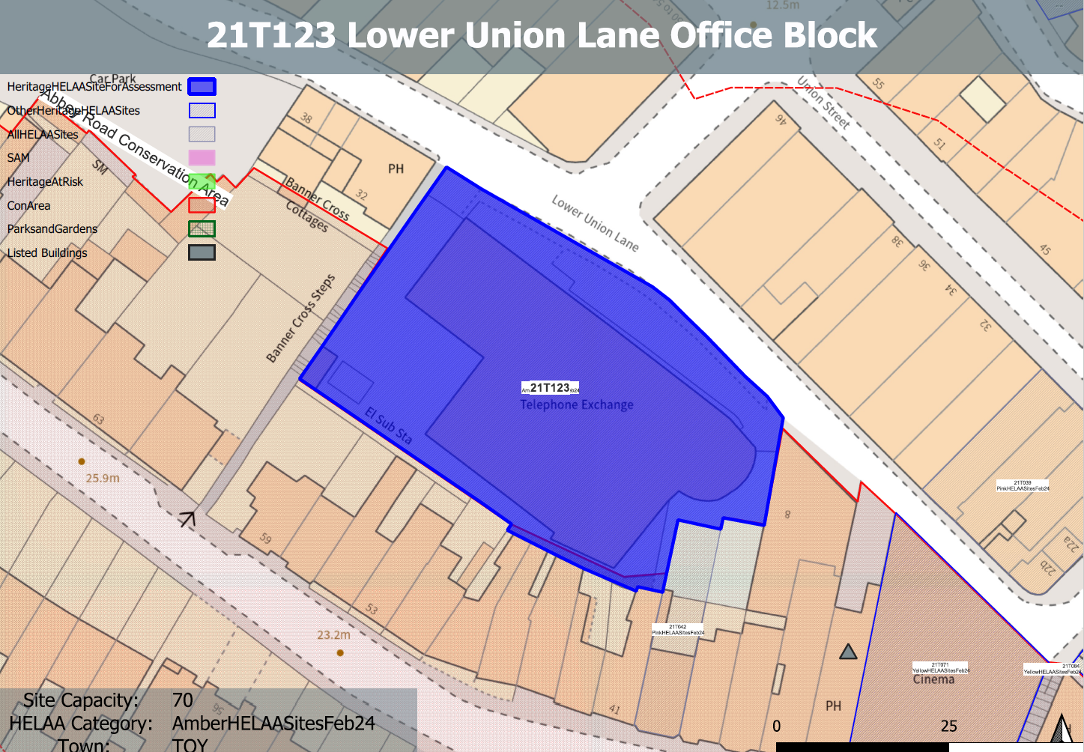
Site overview and heritage context:
The site is accessed from Lower Union Lane and comprises a 6 storey office building which was formerly a telephone exchange. The building dates from the late 20th century and is currently vacant and in relatively poor condition.
The site was originally mainly in industrial use and housed a timber yard in the 19th century.
The site is level, however, the surrounding land rises steeply to the west leading to Abbey Road which results in a considerable difference in ground levels between the site and surrounding areas to the west.
The site is constrained to the west by a significant change in ground levels and associated retaining structures and to all other sides by existing built development and hard urban landscaping.
The site is in close proximity to the Abbey Road Conservation Area and a Grade II listed building can be found to the SE of the site on Abbey Road.

Planning History:
No planning history.

Heritage Asset Affected by Allocation | Designation | Contributing Elements to Significance | Impact of Development on Significance | Mitigation Measures for any Identified Harm /Opportunities to Enhance Significance | Impact on Significance with Mitigation in place
Abbey Road Conservation Area (S and W of site)  Former Falcon Public House (SE of site) | Conservation Area  Grade II listed building | The conservation area is characterised by its preserved 19th century street layout and surviving elements of the historic built environment. The site sites outside of the conservation and currently makes a negative contribution to its urban setting and thereby its significance.  Mid- 19th century former public house, recent use as a children’s entertainment area. Is a prominent feature within the street scene from Abbey Road due to its current colour, condition and striking architectural features. The site makes a negative contribution to the surrounding built environment and how the asset is experienced from the east. The site therefore has a minor detrimental impact on its significance in its current form. | The conversion of the existing building would result in a neutral impact on the significance of the conservation area.  The conversion of the existing building would result in a neutral impact on the significance of the asset.  . | The demolition of the existing building and sensitive redevelopment of the site to complement the character of the area, by introducing a built form more in-keeping with the surrounding historic environment along with the introduction of appropriate public realm would enhance the setting of the asset and would potentially open up views of the asset from the east and would have a minor positive enhancement to its significance.  The demolition of the existing building and sensitive redevelopment of the site to complement the character of the area, by introducing a built form more in-keeping with the surrounding historic environment along with the introduction of appropriate public realm would enhance the setting of the asset and would potentially open up views of the asset from the east and would have a minor positive enhancement to its significance. | Minor enhancement  Minor enhancement

